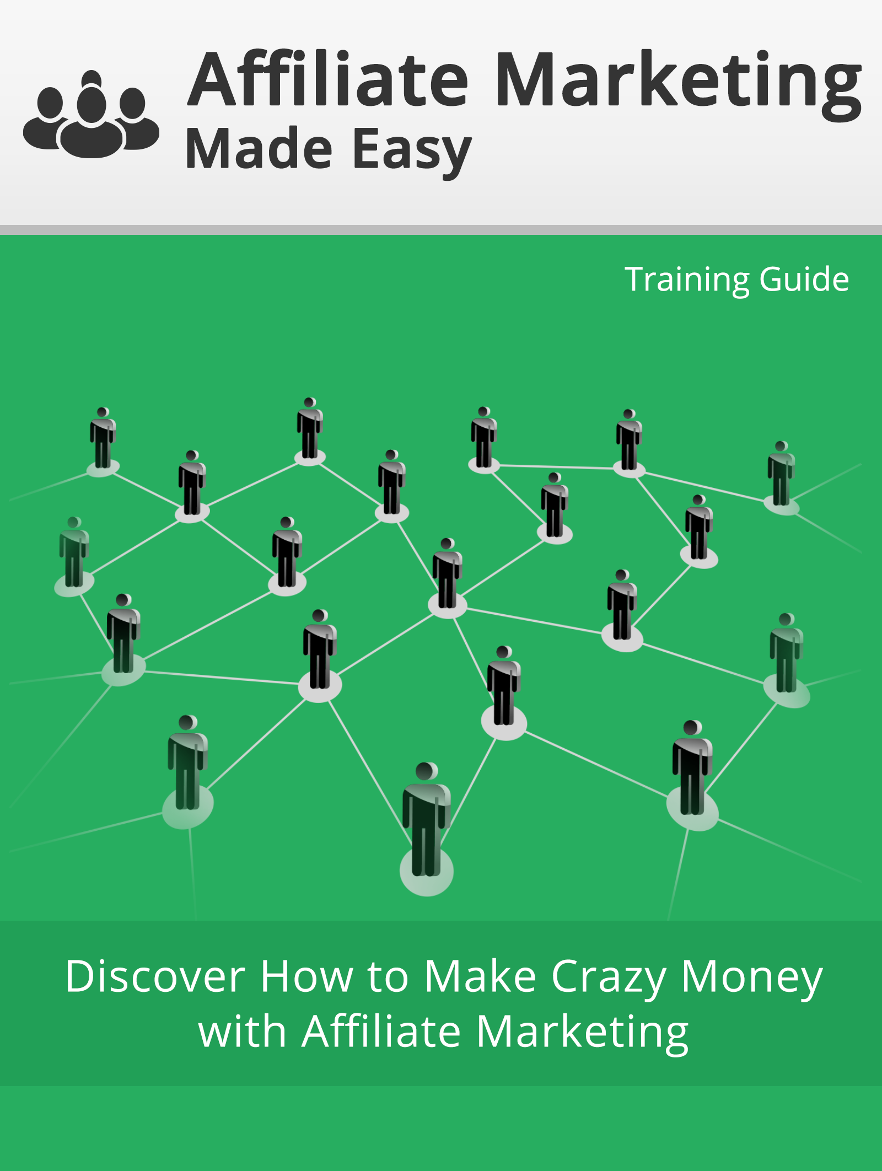

Powered by : Your Website URL

Disclaimer:

This work may not be copied, sold, used as content in any manner or your name put on it until you buy sufficient rights to sell it or distribute it as your own from us and the authorized reseller/distributer.

Every effort has been made to be accurate in this publication. The publisher does not assume any responsibility for errors, omissions or contrary interpretation. We do our best to provide the best information on the subject, but just reading it does not guarantee success. You will need to apply every step of the process in order to get the results you are looking for.

This publication is not intended for use as a source of any legal, medical or accounting advice. The information contained in this guide may be subject to laws in the United States and other jurisdictions. We suggest carefully reading the necessary terms of the services/products used before applying it to any activity which is, or may be, regulated. We do not assume any responsibility for what you choose to do with this information. Use your own judgment.

Any perceived slight of specific people or organizations, and any resemblance to characters living, dead or otherwise, real or fictitious, is purely unintentional.

Some examples of past results are used in this publication; they are intended to be for example purposes only and do not guarantee you will get the same results. Your results may differ from ours. Your results from the use of this information will depend on you, your skills and effort, and other different unpredictable factors.

It is important for you to clearly understand that all marketing activities carry the possibility of loss of investment for testing purposes. Use this information wisely and at your own risk.

Limited Special Offer for You:
Affiliate Marketing Made Easy
(Video Training)
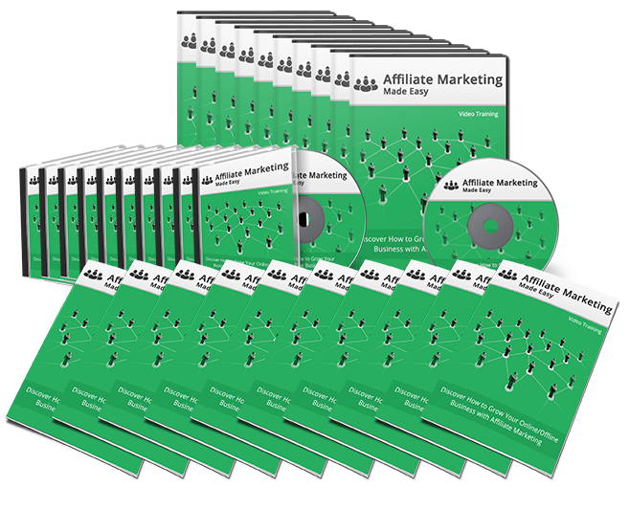
Click Here to Download Your Video Training!
(Insert your Upsell Offer URL)

Table of Contents
Introduction | 4
Chapter I: What is Affiliate Marketing? | 5
Chapter II: Why Affiliate Marketing? | 8
Chapter III: Are Business using Affiliate Marketing? | 11
Chapter IV: The Top 10 Affiliate Networks | 15
Chapter V: My 7-Steps Secret Formula to AM Success | 26
Step 1: Hot Niche Research | 27
Step 2: Main Affiliate Product Research | 30
Step 3: Additional Affiliate Products Research | 42
Step 4: Squeeze Page Set up | 45
Step 5: Autoresponder Set up | 49
Step 6: Advertising | 58
Step 7: Get the most out of your traffic | 63
Conclusion | 71
Resources | 72
Limited Special Offer (for the next 7 days only) | 73

Introduction:
Introduction
Affiliate Marketing has existed for decades: a smaller business promotes a larger related business’ products and then earns a reward for sales. However, the advent of the internet opened an entirely new world of options for the affiliate marketer and the merchant.
In this training guide, you will learn how to set up your site or pages to promote others’ services and products. You’ll advertise and promote, they will make and process the sales, and both of you will make money. It’s an amazing way to capitalize on a niche you already love. Every time someone reads your blog or visits your site and then follows the link to the merchant’s site, you’ll earn revenue. And if they make a purchase, you’ll earn even more.
As you read the following pages, you’ll gain valuable information about affiliate marketing, finding the right product and the right affiliate network, and using your site to promote products and services. You’ll learn about generating traffic and using keywords to boost your revenue even more.
The work is up to you, but the blueprint you’ll find here will help you to work smarter. And when you work both smart and hard, success is much more likely to follow!
To Your Success,
Your Name
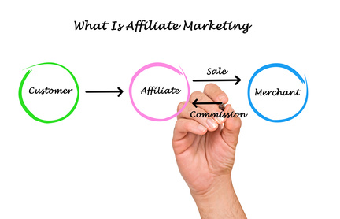
Chapter I: What is Affiliate Marketing?
Affiliate Marketing consists of a performance-based method of marketing in which businesses and affiliates work together to create profit.
In this marketing method, a business rewards affiliates for every customer or visitor brought in by the affiliate’s marketing efforts. In other words, when an affiliate partners with a business, that affiliate can earn money every time their marketing also brings visitors to the parent business.
For Businesses: Affiliate Marketing is an excellent way to generate sales and increase your revenue. It is performance based, which means that affiliates promote your product, and then you reward your affiliates for each click, lead, or sale.
Affiliate Marketing is the single fastest growing industry on internet. Commission Junction, Amazon and ClickBank are just a few of the businesses running top affiliate networks, and they are making a huge amount of money from affiliate programs.
For Affiliates: Affiliate marketing allows you to earn money with your website by joining one of many affiliate programs. These businesses offers affiliate programs to generate traffic to their websites. Businesses offer high commissions based on the traffic and sales that are generated by your website.
Affiliate marketing is a very powerful and cost effective channel; you only have to pay when a successful transaction will happen. Your business will get benefits by acquiring potential customers.
Affiliate marketing works using four roles:
- First comes the merchant, who is also known as the retailer or major brand.
- The network consists of the offers from which the affiliate chooses, and this is also where payments are made.
- The affiliate, who is also known as the publisher, is the one who does the marketing work.
- Finally, the customer purchases the product or service, and that profit is shared by the merchant and the affiliate.
Affiliates use advertising methods to bring customers to the merchant, and they are rewarded for their efforts. These advertising methods can include:
- Search engine optimization
- Paid search engine marketing
- Email marketing
- Content marketing
- Reviews
- Display advertisements, etc.
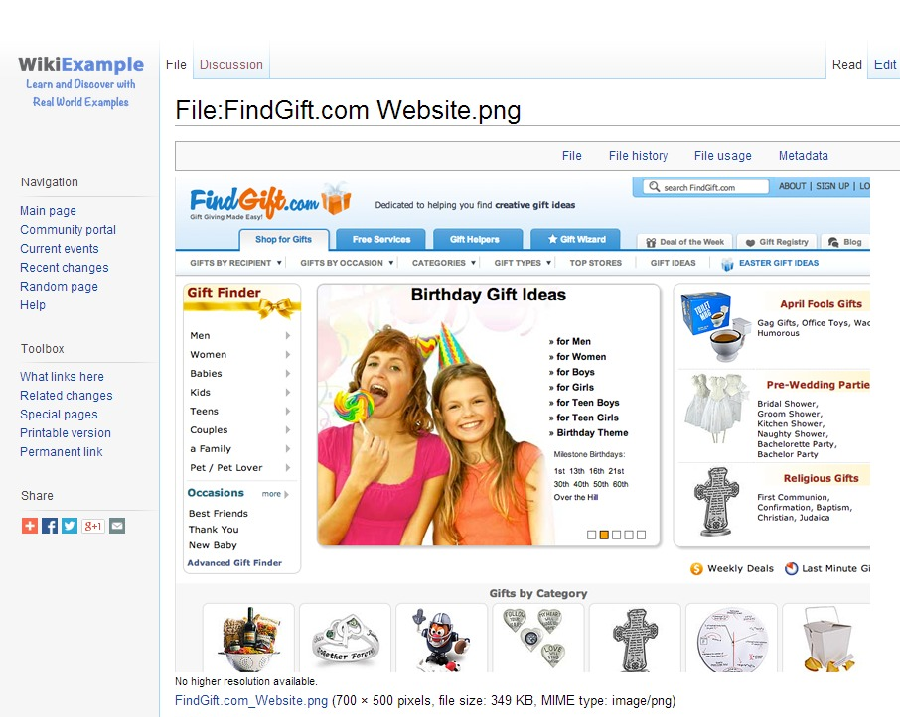
The website above is an example of an affiliate website. Findgift.com directs visitors to the sites of major retailers so that they can purchase gifts, such as toys, jewelry, food, and other items.
When the customer clicks on the items and is directed to the merchant, this affiliate is paid. It is good for the merchant because they get more visitors to their site and more customers buying their products. And it is good for the affiliate because they are rewarded for their advertising efforts.

Chapter II: Why Affiliate Marketing?
Why should you use affiliate marketing? There are many reasons, but it all boils down to mutual benefit. With affiliate marketing, there are incentives for both the merchant and the affiliate. Here are just a few reasons why affiliate marketing is a great marketing option:
- You control the marketing. In affiliate marketing, you determine the program, from commission rates to advertising decisions. Choose your merchants or affiliates and determine how and when you or your affiliates get paid.
- The initial cost is low. While many other online marketing techniques or advertisements have startup costs that may be inaccessible to businesses without a large amount of money, with affiliate marketing, all you have to do is create your site or ads and purchase an affiliate solution. Or you can do the work to generate partners yourself.
- You can generate new profits without new products. As an affiliate, you make money by promoting the merchant’s offers without having to generate your own new product.
- Generate sales without the shopping cart. Let’s face it, setting up a shopping cart and creating an integrated marketing program takes work. With affiliate marketing you can offer bonuses and incentives without having to jump through all of the traditional hoops to make a sale.
- You can benefit from others’ success. As an affiliate, when the merchant succeeds, so do you. You are rewarded for traffic and sales that result in customers for the merchant.
- With affiliate marketing, the workload is shared. In affiliate marketing, the merchant usually takes care of the logistics involved in the sale of products or service, the processing of orders and payments, and the shipping of merchandise. The affiliate produces content and/or advertisements and referrals and then collects commissions from each agreed upon action.
Let me show you some crazy, eye opening facts which will help you understand why Affiliate Marketing is something that can add unlimited value to your marketing efforts:
93% of advertisers support affiliate marketing as an effective marketing channel. (source)
$20 billion in sales have being generated from affiliate marketing and lead generation. (source)
50% of advertisers saw a lack of respectable understanding of affiliate marketing at the level of CEO. (source)
The Affiliate marketing industry alone is an over $7 billion business only in the UK. (source)
Companies spend up to $150,000 a month on commissions. (source)
Over 6o% of blogs use affiliate offers in order to get in some revenue from affiliate programs or display advertising. (source)
85% of affiliate marketers belong to commission junction. (source)
Affiliate Marketing has grown nearly 150% since the year 2000. (source)
In Affiliate marketing 79% of traffic is generated by SEO. (source)
91% of customers’ relationship is maintained via Email. (source)
40% of Amazon revenue comes from Affiliate Marketing. (source)
23% of the total Online Sales comes from Affiliate Marketing. (source)
75 out of 100 online retailers have an affiliate program. (source)
48% of U.S. affiliates businesses have PPC (pay per click) accounts which is the most important category for affiliates. (source)
The Amazon Associates Program is one of the largest and most successful online affiliate programs, with over 900,000 members worldwide. (source)

Data like this makes it clear that there is a lot of money to be made with affiliate marketing. And while lots of people might be talking about it, very few can really teach you how to productively position your business so that you can make money effectively and consistently with affiliate marketing.
Chapter III: Are Businesses using Affiliate Marketing?
In a word, yes, thousands of businesses are using affiliate marketing, and the number is growing every day. Merchants have discovered what a boost it gives their products and services, and affiliates have discovered how easy it is to make money partnering with these merchants.
Small businesses owners are benefitting through their affiliate program via promotional activities to make huge commissions. It is becoming more and more popular to create affiliates in order to generate more sales.
That makes it a win/win relationship. Affiliate marketing is a $20 billion market, and these markets increase revenue of both businesses and marketers. Below are a few examples of businesses that are earning more and making it big using Affiliate Marketing.
The most famous affiliate program is Amazon’s “Associates Program,” in which Amazon offers its affiliates the opportunity to earn up to 15% per sale. Amazon is an example of one of many affiliate programs. As you examine their stats you will find that 40% of Amazon’s revenue is generated from Affiliate marketing.
AWeber uses Email marketing affiliate programs. It pays a 30% commission for each AWeber follow-up autoresponder sale indicating that traffic comes from the unique affiliate link.

Hostgator is a web hosting company that runs affiliate programs to promote its business and increase its revenue. You can earn commissions of up to $125 per successful referral which is almost 1/3 price of that product.
Expedia is the world’s leading online travel company. Expedia runs an affiliate network named Expedia Affiliate Network (EAN) to grow its business worldwide. Expedia pays its affiliates in two ways, and you can earn 5% - 50% commissions on successful sales.
ThemeForest is an Envato Marketplace. It is a site where a customer can buy themes For CMS products like Drupal, Joomla and WordPress, along with html templates for prices ranging from $5 to $40. ThemeForest also has an affiliate program with a 30% of commission for affiliates with a successful purchase.
In addition to the above companies, some of the names you hear every day make use of affiliate marketing as well. Here are 7 top brand businesses who use affiliates:
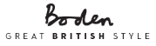
Boden: http://www.bodenusa.com/
Boden is a one-stop site for clothing and accessories. Founded in 1991, they now ship approximately 12.5K packages a day from their warehouse.
Costume Express: http://www.costumeexpress.com/
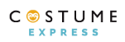
Costume Express is the family-friendly destination for everything needed to celebrate Halloween. Costume Express offers a complete assortment of unique costumes and accessories for dress-up play that encourages children to develop their imagination and creativity.
H&R Block: http://www.hrblock.com/
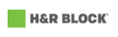
Of course, we all know H&R Block does taxes, but they also offer other services, such as audit support, money management services, and health insurance. These products and services make for lots of opportunities for affiliates to advertise and earn revenue.
Discount Mags: http://www.discountmags.com/
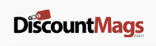
Discount Mags offers subscriptions to more than 1,500 magazines at the lowest prices. Their affiliate program offers an 18% commission on every sale up to 60 days later from any referral. Their dedicated affiliate program is managed by OPM Pros, an organization that specializes in outsourcing affiliate programs.
Home Depot: http://www.homedepot.com/

Home Depot’s slogan may be “More saving. More doing.” But with their affiliate program, you can change that to more promoting, more earning. You can take advantage of the almost endless list of home improvement items they carry. As an affiliate, you can ear commission on over 500,000 free ship to store items sold on homedepot.com.
They are also supported by Commission Junction, which means more services for you. Like many larger companies, the commission percentage is lower – 3% on most products and 5% on custom blinds. However, because they ARE such a large company, there are more sales.

HSN.COM: http://www.hsn.com/

The Home Shopping Network has come a long way from knives and gadgets. HSN.com offers clothing, jewelry, electronics, kitchen, crafts, sports items, collectables, and much more. When a customer shops through your site, hsn.com does all the work except for the referral, and they create promotions and special offers that increase site visits and commissions.
InterContinental Hotels Group: http://www.ihgplc.com/

This hotel company books 161 million hotel guest nights every year; that’s over 688,517 rooms in 4,700 hotels in nearly 100 countries. Their affiliate program is partnered with FlexOffers.
All these companies demonstrate that affiliate marketing will boost your sales and build your brand through the channels your affiliates are using. This company is also partnered with Commission Junction, so you know the service is great.

Chapter IV: The Top 10 Affiliate Marketing Networks
The Affiliate Network is the intermediary between merchants and affiliates. There are a lots of affiliate networks; some are focused on retail programs, and some are focused on lead generation programs.
Affiliate Marketing is the best way to become your own boss, and choosing the right network is key. You should choose the network which provides you statistical information, tracking, and payment processing. Before becoming an affiliate, do your research and find the best affiliate network for your marketing niche.
Most of the networks require a signup and setup fee ranging hundreds to thousands of dollars. You have to make sure that the network provides the level of service you require and the tools to help you properly run your campaign.
On the other hand, the merchant handles all the logistic activities such as selling product and services, placing customer order, and shipping. Merchants provide commissions to the affiliate for all the visitors and customers who come via affiliate link to the merchant’s website.
All affiliate programs are different in some ways, so you can choose the one that is right for you. Some of the more common networks are here:

1. Amazon Associates – https://affiliate-program.amazon.com/
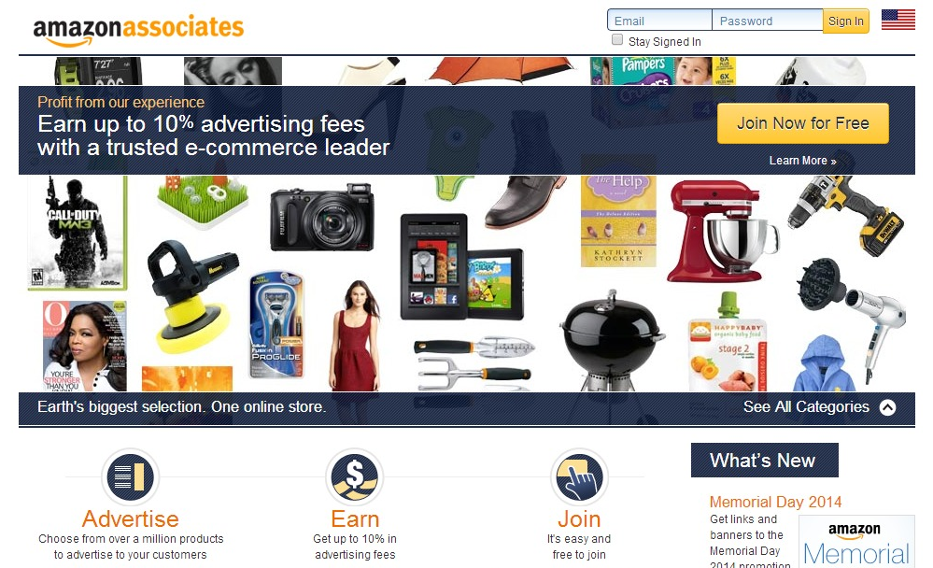
Amazon is one of the most trusted sites for shopping. Amazon Associates is a well-known way to convert visitors into customers. If you are running a blog or website and want to monetize it, the Amazon Associate program is a good way to make money online as an affiliate.
Because Amazon offers more than a million products, you can choose the product that fits your marketing niche and then promote it to your audiences. On your website, you can also add individual products for a customized look.
Amazon provides its affiliates up to 10% advertising fees on purchases. Amazon also provides you with a complete, detailed report of your conversions using report tools. Amazon pays commissions up to 10% on every purchase. Amazon also provides you with a complete and detailed report of your conversions using reporting tools. They also give great and instantaneous support for any problem you may have.
2. ClickBank – http://www.clickbank.com/
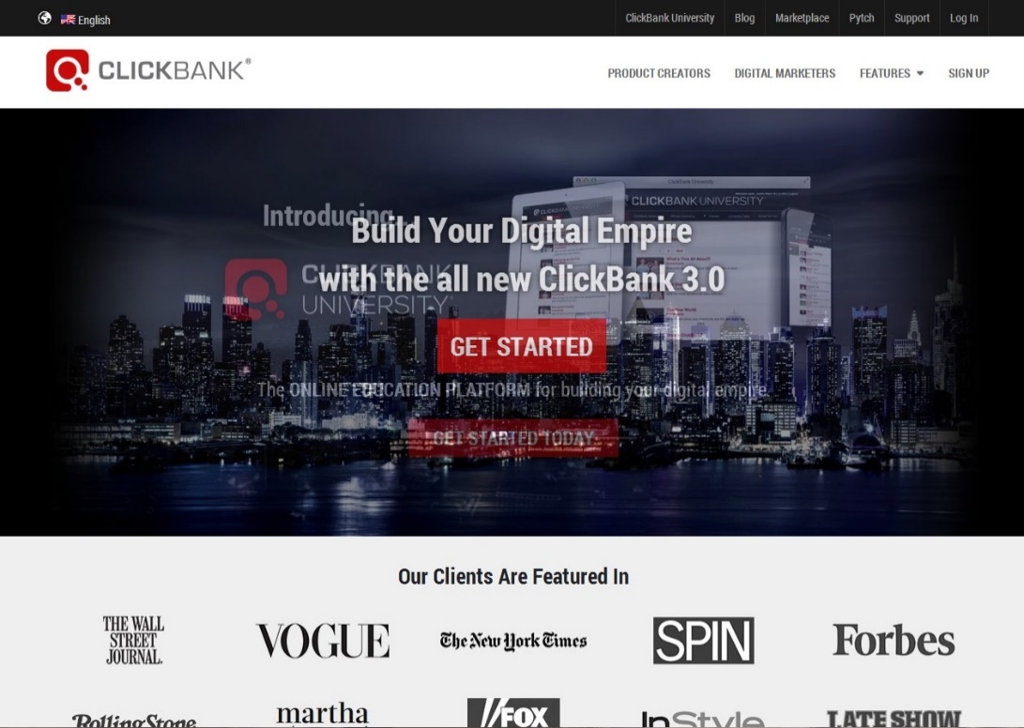
Click Bank is the privately held marketplace for digital products. It is continuously voted as high traffic website, and it builds a connection between affiliates and digital content creators.
This affiliate program allows you to promote the products that are related to your niche. When a customer comes to your website, he or she won’t feel like you are promoting another website on your blog or website; they will feel as if you are providing something they need. This helps you to generate leads.
ClickBank provides a Gravity score of each product to specify how many have been product sold by affiliates in last 8 weeks. A Gravity score shows the popularity of a product and how well that product is generating sales.

3. Commission Junction (CJ) – http://www.cj.com/
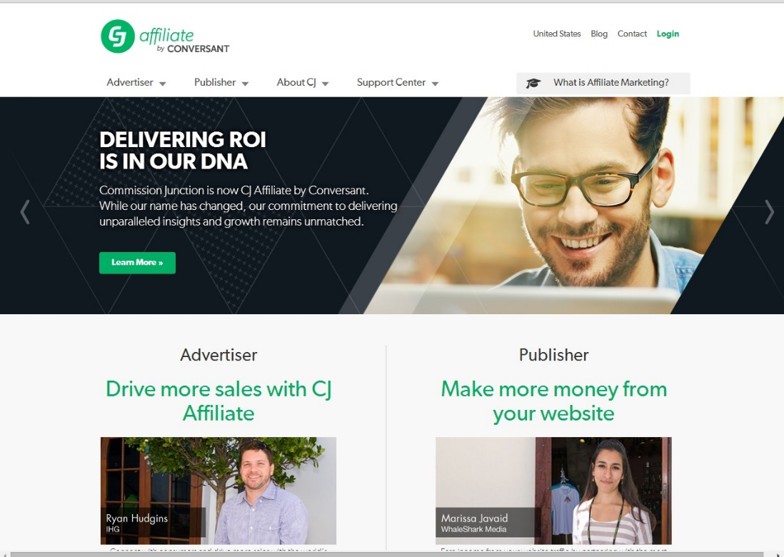
Affiliates familiar with online business need to know about commission junction. Commission Junction is one of the largest affiliate marketing sites in North America, and it operates worldwide. Owned by ValueClick, it is known for highly professional work.
Commission Junction has a wide variety of products, so you can choose the best niche and apply. If the advertiser approves your application, you will become a publisher, and you can post the advertisement onto your website. When someone clicks or purchases, you will earn a commission.
It provides options to connect products with a variety of links, including text, images, buttons, or banners. In addition, it also offers a pay-per-call affiliate program to help the affiliates to get paid for the every lead generation. It has a centralized and secure affiliate payment system.
4. ShareASale– http://www.shareasale.com/
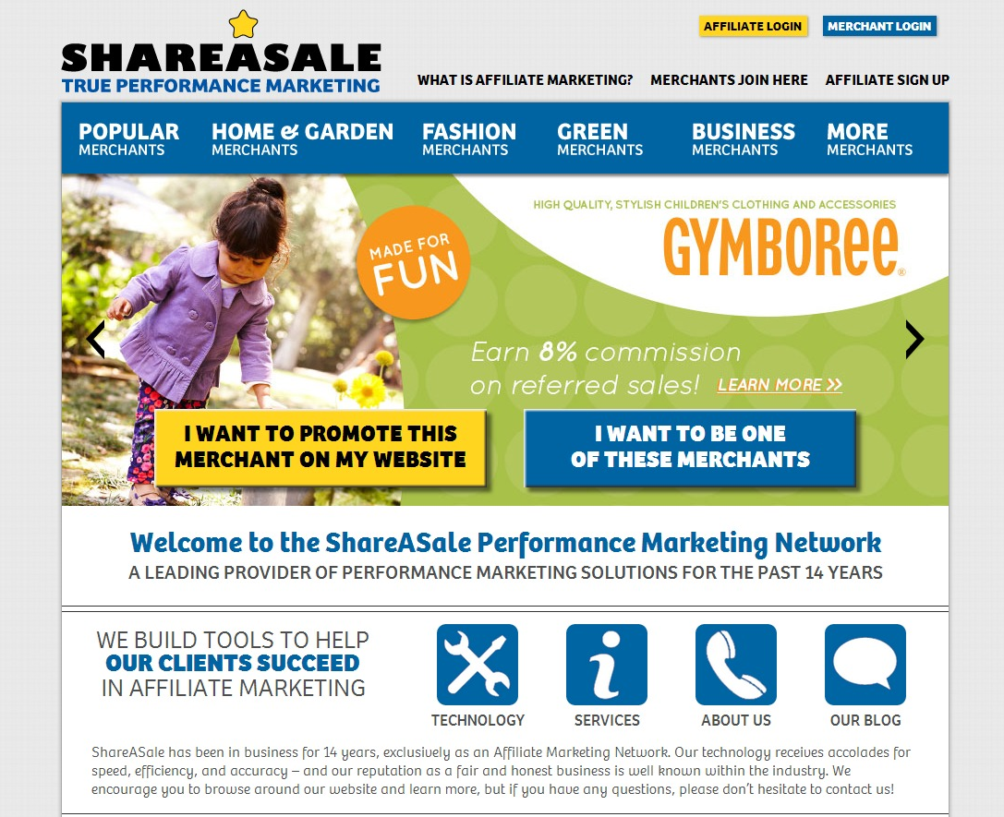
ShareASale (SAS) is one of the oldest and most respected affiliate networks on the internet. There are more than 4000 affiliates advertising their products.
The main benefits of ShareASale are the potential to earn profitable revenue easily and the opportunity find advertiser products that are related to your blog or marketing niche. ShareASale directly deposits in using data feeds ftp and provides real time report.
ShareASale receives excellent ratings regarding company reputation, customer service, and commission payment. They consistently get great reviews from their customers and affiliates.

5. Affiliate Window – http://www.affiliatewindow.com/us/
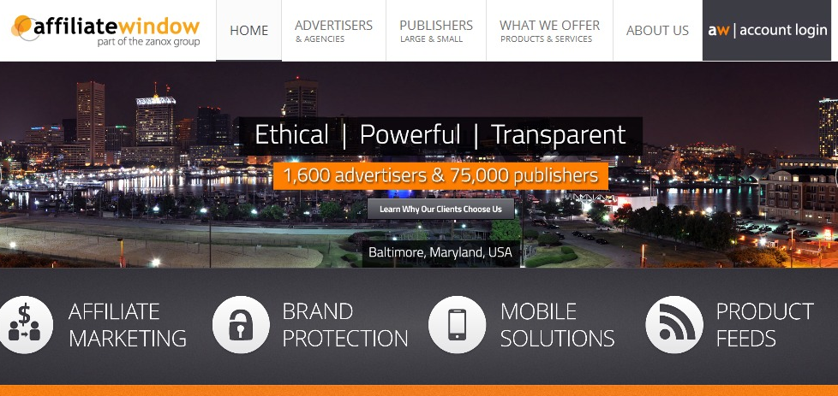
Affiliate Window is the most popular and award-winning affiliate marketing website in UK, with 75,000 registered affiliates. In addition, its prominence is steadily increasing in the US and Canada. It works on the idea of performance based marketing.
This company serves its affiliates by providing high commission rates as well as web and mobile based performance analysis reports. It also runs an online lead generation campaign to help affiliates. Affiliates earn sales based commissions based on the traffic that is sent to the advertiser website. This is known as the Cost-Per-Action (CPA) Model, and it is more transparent than Cost per Click (CPC) Model.
Affiliate Window has a unique business model for advertisers and publishers - ShopWindow and ContentWindow. ShopWindow is the product comparison engine that holds 5 million products. ContentWindow contains widgets with products and services to equilibrate website content.
6. ClickBooth – https://www.clickbooth.com/
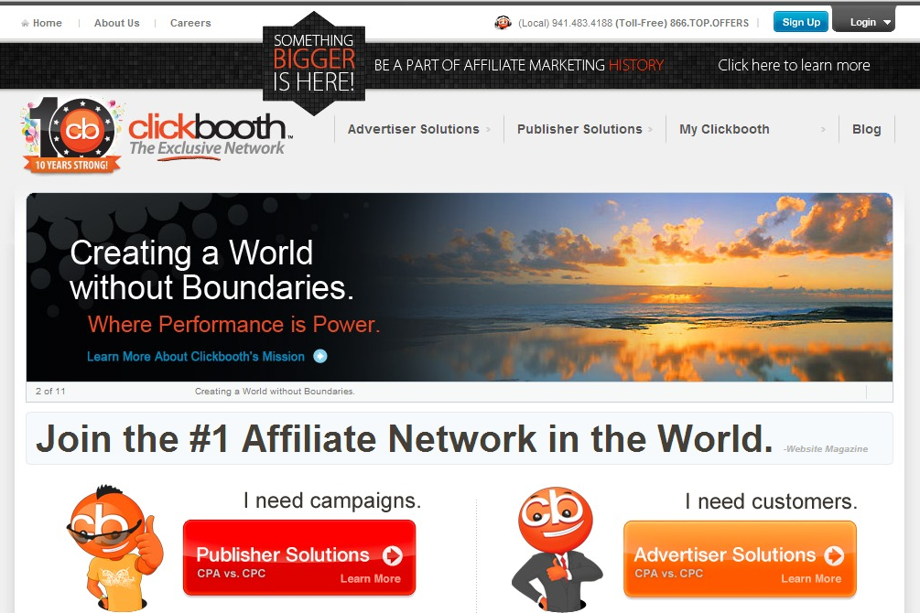
Click Booth is known for its Cost-Per-Action (CPA) and Cost-Per-Click (CPC) networks. Click Booth works with the top selected affiliates. The network works with its affiliates to decide the payment cycle for each individual, and affiliates can choose their payout method from several payout methods.
Click Booth affiliates get highest payouts and 24 X 7 support. It also looks for innovative technology in order to remain at the top of the industry.
Click Booth values each partnership and strives to exceed publisher expectation to monetize the traffic of affiliates. An expert affiliate will utilize all the resources to create huge traffic. Click Booth affiliates can refer to other affiliates using click bank publisher referral and receive 2% of gross referral credit and additional $10 bonus for every affiliates.
7. PeerFly – https://peerfly.com/
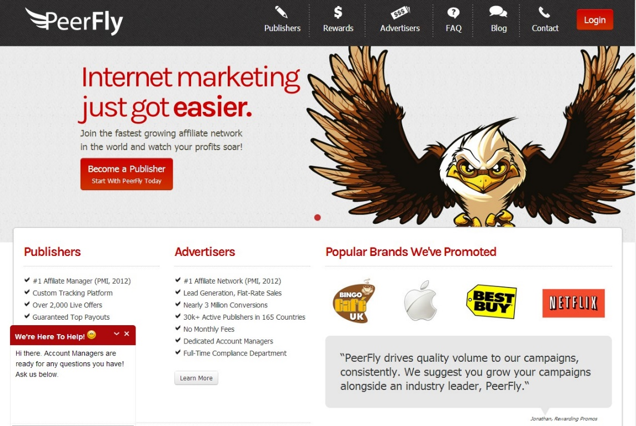
PeerFly is a Cost-Per-Action based affiliate network. With their referral program, you can earn 5% commission on each referral for a life time.
It accepts affiliates from all countries, and the amount of money you want to make is proportionally dependent on how smart and how hard you are willing to work.
The average conversion rate on PeerFly is about 8%. There is no cost to sign up with PeerFly or to use their services. All you have to do is explain how you are going to promote their products.
PeerFly requires the minimum information from customer, so if you are looking for easy affiliate products to start with, you can start with PeerFly.

8. MaxBounty – http://www.maxbounty.com/
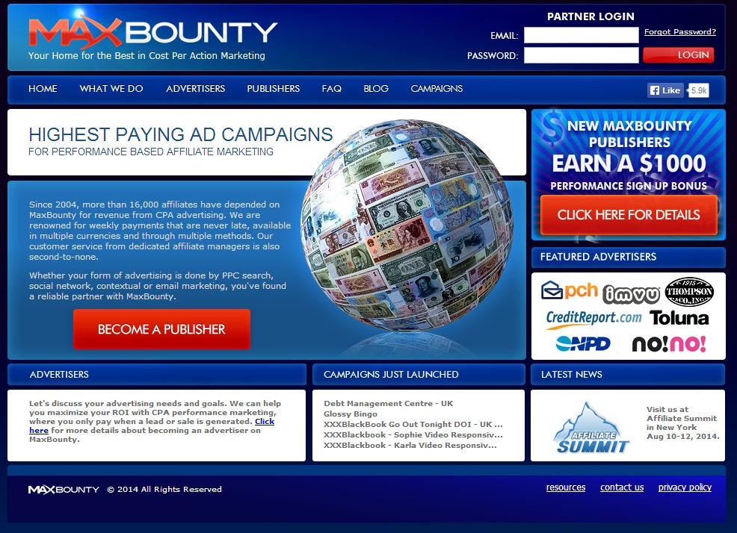
Max Bounty was founded in 2004 with the philosophy of paying more to their affiliates. More than 16,000 affiliates are dependent on Max Bounty for revenue via Cost-Per-Action (CPA) advertising.
It is known as hub of high payout offers. Max Bounty is not offer thousands of products but it has leads and exclusive offers.
In addition, it has some of the easiest types of offers to use, like email submits, and you will be paid well but conversions, which are much easier than sales.

9. NeverBlue – http://www.neverblue.com/
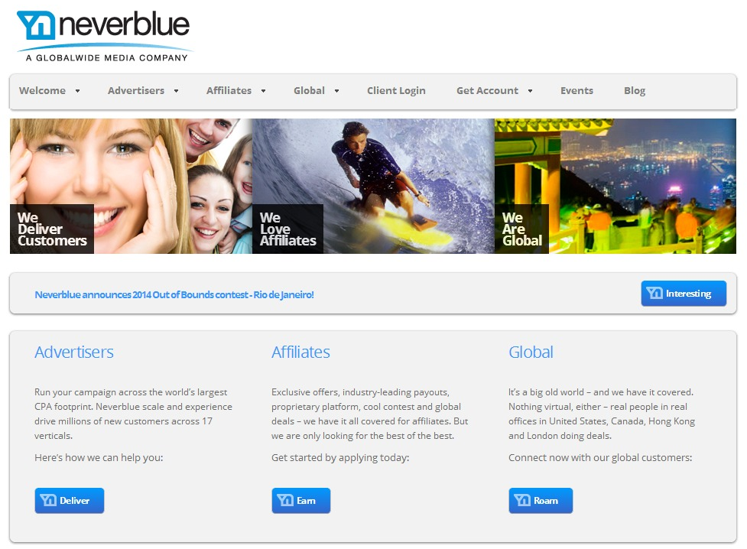
Never Blue rewards its affiliate for each and every lead generation, sale, and download according to its Pay-Per-Action affiliate program. Each affiliate is evaluated, and only a few applicants will be affiliated based on a complicated interview process.
Terms and Conditions of Never Blue include a strict email and search policy. Once you become an affiliate, Never Blue provides you two contacts for support: first for Client Services and second for the Network Manager.
Never Blue use a proprietary technology model that allows you to make money quickly. It pays accurate and generous payouts to its affiliates, and high quality affiliates are also payout with exceptional reward.
10. Link Share – http://www.linkshare.com/
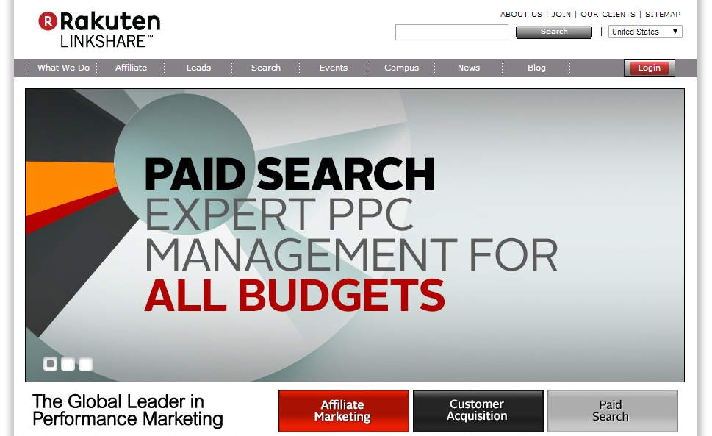
It does not matter whether you are an advertiser or a publisher; Link Share is a great option for increasing your online revenue. It provides training to its affiliates regarding how to advertise or monetize online businesses.
With product offerings in many different niches, affiliates can choose their products according to their niche without having huge list of product to search. There commission percentages are lower than other networks, but there are some products that pay 50% commission or more. However, payouts take longer than on other networks.
Link Share also arranges monthly webinars, newsletters, and online tutorials for affiliate to refine their skills. And it provides excellent tracking services with reports and sales and commission rates.
Chapter V: The 7-Steps Secret Formula to Affiliate Marketing Success
Step 1: Hot Niche Research
Step 2: Main Affiliate Product Research
Step 3: Additional Affiliate Products Research
Step 4: Squeeze Page Set up
Step 5: Autoresponder Set up
Step 6: Advertising
Step 7: Get the most out of your traffic

Step 1: Hot Niche Research
The easiest way to do hot niche research is to answer 5 basic questions: Who, What, Where, How, and Why.
- Who is my audience?
It’s important to know your audience. You want to know who they are, how large they are, and what they need. Often a business makes the mistake of promoting a product rather than promoting to an audience.
The problem with this thinking is that if the product becomes obsolete, then so has your market. However, if you know your audience, you know what they need, and you know how to help provide that need, then you will have longevity in the niche.
- What is my angle?
In a profitable niche, there will be a number of affiliates. In fact, avoid becoming involved in a niche that has few or no PPC advertisers or affiliate programs as well as products or services offered by only one merchant.
This means that you will need to set yourself apart from the competition. Is there content lacking that you can provide? Are there features missing? What can you do better than the competition? Is there a demographic being missed? Are there unexplored avenues? What is your voice? Make sure there is a strong point of difference (POD) between you and the competition.
- Where is the traffic?
Look for search terms that generate traffic in your niche. You can use the following to help you search for these terms:
- https://adwords.google.com/KeywordPlanner
- http://www.bing.com/toolbox/keywords
- http://www.wordstream.com/
- http://raventools.com/
- http://www.semrush.com/
Each of the above tools will help you find traffic-rich terms. In addition, you need to look at the trends for your niche; is interest in your niche and its competitors going up or down? If interest is declining, it is not a good bet.
- How can I break through this niche?
Thinking about how you are going to break through this niche is extremely important. You must analyze what affiliate marketing tricks are usually used to market this niche over the web.
What info channels are used to deliver the content to buyers? Is it Video, Training Guide, Audio, or all of them at the same time? What traffic channels bring you the most benefits? Is it PPC, SEO, Solo Ads, Social Media, PPV?
- Why should I choose this niche?
Once you’ve answered all the above questions, the answer to this question should be easy. You choose the niche because you feel strongly that you can succeed there given all of the available information.
You must feel trust this is going to work really. If it has worked for others it should definitely work for you too.
Before we leave this step, there are 3 marketplaces that you should get familiar with. This areas will give you a lot more information about your niche.
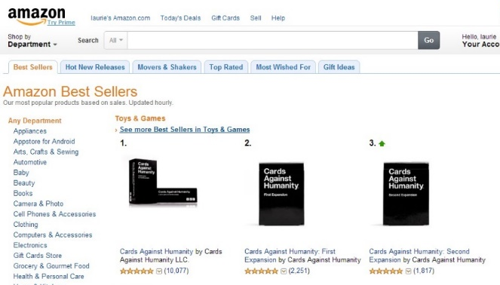
Amazon Bestsellers is a great place to go to find physical products that will help you narrow down your niche research. This site sells millions of products, so that means you will find millions of hot topics as well.
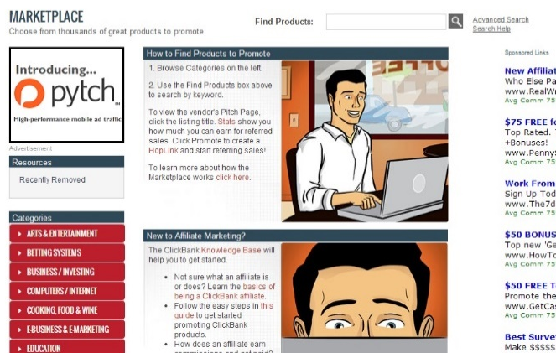
The ClickBank Marketplace is a great place to find digital products and do your niche research as well. An array of categories can be found on the left side of the page. You can have the awesome ability to sort all products by several factors.
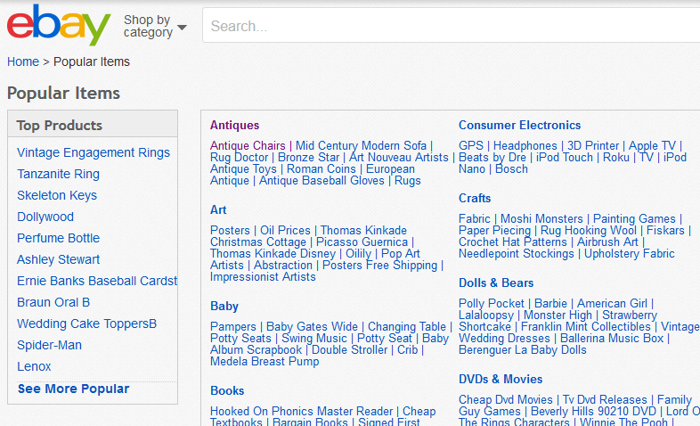
EBay has an amazing place where you will definitely find some great and hot niche ideas. They has organize a place dedicated to show you products organized by popular terms. They will even show you a really nice list or popular searches on every niche you are searching on. You just need to see it for yourself, it’s amazing.
Step 2: Main Affiliate Product Research
Once you’ve found your niche, the next step involves finding your primary product. Here are some important things to consider when choosing your product(s):
- High Converting Sales Page
I can’t tell you all the components of a high converting sales page. There are so many different sales pages over the web and many of them are high converting at the same time. It also depends on the niche.
That’s why is important for you to turn to hot seller products, and no matter what kind of sales page they have, you just need to care they are high converting.
- Price:
Price matters, but it isn’t necessarily the determining factor of quality or potential success. In other words, be careful not to let the price define the product.
A lower priced product can still be helpful for your customer while earning commissions, but any way if high priced products are high converting, then you should take advantage of that.
Expensive products doesn’t exist. High priced products doesn’t mean the product is expensive because there is an audience for that product, and that audience already knows that product is high priced.

- Commission:
There are a variety of options for earning higher commissions, and much of this is based on the product. You can earn up to 100% commissions on some products like on JVzoo.com, and some businesses pay for lead generation and referrals.
Same as price, here is where you decide how much money you want to make. Amazon affiliate program offers a really low commission rate but getting 10% of a $3,000 product like a laptop (which sells well on Amazon) is not that bad don’t you think?
- Content:
You should make sure the content of the product is of high quality. The products you promote will tell that kind of marketer you are. The smartest thing you should do as a marketer is buy the product yourself and make sure it is of high quality. Real information that really works.
You have to make sure the buyer won’t get disappointed once he hits the payment button and buy the product.
- Incentives and Rewards:
A business often runs incentive programs for their affiliates in order to increase its sales. An example may be, “Double your sales this month and get 5% extra commission”.
A business can offer a long term incentive and a short term incentive, and both will increase your sales. Long term incentives are for a long time period like months or even a year, and Short term incentives are for a short time period like a month, week or day.
- Testimonials:
Testimonials are a very important part of a sale page. Testimonials are proof the product works. That’s another way to tell the product you promote is of high quality, without the need of buying it. But anyway is recommended you make sure by buying it and applying it yourself.
As mentioned before, there are several sites that make your product search easier. As an example, let’s say that I have decided to be an affiliate in the Parenting niche.
I would like to focus on Potty Training. If I went to Amazon’s best seller page then I’d click on the Baby category, along with Potty Training. I’d end up on the page below:
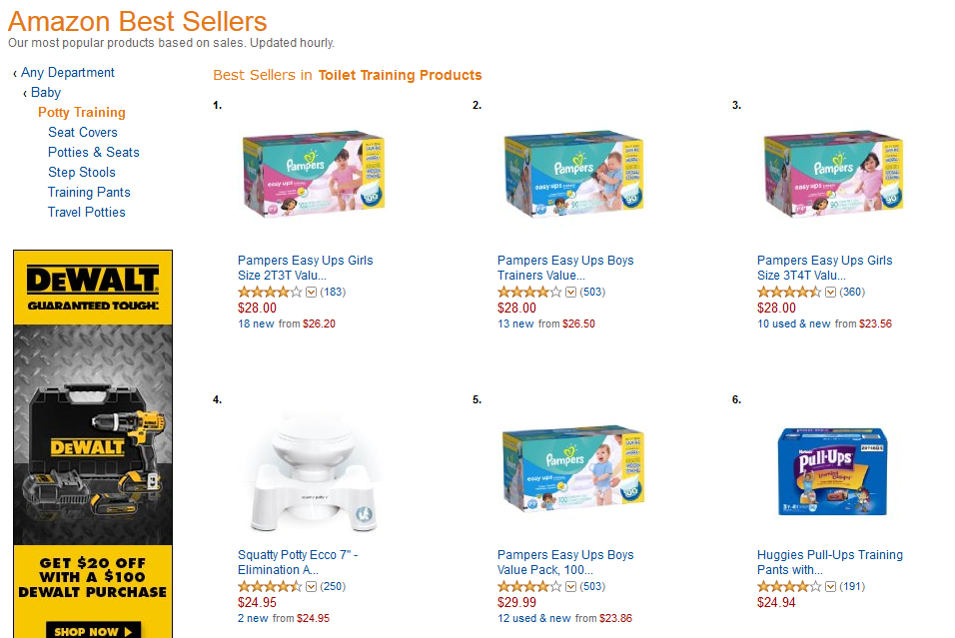
Something absolutely great about Amazon is that they make it very easy for people to leave their review about the product.
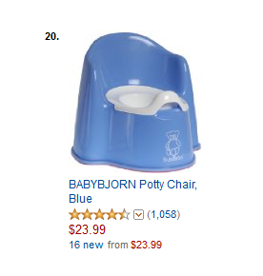
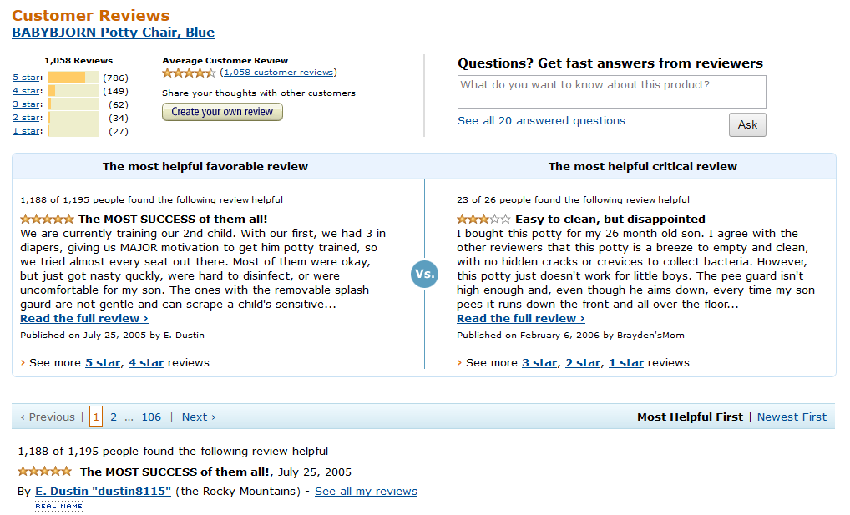
Right here you can see some awesome information about the product. This will absolutely tell you how great the product is. You can even use these reviews as a guide to write a review about the product. You can do that in this case because I don’t think would be a good idea to buy a medicine or something alike to test if it works, if you don’t have a need for it.
You can do something similar with ClickBank by going to their marketplace. This is how the parenting and family section looks like:
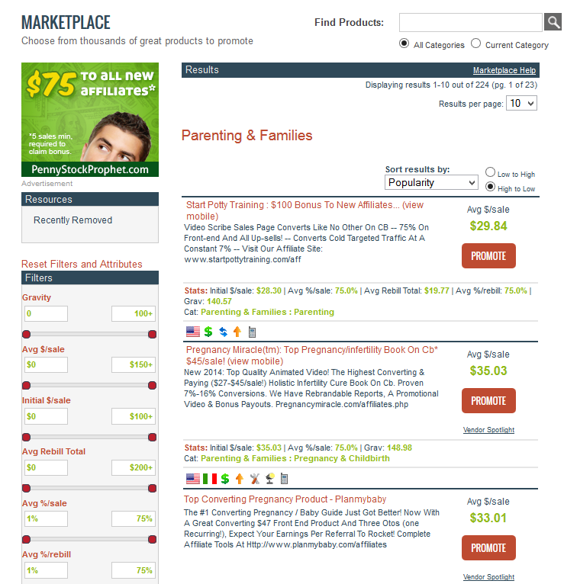
Something absolutely great about ClickBank is that you are able to sort the products by different factors.
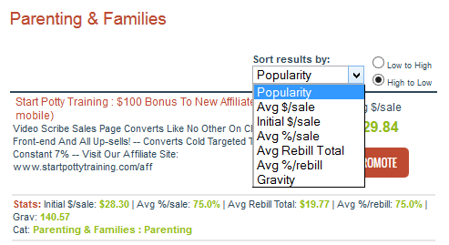
The way you can see a product is a hot seller is with the value called “Gravity”.
This is what ClickBank says about Gravity:
Grav: Short for GRAVITY™ performance statistic, this number represents a unique calculation by ClickBank that takes into account the number of different affiliates who earned a commission by promoting this product over the past 12 weeks. Since more recent transactions are given a higher value, this number can give you an idea of what products are “hot” at the moment, in terms of being promoted by many affiliates and making a good number of sales. However, high gravity can also indicate that there will be a lot of competition in promoting this product. Source
Sorting my results according to gravity we found a really cool product complete related to the Potty Training Niche:
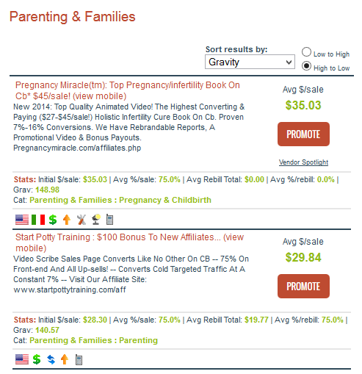
Grav: 140 means 140 different affiliates have earned a commission by promoting this product over the past 12 weeks. That number is not telling how many sales where generated but I’m really sure it was not just 1 sale per affiliate.
Something great about ClickBank Products as well (different from Amazon) is that product owners create a very special for you as an affiliate. That place is called Affiliates Page or Joint Venture Page.
For the Potty Training Product here you can see a really nice Affiliates Page:
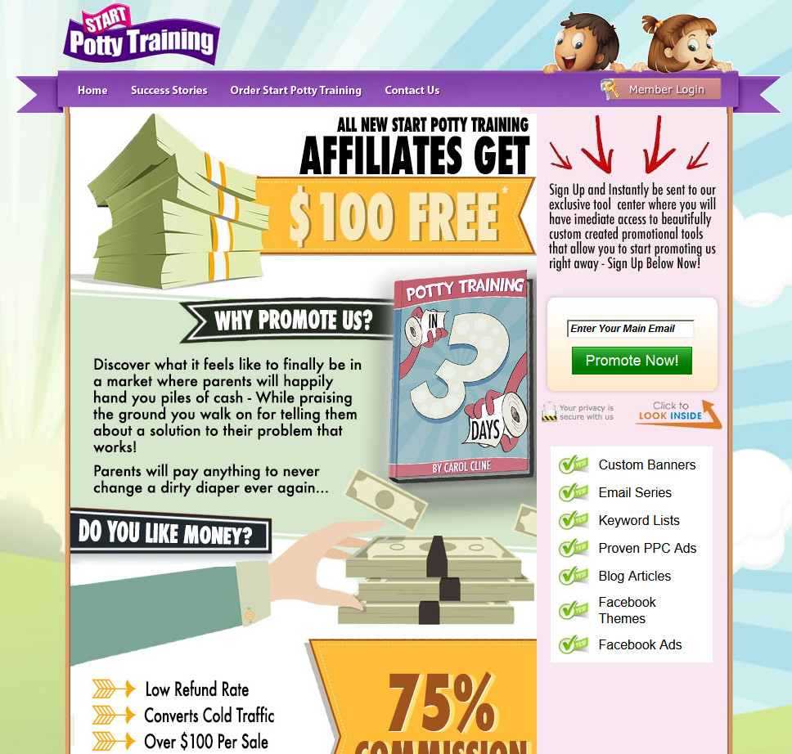
Here you will get access to all kinds of great promotion tools created by the owners of the product. They also sponsor some great affiliate contest depending on your efforts as an affiliate.

There are 2 more affiliate networks I would like to mention. I’m sure you have heard about them before but these places are mostly for products related to the Internet Marketing Niche, which is one of the hottest and most profitable niches over the web.
Jvzoo.com is an instant commission sellers’ platform that features a variety of products as well. JVzoo sponsors products not related to internet marketing as well, but I never have seen anyone of them listed a best seller JVzoo product.
Following the same procedure, you can visit their products page to search for a product that fits your niche. In my hypothetical search for parenting products, I clicked on Parenting/Children/Family:
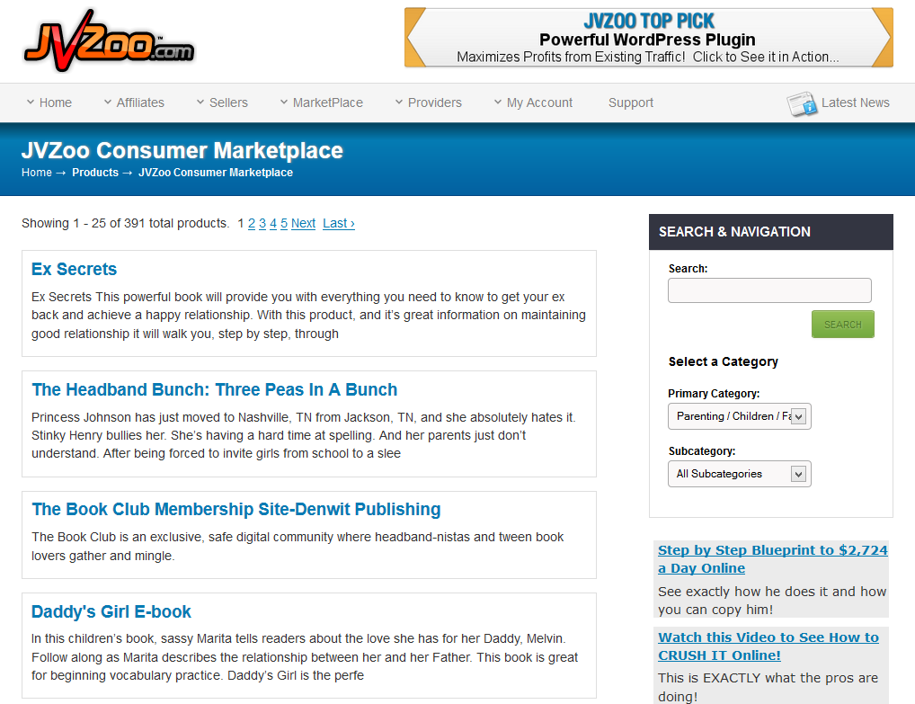

The only way you can check on detailed stats about a product –things like sales, conversion rates, EPC, commission percentages, and refund rates is by been approve as an affiliate of the product which is by invitation.
There are 2 ways to get that invitation. The first one is by going to the Sales Page of the product and going down to the button of the page. Most of the time they will have an affiliates section for you as an affiliate to get your invitation.
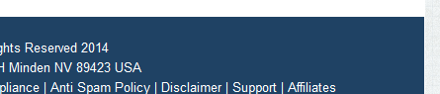
For products that don’t publicly show this page you just can contact the owner of the product by email. They have to have a way of contact in their sales page, support is a common page on a sales page.
There is a way to find out what are the best seller products on JVZoo.com, and that is in the Top Sellers and the Featured Section Pages.
Jvzoo.com has a really nice tradition of showing the Top Seller Product of the day right on top of the entire website. In the feature section you will be able to find what where the best seller of every single day and of every single month starting back from 2011.
Here you can see that the products listed there as top sellers are often products related to Internet Marketing. You can promote non Internet Marketing Niches from JVzoo but the hottest topics on JVzoo.com are the Internet Marketing related ones.
WarriorPlus gives you even more options when it comes to staying up to date on new products and promotions.
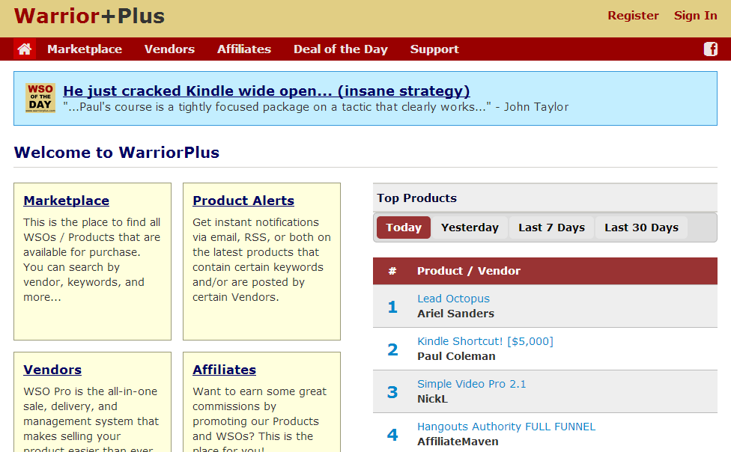
Not only you get to take a look at new products and launches, you can also have alerts sent to you. And they have a special place and programs for affiliate marketers as well. They are in some degree very similar to JVzoo.com.
There is something very important I would like to mention before finishing this step. This is a really cool trick used by gurus that will help you skyrocket your affiliate sales.
As an affiliate, it is important to know when new products within your niche are about to be launched. When you know about a new product in advance, you can begin promoting that product, take advantage of presales, and get a jump on your competitors.
There are several sites that help you to stay informed regarding new or upgraded product launches.
The first one I want to talk about is MunchEye
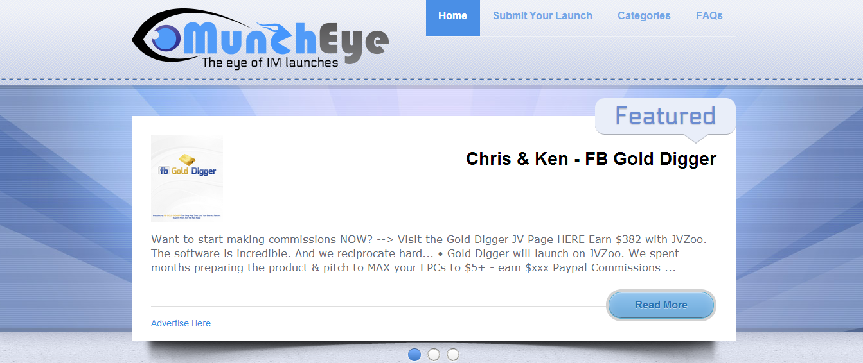
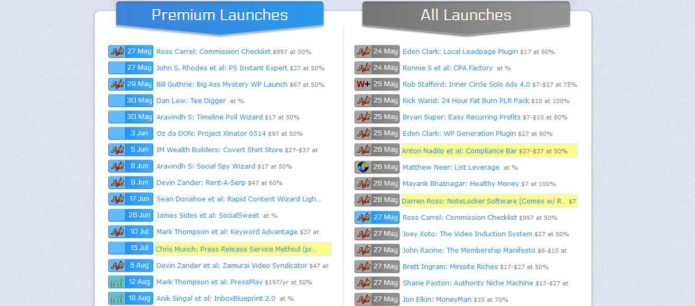
Merchants can set up a launch on MunchEye for free, and affiliates can go there, choose the category of their niche, and stay up to date on new products that are about to be launched as well as keep an eye on their competitors.
It can give you an edge when it comes to promotions, special incentives, and increase traffic and actions on your page.
JVNotify is also a great site for the affiliate who wants to stay informed and gain an edge in marketing.
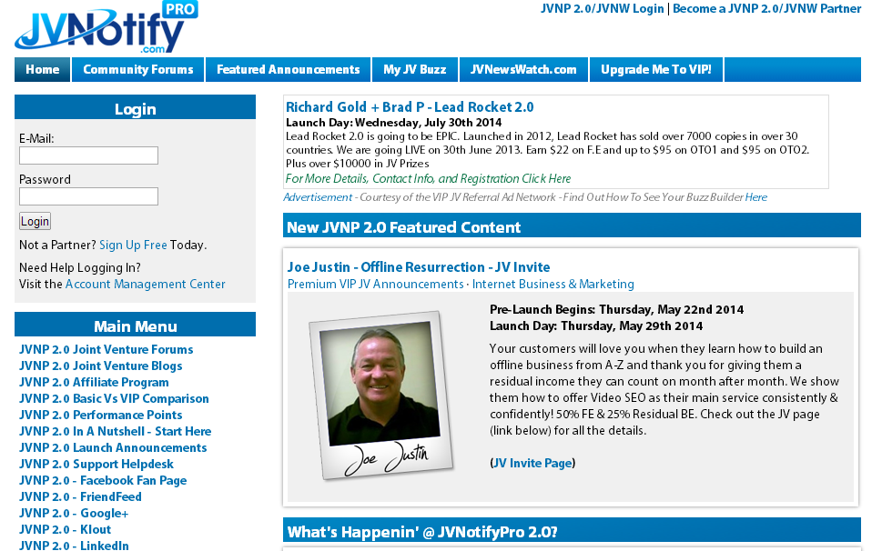
In addition to information about products and launches, assistance for vendors and merchants, and programs for affiliates, JVNotify has excellent forums as well.
In their own words, “The main focus of JVNotifyPro 2.0 is the ongoing task of maximizing the Win - Win using Joint Venture Marketing as the vehicle to get there.”

Step 3: Additional Affiliate Product Research
You might be asking yourself why there are 2 steps almost identical to each other. Well, the answer is: because this is what will make you money the most.
You already have find out what is the main product you would like to promote. But I’m really sure you have notice there are so many great product you would love to promote, and let me tell you, you can promote all of them as well, that’s what this step is all about.
The Main Affiliate Product is the core product you will start promoting and you will dedicate the most of your advertising efforts.
Then after promoting that product you will also be able to advertise other related products as well to the same audience but 100% free. How? Let me show you how:
First of all, all of your traffic will be sent to your Squeeze Page which propose will be to collect the contact information of your visitors which will be highly interested in your topic.
Then -besides sending your free subscribers straight to your Main Affiliate Product- they will start receiving your emails talking and preselling the main product you will be promoting. You will prepare several emails to promote that product to your list of subscribers.
And then you will also start promoting some directly related offers that will come after the emails promoting the Main Affiliate Product. And this will happen for days, weeks, months and years to come. And all of this 100% automatically. That my friend I what is called Making Money on Autopilot and you will know exactly how to do that in the coming steps.
Ok, now I’m really sure you already know how to search for some high converting products to promote.
A very important piece of advice to consider is that the topic don’t have to be exactly about the same. You could cover other area of your niche without adverting something 100% related to your main offer.
For example. I will be promoting a Potty Training Product from ClickBank as my main affiliate product to promote. I think won’t be necessary to promote another Potty Training Product again.
That is something that might confuse your subscribers and you will end up been a wild advertiser instead of a big helper to you subscribers, looking to really satisfy the needs of our subscribers.
A product that I can promote inside this niche might be something related to help solve the principal need, for example a potty chair, or a potty training dipper, or something alike. Amazon will give you a great list of ideas all centered in the same topic:
Something else I can promote to this same audience are other products related to parenting and families:
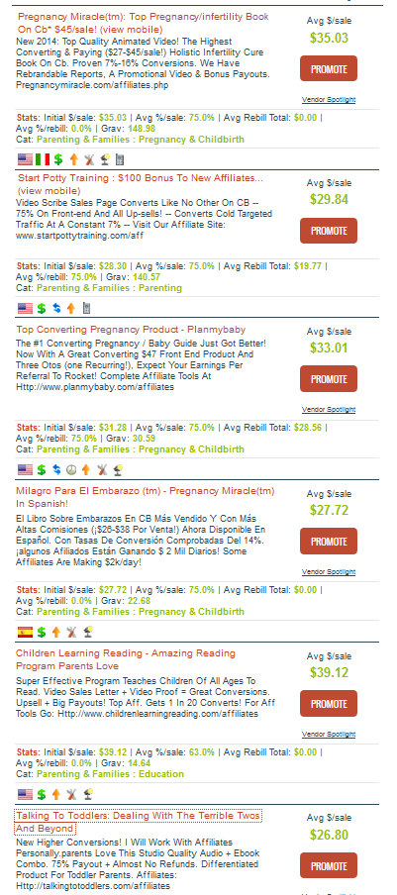
Here at ClickBank you will find a great deal of High Converting Products related to the Parenting & Family niche.
Step 4: Squeeze Page Set Up
Great. Now is time to talk about the Landing Page where you will be sending all the traffic to, so you may build your list and start collecting your Future Success. Remember, the bigger your list, the greater your income will become.
A squeeze page is a landing page created to solicit opt-in email addresses from prospective subscribers. Source
There are all kinds of ways to create a squeeze page. But I will focus in the easiest one. I don’t want you to spend too much time on this. Internet Marketing is all about testing. You will have to do a lot of testing in order to find a niche, affiliate products and a traffic channel that all together will perfectly fit to bring you profit on complete autopilot.
So for that reason you don’t have to spend too much time on this testing phase. Because maybe you will need to repeat all this process several times until you find your own Chicken of the Golden Eights.
There is an absolutely amazing website where you will be able to create a complete free squeeze page with lightning speed.
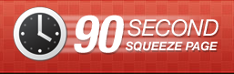
This absolutely free service is called 90 Second Squeeze Page where you will be able to easily create your Squeeze Page without having to deal with coding.
The service is extremely easy so use. They even have a very detailed video on every step of the process.

Using the Affiliate tools provided by the owner of the product. I had to ability to create the following Squeeze Page by using the 90 Second Squeeze Page Online Software.
https://90secondsqueezepage.com/sp/abinadisuarez/PottyTrainyourKidsin3Days
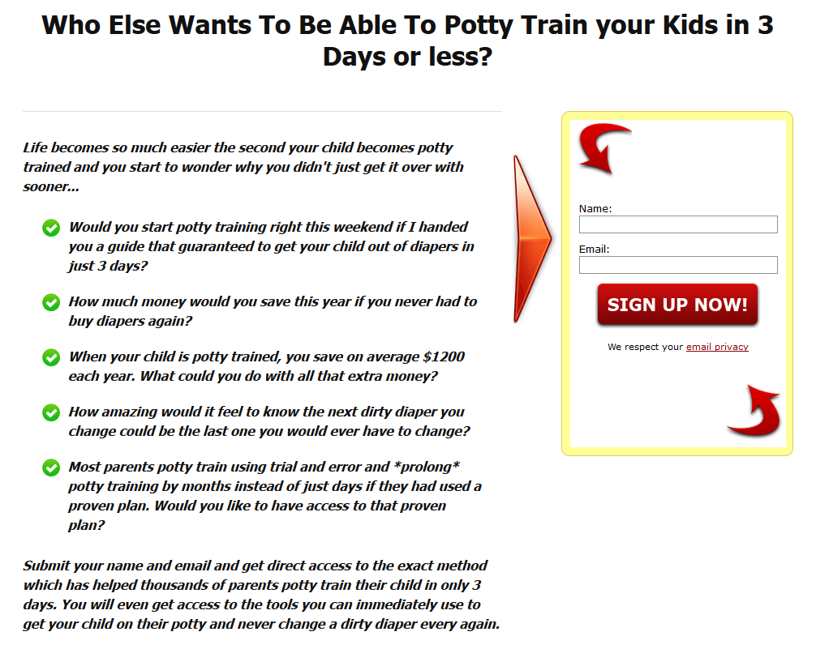
But something very important to notice is that, you will have some troubles promoting that long URL on several advertising channels.
What will solve this situation is been able to register a domain name and redirected to that URL. Let me show you how.
A domain name will be the address of your website. It will be the place where all the URLs of your website will be attached to.
You will need to buy a domain name that might be directly related to the topic of your main affiliate product.
Just try to make it easy for people to remember, so just in case they remember your topic they can easily go there and check your offer again and even decide to get access to it.
In order to register a domain I use my favorite domain name provider NameCheap.com. I have been using Namecheap.com for years and I have not faced a single problem with any of my domain names. They have great offers as well on some occasions.
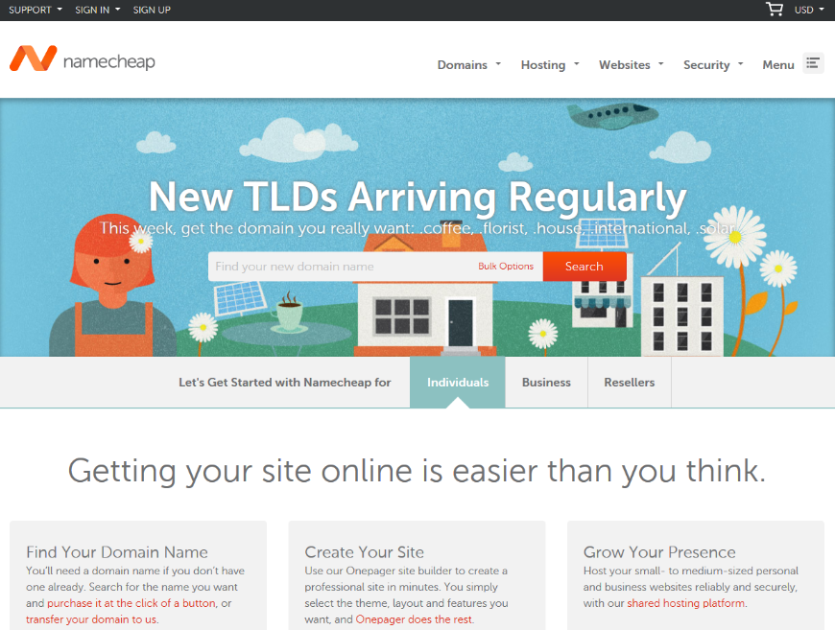
Just follow the steps shown to you in the buying process and you are done.
Inside the settings of your Domain Name you will be able to forward your domain name to a URL.
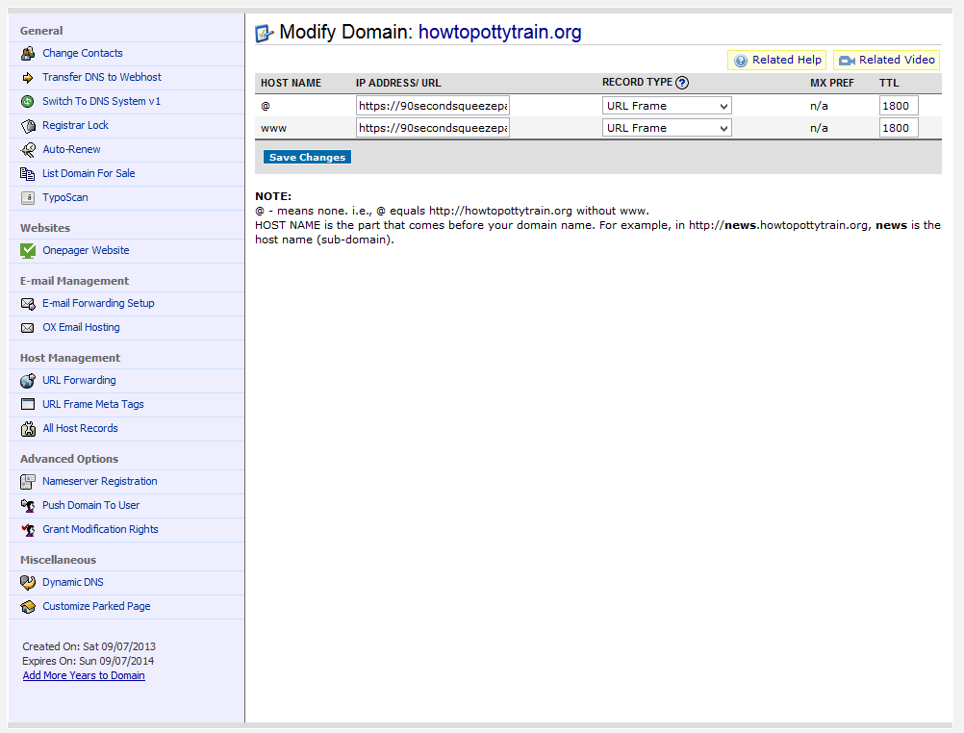

Step 5: Autoresponder Set Up
Here I will show you two very important parts. The first part will be setting up your autoresponder lists and sequences, and in the second part we will creating and the sign up forms. I will be using AWeber only.
- Setting up your autoresponder lists and sequences
Login to AWeber and click where says create and manage lists.
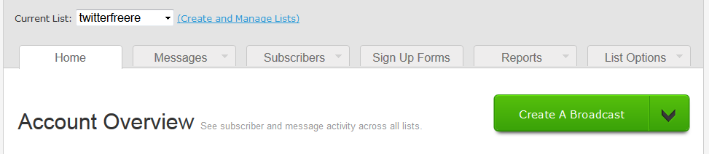
Click on “Create list”…
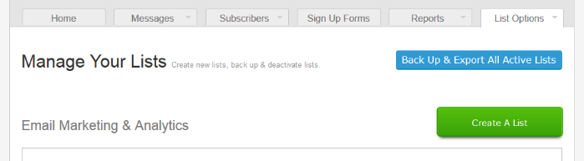
Here we will be creating the list for all of your Potty Train Subscribers.
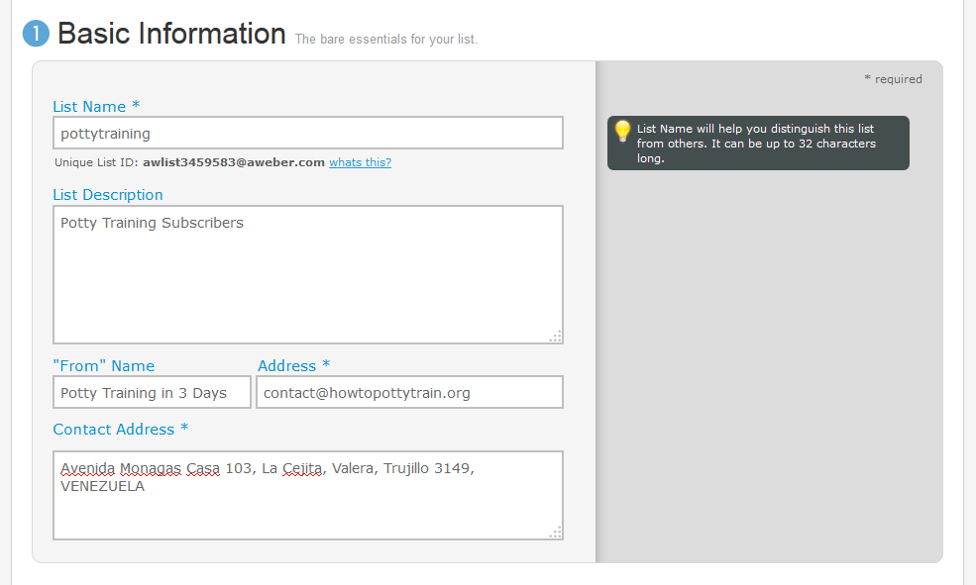
- Basic Information
List Name: here just type a name of your choice, this is for personal reference.
List Description: here just type a description, this is for personal reference too.
“From” Name: Here you have two options. You can put your name. This is important if you already have an importance personal presence among your list, and the other will be the Topic, so people may identify your emails right away once they start getting your emails.
Using your name is important, but in that way they won’t know the topic right away. I like to use the topic because being new subscribers they will be interested in getting their report right away.

They can identify that in the email’s subject as well, but the sender is in reality the first thing a reader looks at before deciding to open an email. All of this is just my personal point of view. You can decide what to put in there according to your subscriber’s behavior.
Address: This is the email that will be shown to them as the sender. If they decide to reply anything to you, that message will be sent to this email.
Contact Address: Here is where you will type your physical mailing address, this is optional as well.
Click Save Settings.
- Personalize your List
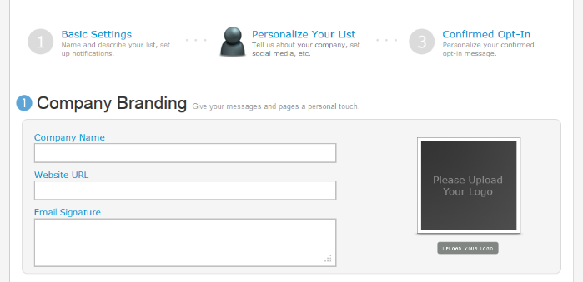
Here you will insert your Company Information, Social Information and snippets. I myself really don’t use this area.

- Confirmed Opt-in
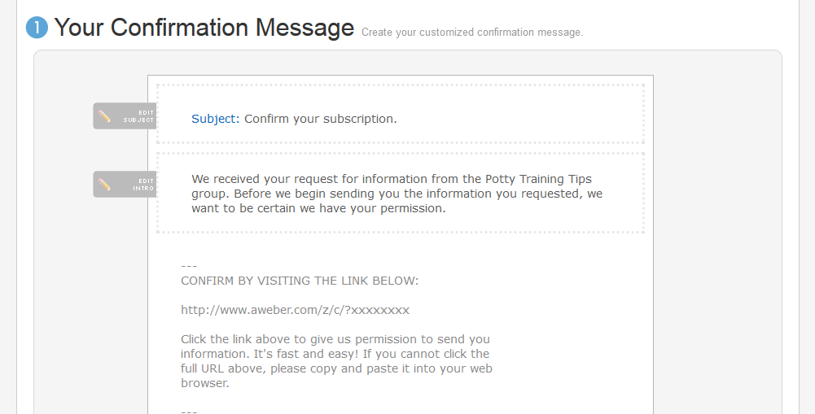
And here is something I don’t use either, but is up to you to use it or not.
This is used so you may confirm that the people in your list are real people with real emails. Once they sign up they must go to their email accounts and click on a confirmation link AWeber will send to them automatically in order to get access to their Free Report. This is what is called “Optin confirmation.”
If you decide to use it this is the email your subscribers will get it right before they are part of your list and then they will start receiving your emails. I advise you to edit the name of the list right here and put something better, like the name of your Free Report, which is the same name as your product.
Besides that you must provide a “Confirmation Success Page URL.” This is the URL your subscribers will be lead to, once they click onto the confirmation link.
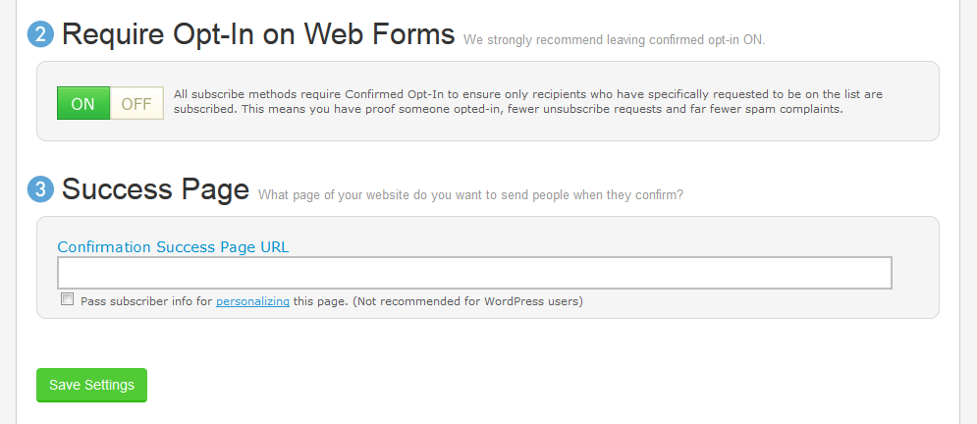
If you decide not to use all of this confirmation process and want to make sure that every subscriber gets directly into your list and starts receiving your emails, you can just turn it off. Click save settings and you are good to go.
Now let’s start inserting the emails into this list.
You will go to messages and select Follow up series and click “create your first follow up”…
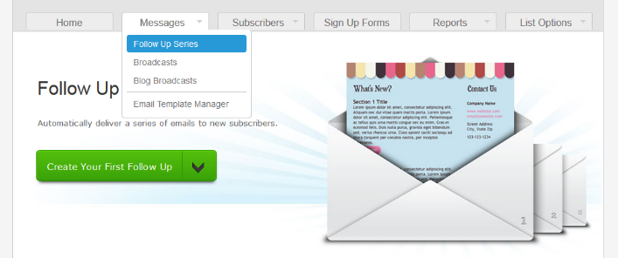

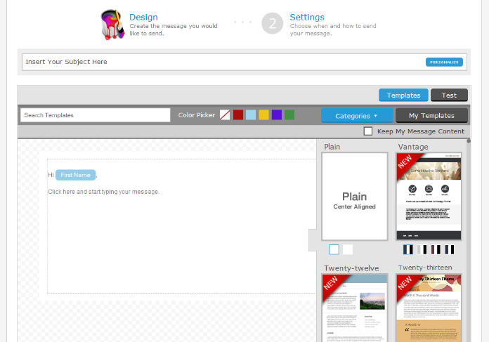

Here is where you will create all emails promoting your Front End Offer to your Special Free Report Subscribers.
The first email will be used to thank your subscribers for being interested in getting information from you. You will invite them again to check out the Main Affiliate Product.
The rest of the emails will be used to invite them again to check out Main Affiliate Product as well as all of the Additional Affiliate Products.
The following chart will show you a really nice advertising plan to your subscribers by using the follow up emails.

Days 1, 3, 5, 7, 9, 11 | Main Affiliate Product
Day 13, 15 | Additional Affiliate Product 1
Day 17, 19 | Additional Affiliate Product 2
Day 21, 23 | Additional Affiliate Product 3
Day 25, 27 | Additional Affiliate Product 4
Day 29, 31 | Additional Affiliate Product 5

You will have the chance to put when you want to send all of these emails. I recommend you do not send them every day, send them every 2 days.
- Creating the sign up form.
Now make sure the Subscribers’ list you have just created is selected. Click on signup forms and click on “create your first sign up form.”
- Design
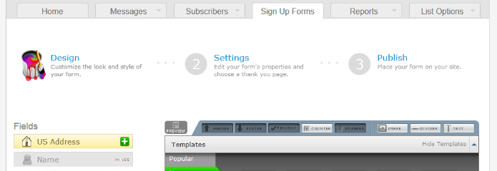

Here you will have the chance to edit the signup form however you want. You can even pick among the different templates that are already there. Just design it in a way that may be nicely fitted within the layout of the squeeze page.
We advise you to select among the popular templates, the template called “Pointer”.
- Settings
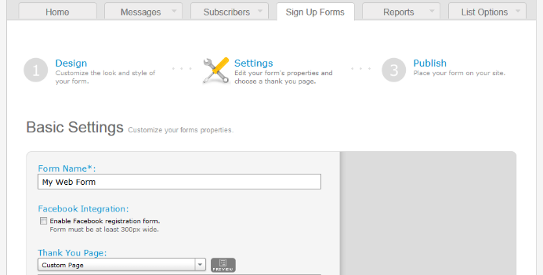

Right here you have to be very careful. You can put a name to the sign up form for you to identify it, then you can insert the URL where your subscribers will be redirected once they enter their name and email. Here you will place your Affiliate URL promoting the Main Affiliate Product.
Once they put their name and email, they will be redirected to what is offered in the squeeze page content. Which is the Main Affiliate Product.
Click on “Save your Form” and click on “Go to Step 3.”
- Publish
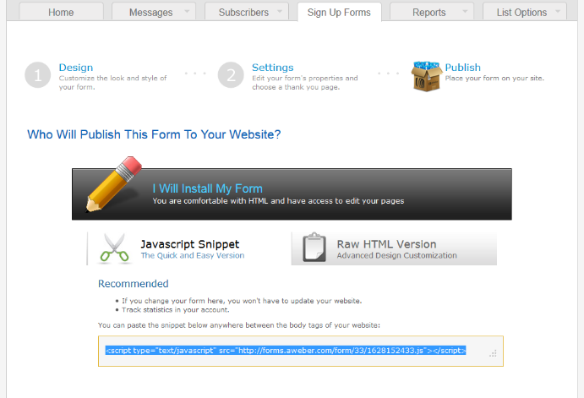
This is the code you will embed into the autoresponder optin code section inside the 90 Second Squeeze Page designing area.
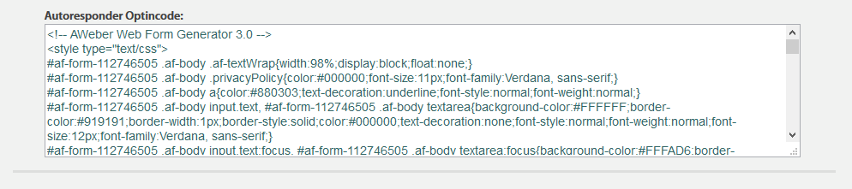
I advise you to test it out. Put in your name and a test email. Check if it redirects to the Main Affiliate Product and also go to your inbox and see if in a few minutes you get the First Email of the autoresponder series. Check the links you will get there just to make sure everything is working great.
Step 6: Advertising
Something extremely important for you to get success promoting any offer is the quality of that traffic you send to that offer.
You could be promoting the greatest product ever, but if you send 1 million horrible quality visitors to your offer you will be wasting all of your money, time and effort. Do not let other people deceive you.
Below you will see a really nice list of 15 traffic getting methods you can use, as well as where to get those type of services.
- Pay per Click: Pay per click (PPC) is a form of Internet advertising that directs traffic to a website, and the advertiser then pays the website owner when someone clicks onto the add. So, instead of bidding on keywords relevant to their target audience, the PPC displays, which are usually some sort of banner ad, are placed onto either search engine results or some sort of website that has content that is related to the item for sale in the ad.
Pay Per Click Networks

- Pay per Call: Pay-per-call is a type of performance based advertising somewhat similar to Pay per Click. The difference is that instead of there being a fee for each click, the business must pay their service provide a fee for each call when the customer calls the connected phone number.
Pay Per Call Networks

- Email Newsletter: Email newsletters are updates that a business sends out to customers who have signed up to receive various notices from that business. They are sent out on a regular basis and could include tips, facts, savings, and special offers. Some include HTML hyperlinks to go to the business website for more information. The content is written by a copywriter and the newsletter is designed by a graphic designer.
http://buysellads.com/buy/allsites/by/email

- Solo Ads: Solo Ads are an email centered advertising method that works through a system two marketers have agreed upon that is used to reach the subscribers to the program. The Internet marketer sends out emails to the subscribers on the behalf of the other marketer in order to show their offers or ads. It usually has between eight and 10 lines of text.
http://www.soloaddirectory.com/
http://safe-swaps.com/

- Podcasting: Podcasting is a method of sending out audio files via RSS. It is done just like any other RSS feed except that the feed subscribed to is an audio one instead of a text one. The resulting podcast can be listed on a website by a clickable link.
http://mashable.com/2008/10/03/audio-ad-networks/

- Traffic Agencies: Traffic agencies are services that create, plan and manage advertising and other promotions for their patrons. They can also handle marketing and branding plans for their clients.
http://trafficadv.com/
http://trafficagency.biz/

- SEO/Organic: search engine optimization (SEO) is the process of affecting the visibility of a website or a webpage in a search engine's "natural" or un-paid ("organic") search results. In general, the earlier (or higher ranked on the search results page), and more frequently a site appears in the search results list, the more visitors it will receive from the search engine's users. SEO may target different kinds of search, including image search, local search, video search, academic search, news search and industry-specific vertical search engines.
http://moz.com/beginners-guide-to-seo
http://searchengineland.com/guide/what-is-seo
http://www.seobook.com/

- Banner Media: Bash banners that employ images, text, sound and video. Sometimes they are also interactive between the customer and the advertiser, i.e. asking the customer to play a game, go to certain pages, etc. It uses technology like flash, java, JavaScript and DHTML.
http://buysellads.com/buy/allsites

- Social Media: Social media is a type of interaction between people where they generate, share or exchange data, pictures, etc. via sites such as Facebook, Twitter, Pinterest, Google Plus, etc.
https://www.facebook.com/
https://twitter.com/
https://plus.google.com/
http://www.pinterest.com/
https://www.linkedin.com/
http://buysellads.com/buy/allsites/by/tweets

- Mobile: Mobile marketing is a type of marketing where the advertiser sends out the ads to a person’s mobile device, i.e. a smart phone or other Internet capable device. Mobile marketing provides patrons with all kinds of information on the advertiser’s goods, services, coupons, etc. It has become a very popular advertising media since many people own mobile phones.
http://www.hongkiat.com/blog/mobile-app-monetizing-networks/

- Content Syndication: Content syndication is a type of form of syndication where the content is available for other users and websites to access. This may be done via web feeds, forums, etc. It is also a kind of licensing for website content to allow other websites to use the same material.
http://searchenginewatch.com/article/2049167/Content-Syndication-How-to-Get-Started
http://contentsyndicationservices.com/

- Video: Video is a type of advertising where short video content is compiled to send out either on the web or to mobile devices. The nature of these advertisements comes in several different forms and can be used for information, entertainment, how to, or sales opportunities.
http://easyvideosuite.com/launch/
http://www.vidcaster.com/

- Offline Media: Offline media is the traditional forms of advertising such as newspaper, flyers, or any type of advertising that is not going out over the Internet or over any sort of broadcast media like TV or radio.
http://www.vishwamart.com/OfflineMedia.html
http://advertising.about.com/library/weekly/aa111300a.htm
- Traffic Exchanges: A traffic exchange is a website that provides website owners with some type of service in exchange for them getting traffic. The website gets transmissions from website owners when they join traffic exchange networks. Then, the one who submitted the website must browse other member’s sites listed on the network to get credits, and those credits allow their websites to get seen by other network members. This in turn helps all of the signed up sites get more traffic, and thus possibly more profits.
http://www.traffic-exchange-monitoring.com/traffic-exchanges-top10.html
http://advsites.net/top+10+traffic+exchanges

- RSS Directories: RSS directories are comparable to website directories, however, they have lists of RSS feeds instead of lists of various websites. An RSS feed contains full text or a summary, as well as metadata such as a publishing date and the name of the writer. Subscribing to one makes it so the user is informed of any updates to the list of articles.
http://www.rss-specifications.com/rss-directory.htm
http://www.feedzilla.com/gallery?cc=en_us
http://buysellads.com/buy/allsites/by/rss

I just can’t finish this section without telling where you can find all kinds of services. It’s just crazy, but here you can find almost anything you may be looking for online, and only for $5. Yes, I’m talking about Fiverr.com.

Step 7: Get the most out of your Traffic
The smartest way in the world to get the most of your traffic is by retargeting.
- What is Retargeting?
Retargeting is also sometimes referred to as remarketing. When you use retargeting, you place a piece of code on your website, and every time someone visits your site, this code drops a browser cookie.
This cookie is also referred to as a browser tag, and it is a snippet of JavaScript code that allows them to be “followed” as they surf the web. This allows your retargeting provider to know when to use ads and ensures that your ads are served to people who have visited your site.
This trafficking tool is effective because it more effectively focuses your advertising. The people who see it are already familiar with your brand and have recently shown interest in it.
Therefore, when a visitor comes to your site but leaves before making a purchase, the retargeter shows them your ads on other sites they visit so that they are repeatedly exposed to your product.
This can result in a return to your site, an action, and even a sale.
There are several different types of retargeting out there, and it’s important to learn about all of them.
Site Retargeting is the best known, and that is the type of retargeting where your banner ad will appear on other pages as recent visitors surf the web.
There is also Email Retargeting. In this method, a visitor who, for example, placed things in a shopping cart and then left the site will be sent an email asking them to come back and consider purchasing the items.
In Search Retargeting, a search engine user is targeted with ads that are based on their searches. In this case, they may not have previously visited the site, but they have expressed interest in the topic.
Contextual Retargeting allows websites who share similar customers to partner and share cookies. If the visitor leaves site A and visits site B, then an ad for site A may appear there.
- Why Retargeting?
Let’s face it, for your initial advertising efforts, you are simply casting as wide a net as possible to get those initial visitors. However, with retargeting, your advertising efforts are focused.
The people who see your ads are people who have already visited your site. This also focuses your advertising spending so that it is used to bring in people who have already shown interest.
Think of it this way. Initial web site visits can be like a billboard. Lots of people see it. But retargeting is like the flyer you get in the mail after you visit a specific store. You’ve been there, and the flyer reminds you what you saw and may encourage you to return.
I think we can all agree that the flyer for a previously visited store will probably be more effective that a billboard.
It has been said that it takes seven contacts or interactions to close a sale, so the benefits of retargeting are pretty clear. When they see ads for a site they have already visited, they are reminded of that site. It’s another interaction. It plants another seed.
There are many reasons someone may abandon a site, from realizing they are running late to a pot boiling over to a child needing dinner.
In our busy lives, we may forget all about that great site where we saw that amazing item. Retargeting reminds the visitor of their former interest.
Kimberly Clark is a globally known, highly successful corporation. Listen to what Jeff Jarrett, the vice president of global marketing, has to say about retargeting:
“We do retargeting because it is clearly an opportunity to target an interested customer…If a consumer visits our property and expresses an interest, there is an opportunity to take advantage of that interest...Customers who visit the brand site are 20% more likely to act on a message than a consumer who has not expressed this interest.” Source
Where Do I Go to Start Retargeting?
There are a variety of retargeting services out there, and some are better than others.
Here are a few of the top-rated retargeting services along with a bit on information about each.

AdRoll: www.adroll.com
AdRoll was started in 2007, and they have had lots of success with their services. Their basic plan offers site retargeting, contextual retargeting, and behavioral retargeting.
The basic plan does not have a minimum spending requirement. However, the plus plan requires you to spend about $10K, and the pro plan requires about $20K. Of course, as you go up with the plans, you get lots more services as well.
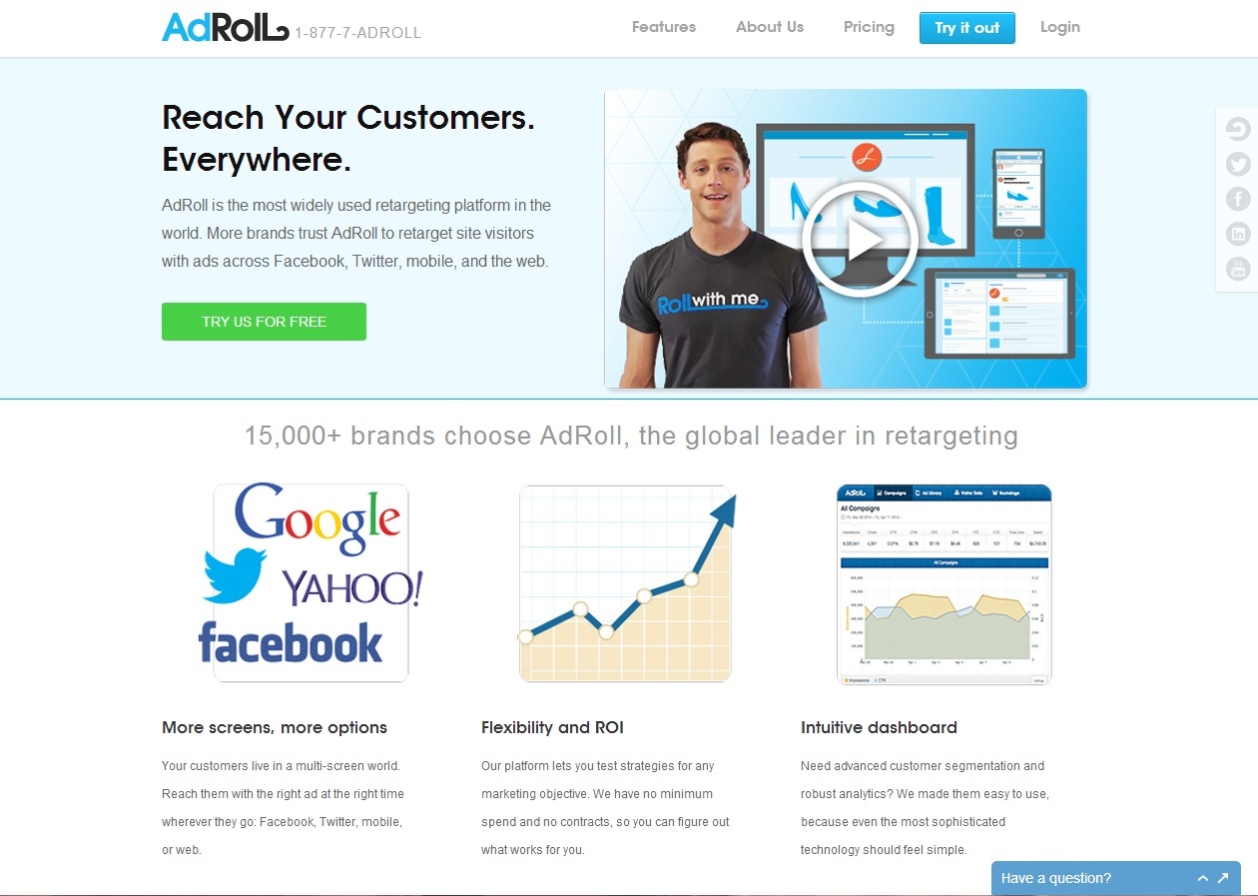

FetchBack: www.ebayenterprise.com
This service has their own patented technology, which is aptly named FIDO. It analyzes information on your visitors sent by smart pixels.
They are advertiser specific, so you have to contact them to get a quote specific to your needs. They do have several pricing models available, and they also work with revenue-sharing.
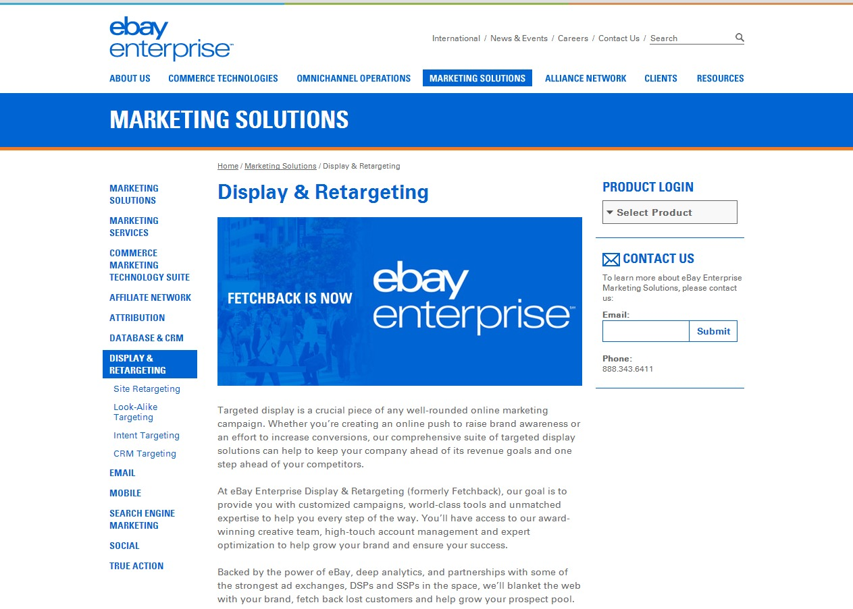

Retargeter: retargeter.com
This service offers site retargeting, social retargeting, and email retargeting. They are also closely integrated with sites like SlideShare and KISSmetrics.
They have a package that is devoted to site retargeting and a package that is display-focused, targeting visitors based on location, content, and demographics. Both of these packages start at $500.
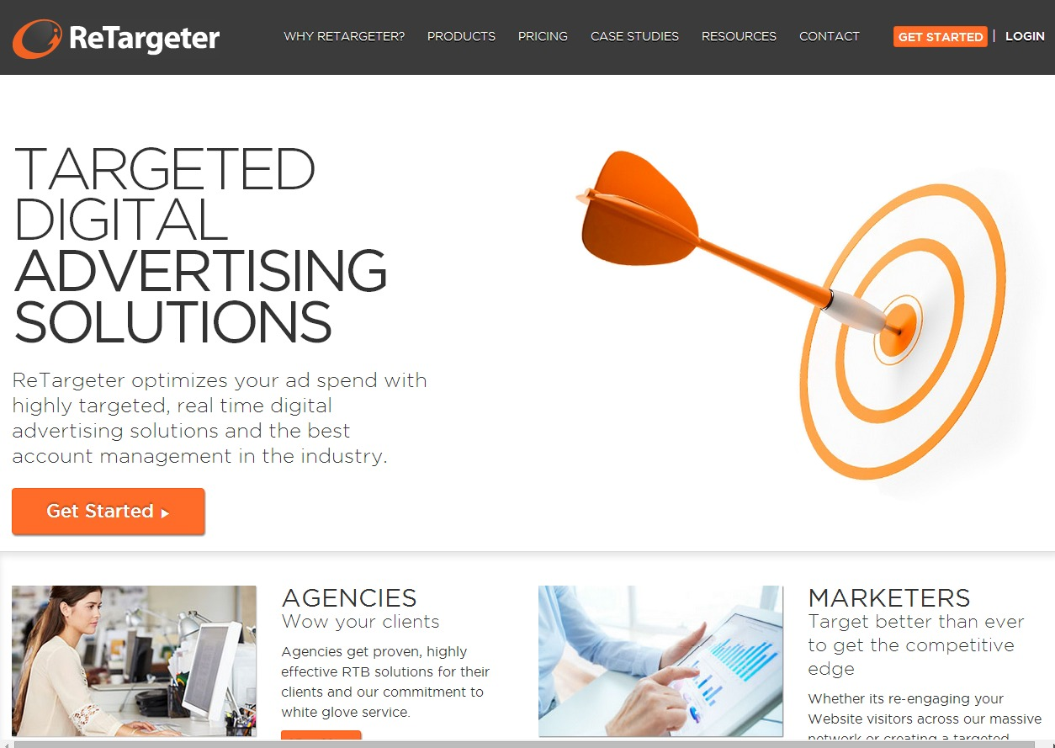

Chango: www.chango.com
This provider specializes in search retargeting. They are a media buying platform that offers full-service search retargeting along with limited site retargeting as well. As with FetchBack, you must contact Chango for a price quote.
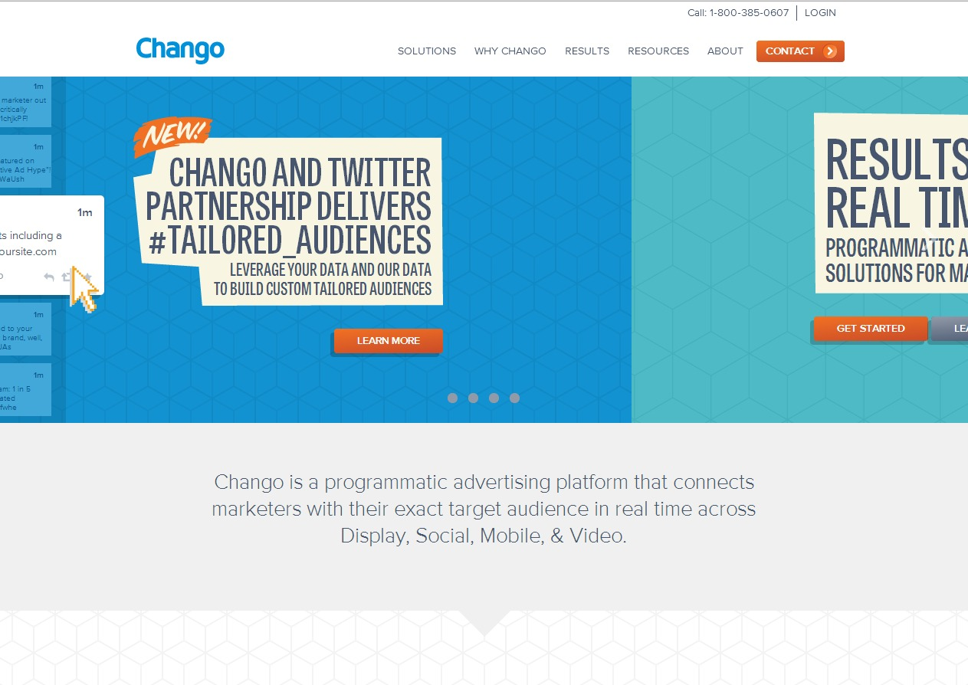

Perfect Audience: www.perfectaudience.com
Perfect Audience is a great option for marketers who want to keep things as simple as possible.
You insert a simple code into the body of your website, list the types of visitors you want to attract, design campaigns to target those segments, and your ads will begin to appear on visitors’ screens. And because you do not have to pay a setup or maintenance fee, this is an ideal choice for someone on a strict budget.
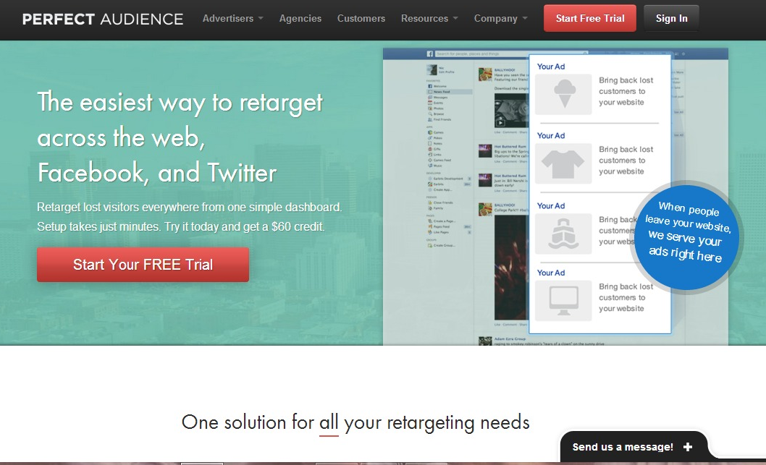

Conclusion:
From finding your niche, to selecting the best products, to researching the network that is your perfect fit, this guide has provided you with tools to help you succeed as an affiliate marketer. If you use these tools faithfully, our chances of building a successful affiliate marketing business are excellent.
So it’s time to get started applying all your newfound knowledge. Put your interests to work, and use your site to earn money for you and your merchant. As your success grows, so will your partners’, and with consistent work, the revenue you earn can go from some extra cash to life-changing.
We’re thrilled that you have chosen to take advantage of our training guide, and we wish you amazing success. And in order to take your affiliate marketing even farther, we invite you to get the most out of Affiliate Marketing by getting access to the Complete Training clicking here (Insert your Front End Offer URL).
Thanks so much for the time you have dedicated to learning how to get the most advantages from Affiliate Marketing. Affiliate Marketing has come to stay in the market forever.
A lot of money is invested in Affiliate Marketing, and all of it is for both of us. Let’s use it and reach our most precious business goals.
To Your Success,
Your Name

Resources
Videos
- http://www.youtube.com/watch?v=bedxiZXtxKo
- http://www.youtube.com/watch?v=mfj6IkzCkxs
Tools
- http://www.offervault.com/scoop/2013/02/20/38-affiliate-marketing-tools/
- http://retiredstudent.com/useful-affiliate-marketing-tools/
Training
- http://www.usanfranonline.com/programs/certificates/internet-marketing/advanced-specialized-certificates/advanced-affiliate-marketing/
- http://www.toptensocialmedia.com/social-media-business/ten-affiliate-marketing-training-programs/
Blogs
- http://adamriemer.me/
- http://affiliatetip.com/
Forums
- http://www.abestweb.com/
- http://affiliate-marketing-forums.5staraffiliateprograms.com/
Programs
- http://www.yeahmobi.com/?gclid=CNKmjOWRwL4CFW4R7AodnB8Aeg
- http://blog.intuit.com/marketing/4-highly-profitable-affiliate-marketing-programs/
Demographics
- http://www.alexa.com/siteinfo/www.cj.com
- http://www.alexa.com/siteinfo/www.affilorama.com

Limited Special Offer for You:
Affiliate Marketing Made Easy
(Video Training)
Click Here to Download Your Video Training!
(Insert your Upsell Offer URL)

