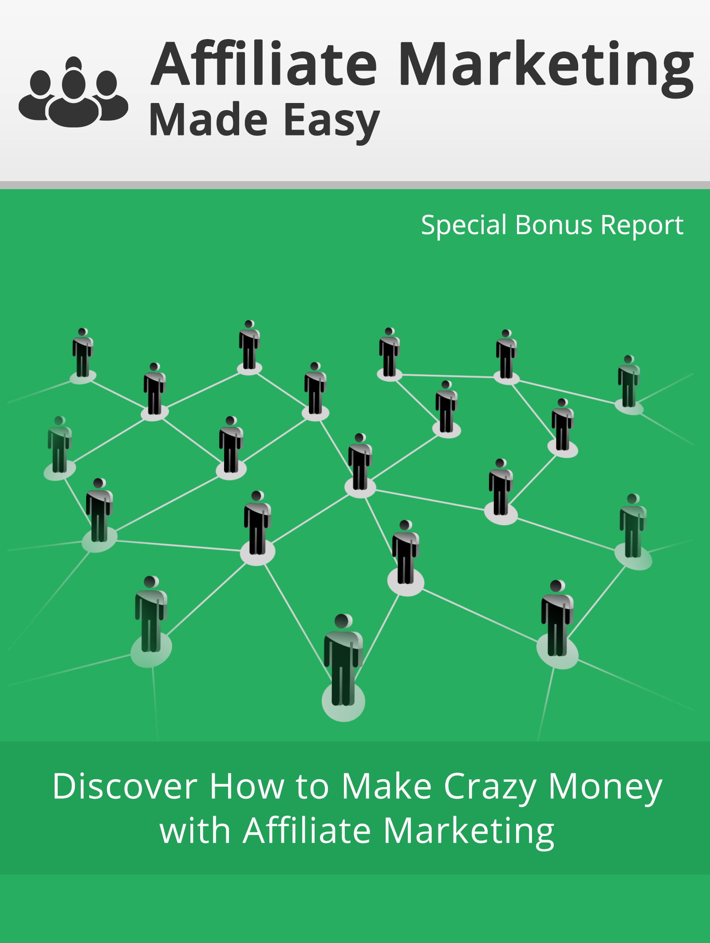

Powered by : Your Website URL

Disclaimer:

This work may not be copied, sold, used as content in any manner or your name put on it until you buy sufficient rights to sell it or distribute it as your own from us and the authorized reseller/distributer.

Every effort has been made to be accurate in this publication. The publisher does not assume any responsibility for errors, omissions or contrary interpretation. We do our best to provide the best information on the subject, but just reading it does not guarantee success. You will need to apply every step of the process in order to get the results you are looking for.

This publication is not intended for use as a source of any legal, medical or accounting advice. The information contained in this guide may be subject to laws in the United States and other jurisdictions. We suggest carefully reading the necessary terms of the services/products used before applying it to any activity which is, or may be, regulated. We do not assume any responsibility for what you choose to do with this information. Use your own judgment.

Any perceived slight of specific people or organizations, and any resemblance to characters living, dead or otherwise, real or fictitious, is purely unintentional.

Some examples of past results are used in this publication; they are intended to be for example purposes only and do not guarantee you will get the same results. Your results may differ from ours. Your results from the use of this information will depend on you, your skills and effort, and other different unpredictable factors.

It is important for you to clearly understand that all marketing activities carry the possibility of loss of investment for testing purposes. Use this information wisely and at your own risk.

Limited Special Offer for You:
Affiliate Marketing Made Easy
(Video Training)
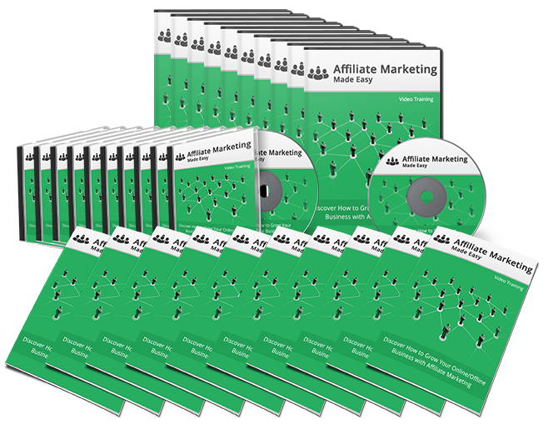
Click Here to Download Your Video Training!
(Insert your Upsell Offer URL)

Table of Contents
Introduction | 4
I. Tools and Services to make Affiliate Marketing a lot easier | 5
II. Affiliate Marketing Compensation Methods | 14
III. How to apply on affiliate networks | 16
IV. Awesome ways to do Affiliate Marketing with a website | 23
V. Awesome ways to do Affiliate Marketing without a website | 27
Conclusion | 31
Resources | 32
Limited Special Offer (for the next 7 days only) | 33

Introduction:
In Affiliate Marketing, the advertiser – also called affiliate – promotes products or services, and the merchant pays the advertiser for clicks, actions, or sales that result from the advertiser’s efforts. Every time a visitor moves from the affiliate site to the merchant site to express interest in a product or make a purchase, the affiliate earns revenue. This relationship between the merchant and advertiser is called an Affiliate Program.
Introduction
As an example, let’s take a look at Amazon.com. As a merchant, Amazon sells products and services. The affiliate – which might be you – promotes those products and services and directs consumers who visit his or her site to Amazon. When that happens, the affiliate earns a commission.
The third party in this type of marketing is called the affiliate network. They facilitate the relationship between the merchant and the advertiser. For merchants, the network provides a platform to manage their affiliates using multiple tools, such as conversion and commission tracking services, affiliate payment services, spam detection, and more.
For affiliates, the network provides access to merchants, reporting tools, comparison tools to help you select the most profitable programs, along with other tools to help you succeed as an affiliate.
To Your Success,
Your Name
I: Tools and Services
Affiliate marketing definitely is blooming and competitive. Wise affiliates execute their plans in the best way that they can using the proper tools.
Affiliates maximize their potential customer to by using right tools which is necessary to be a successful affiliate marketer. We will tell you what are the necessary tools to make it easier than it had ever before?
Video Creator:

Affiliate Marketing has been gaining tremendous traction on internet, and videos can be an incredible tool to promote products with descriptions, which can help consumers to know more about the product...
There are so many tools are available to create videos, such as:
- Magisto
- YouTube Video Creator
- Video Maker
- Stupefilx
- Kizoa
- Wevideo
- Ezvid
- Animoto
YouTube can be the fastest and easiest way to gather more traffic consistently. YouTube has more value than any other video creator, and recently YouTube introduced click-to-buy links attached to their videos, which helps to generate more revenue.
YouTube can be a primary tool to promote new products and services. It attracts millions of users and delivers the most bang with no bucks. You can attract more and more viewers using the video cleverly. Amazon is even using YouTube to promote products, and many other websites are using video creators to promote themselves.
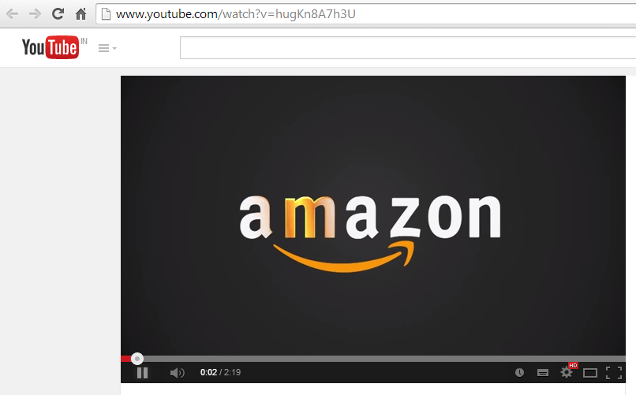
Want to become a successful affiliate marketer? Create something of value, choose your market, create a video of your product, load them to YouTube, and link them to your website or blog.

Text to Audio Converter:

As humans, we use five senses to collect information and data. Statistics show that people remember 70% what they hear, but they remember only 20% when they read.
By using audio on your website, you will get more powerful responses from customers than from text. It is more than words on a page, and it will help you to form a connection with your customers.
There are so many free text to audio converter tools are available in market, like:
- Natural Readers
- Announcify
- Fox Vox
- Balabolka
- Chrome Speak
- Odiogo
- Power Talk
- Text to Voice
- Speak It
You can introduce yourself, and you can link an audio tour on your website, which helps your customers to become familiar with you. You can also use audio logo with some background music or voice, and it will be remembered by your customers.

Squeeze Page Templates:
The squeeze page is specifically designed to generate leads by using opt-in forms for potential customers to provide their name and email address. A squeeze page is very similar to a sales page.
The opt-in form is generated by an autoresponder provider and coded into the HTML code of your squeeze page template. This tool is a great way to collect as many email addresses as possible, and they will become the part of your mailing list so that you can market to them and make money over and over.
Of course, you must target appropriate customers to make it successful, such as a weight loss product targeted to younger clientele. You can also add hyperlinks to additional pages in order to find more potential buyers.
To make it even more powerful, just turn your call-to-action into give-the-payoff by using “Send me free tips” instead of “submit”, or use “Get instant access” instead of “Join”, etc.
You can choose squeeze page from:
- Squeeze Page Creator
- Squeeze Page Templates
- Video Squeeze Creator
- 90 Seconds Squeeze Page
Squeeze pages are great for beginners who have recently entered in online marketing.

Graphics:
Graphics make your product much easier to understand and remember what you want to say with your graphics.
Graphics on website will attract the visitors. There are many reasons to choose a correct graphic to increase your website traffic. Correctly placed graphics enhance the website visually and catch eyes of your visitors.
Before choosing the graphics, keep in your mind that the graphics you are going to use will support your website content and that the number of colors used per graphic should be minimal.
Limited animation and appropriate colors should be used in graphics because the correct colors will increase recognition by 70%. Use text fonts that are tied into the style your audience wants.
There are so many web graphics website where you can search for a graphics or you can hire a service provider for this. You can search for graphics form:
- Sutterstock
- Graphics Factory
- Free Digital Photos
- Getty images
- 99designs
- Canva
- Awwwards
- Lotem

HTML Templates:
To promote a product, you need a website; it will increase your business credibility.
Affiliate marketers are constantly searching for most effective and developed platform. WordPress is good choice to power your online presence.
You don’t have to learn html to create a website; the only thing you have to know is how to insert your content and how to insert your opt-in form, along with adding some graphics to improve website conversions.
Signing up with one hosting account is easy, and a page builder will be there inside your account.
This type of software enables you to create and edit HTML in your web browser. If you know how to use word documents then you can easily use this software.
With WordPress you can create templates and websites for your affiliate sites. WordPress has huge range of built in plugins, and whether you are using CPC affiliate marketing, an SEO plugin can be used to gain natural search traffic.
There are so many templates, and a range of themes are available on WordPress for every conceivable purpose.
You can use WordPress pre-made templates for your sales page.

WordPress Plugins:
WordPress is probably the easiest blogging CMS out there, and it’s free. They also have tons of great free themes and plugins that will help you with blogging, forms, tracking, and SEO.
Amazon Product in Post plugin can be used to quickly fill your sites with Amazon products. You will be capable of adding only those products which are right for your website, and you can monetize your blog posts with customize Amazon products.
Affiliate Plugin is a great tool for Affiliate marketing programs. Complete affiliate and referral statistics and data are recorded by this plugin and provided instantly. You can have as many affiliates you choose. It provides API (Application Program Interface), which is compatible with Ecommerce and Membership System.
This site has hundreds of thousands of royalty-free stock photos for you websites and blogs. They have both “Plus” and “Super Plus” subscriptions so that you can choose one that fits your needs and budget.
Gravity Forms This is the easiest way to create contact forms for your website. They are easy to create, edit, configure, and embed using this plugin.
ClickBank Press Plugin helps you to customize your product description. With this plugin you can add custom categories to your marketplace. It provides you facilities to update you product and services with just one click.
Yoast Video SEO Plugin With this plugin, all of your embedded videos will be shown in search results as videos with a thumbnail image. This allows your videos to rank higher and capture more attention. Here is an example of a search result using Yoast:
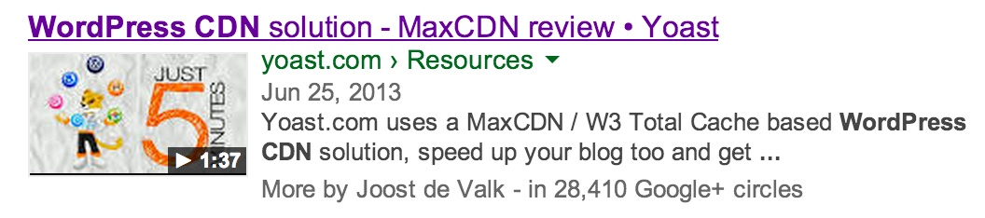
Social Locker Plugin Social Locker is both a social locker and a set of social buttons. It allows you to lock some of your content until your visitors click on one of the social buttons. This helps to improve your social performance as well as get more likes/shares, which will attract more traffic.
Ad Injection Plugin This plugin will inject any type of ad (Google AdSense, Amazon Associates, ClickBank, etc.) into your existing WordPress content. You can also control the number of ads based on the length of your posts and restrict who can see the ads based on post age, visitor referrer, or IP address. You also have options for configuring the ads, along with support for A:B split testing and ad rotation.
Broken Link Checker This plugin does exactly what it sounds like; it checks your content, posts, and comments for any broken links or missing images and then notifies you.
There are many other plugins are available for affiliates and affiliate marketers. WordPress help its affiliates to extend functionality of their website and marketing campaigns with its plugin.

Article Spinners
On affiliate marketing there is a lot, I mean a lot of article writing. When you use article spinning services you’re giving yourself the ability to have the same article rewritten over and over again.
This essentially means that you're going to get quite a few articles out of just the one article submitted.
You're also given a variety of options so that you're able to look at the spun articles and then compare them all together in order to see which one is going to best benefit the goals of your particular website.
- https://spinbot.com/
- http://thebestspinner.com/
- http://bestfreespinner.com/
- http://free-article-spinner.com/
- http://ezarticlelink.com/articlespinner/free.php
Writing Services
Hiring a writing service to completely take the reins so that they can provide for you all the best Content that will work best for your particular website is definitely an option, especially for those who are new to the online world.
- ContentDevelopmentPros.com
- http://www.iwriter.com/
- ContentProz.com
- http://www.wlmarketing.com/content-writing-service.html
- https://www.hirewriters.com/


II: Affiliate Marketing Compensation Methods
Of course, you want to make money as an affiliate marketer. So once you’ve got some great tools, great hosting and plugins, and great content, compensation is obviously the next consideration. There are several ways in which affiliate marketers are compensated by merchants, and it’s important to understand each of them.
Predominant compensation methods pay only if a visitor converts into a customer by purchasing a product. 80% of affiliate programs use Cost-per-Sale to share revenue.
19% of affiliate programs use Cost-per-Action to share revenue, and the remaining 1% use Cost-per-Click and Cost-per-Mile compensation. Cost-per-Sale and Cost-per-Action compensation is performance-based.
This means that visitors have to do more than visit; they have to subscribe, complete a form, or actually make a purchase.
Diminished compensation methods, such as Cost-per-Click or Cost-per-Mile compensation are mostly used in display advertising and paid search methods. In this type of compensation, the affiliate is not concerned with the sale because their commission is earned simply by the click or mile.

Pay-per-action: Also referred to as Pay-per-lead, this method is fairly straightforward. The affiliate is paid for every visitor referred by the affiliate to the merchant website who performs the desired action, such as signing up, completing a form, etc. Many online companies use this type of compensation.
Pay-per-click: In this mode of compensation, the affiliate is paid when a visitor to their website clicks on an ad or link and visits the merchant website. The main purpose of this is to generate traffic to the merchant’s website.
Click-per-impression: This is a highly popular method of compensation; however, the pay for this action is generally lower. All that the affiliate needs to do is provide space for a merchant to post ads and banners. The affiliate is paid when the ads or banners are viewed.
Pay-per-sale: As far as the “pay per” methods go, this one generates the most revenue per action. In this method, the visitor to the affiliate’s website must not only go to the merchant’s site, they must actually make a purchase.
Pay-per-call: In this method, the affiliate receives compensation for each phone call received from potential prospects or customers. This type of advertising is fairy new but is expected to grow.
Pay-per-install: In this model, the merchant pays the affiliate for every install of an application. These applications are usually free and are bundled with adware applications.

III: How to apply on Affiliate Networks
You have a website and want to monetize it. Becoming an affiliate can be a good way for money making. Just add advertiser products link or services to advertise and when visitors click the link or purchase any product by your affiliate link, you will get commission.
Amazon associates affiliate program is one of the best resource for affiliate to make money. This program offers many advantage and it easy to join and use. Here I will show you, how you can set up your affiliate account on Amazon associates.
To become an amazon affiliate you need a website and blog to promote it. You also have to describe about your website on amazon and choose the products accordingly to your website.
Go to the amazon website and scroll it down, you will find “Become an Affiliate” which is grouped in “making money with us”. This link redirect you to amazon associates page.
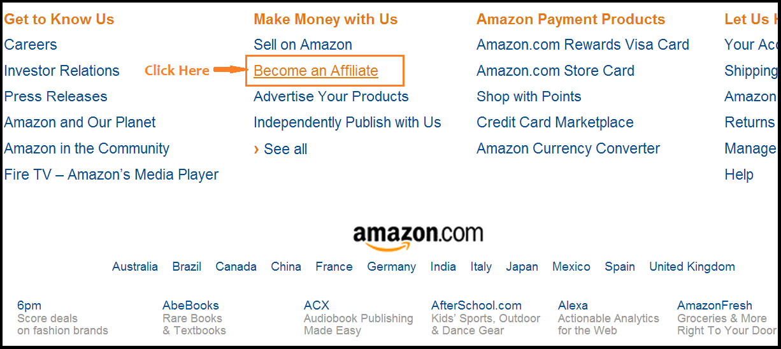
If you already have an account on Amazon.com, login with your email id and password. You are a new affiliate, click on “Join now for Free”.
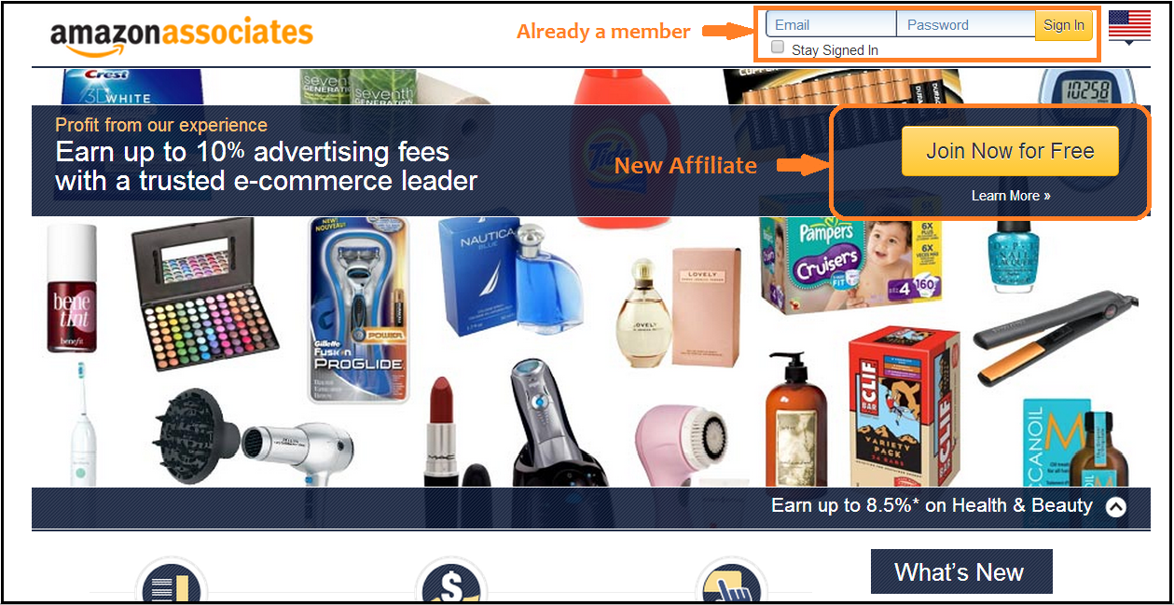
New customer have to enter email address and click on “sign in using our secure service”.
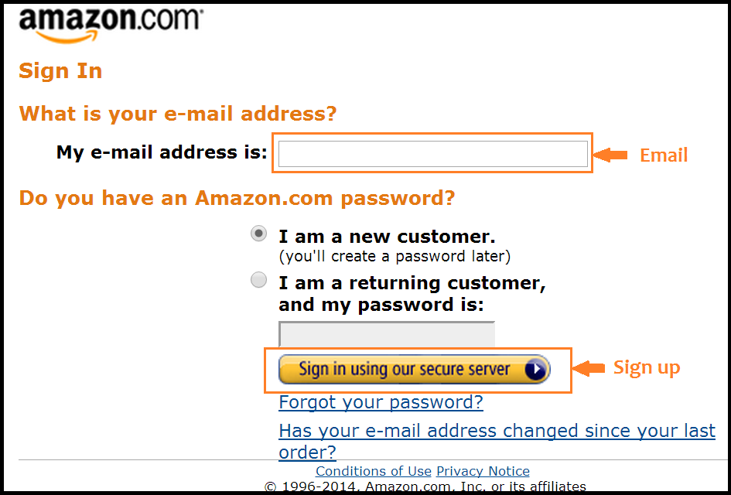

Fill out All Account Information:
You have to fill your name, address, city, state, contact and other information. All the information should be completely correct.
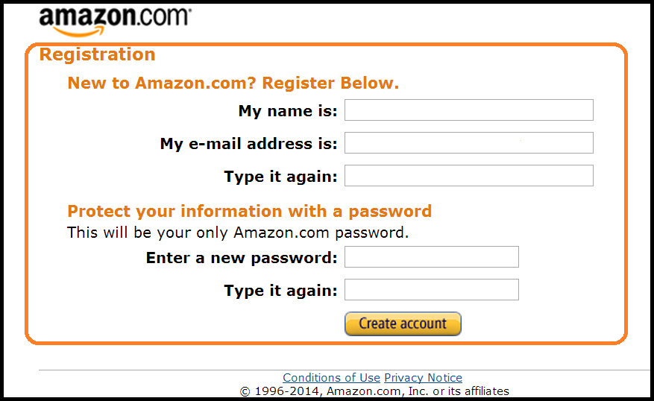
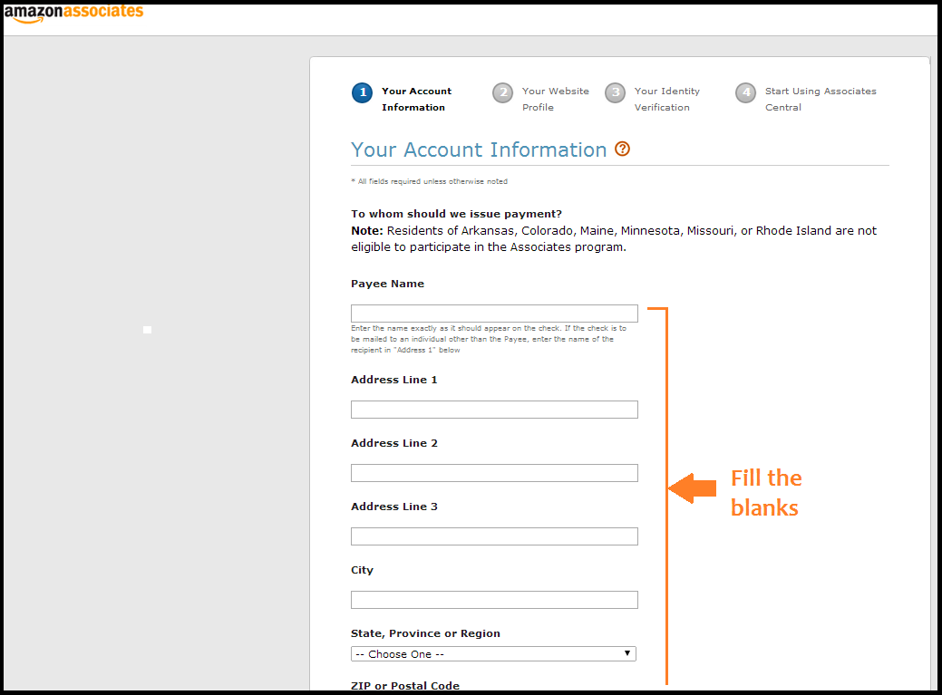
Here you have to fill information about your website and you have to answer a question “what is your website about?” with a summarize description of your website. You have to choose primary and secondary topics which describe your website. Now moving further you have to choose the item of list you want to promote as an affiliate. And lastly you have to answer “what type of website do you have?”
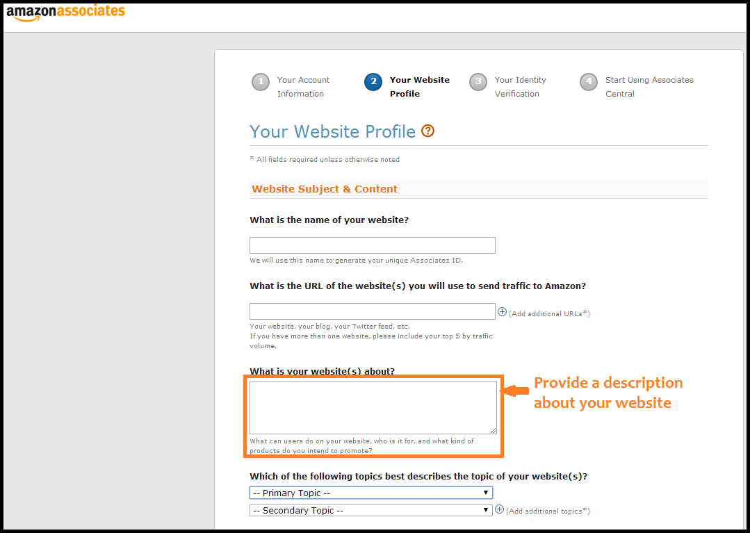
To verify your account you have to enter you contact information and click on “call me now” button. A 4 digit pin number will appear on the screen when you entered your contact information. You will get a call from Amazon and follow the instruction. After verifying, agree with term and condition and click “finish”.
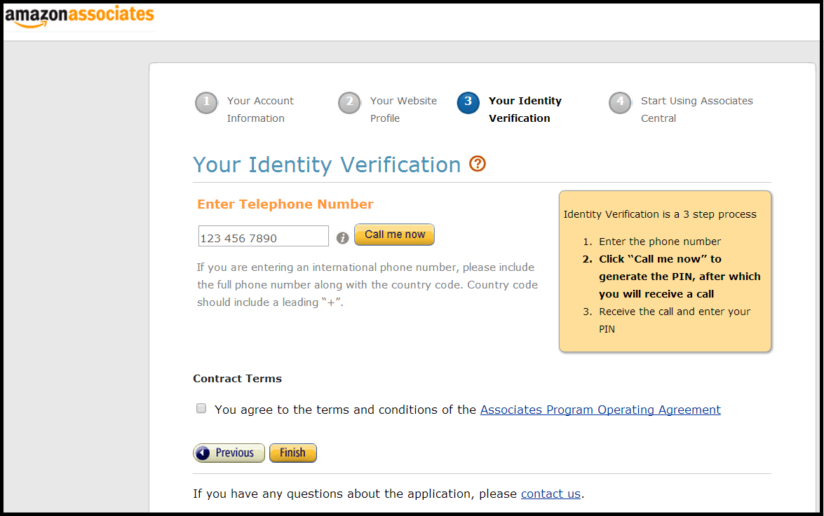
You can take help feature to know more about the program. There are so many tools are available to help affiliates like banners, widgets, site stripe, slide show and text product link. It has a store facility that helps you to create an online store. It also provides a daily report tracking tool.
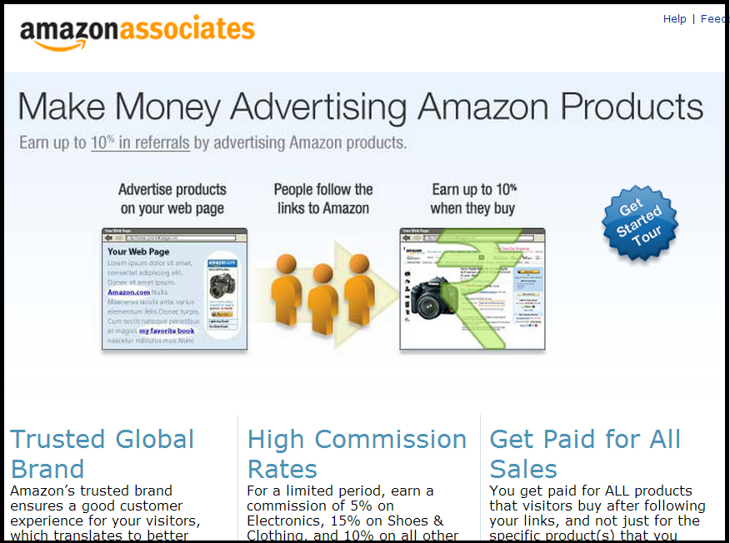
Here are some general instructions for applying to other affiliate networks that will increase your chances of being accepted.
Own a Domain: A domain registration generally costs about $10, and it is the best way to begin to be taken seriously by affiliate networks. Yes, there are lots of free site builders out there, but having a domain of your own legitimizes you.
Your Domain Name and Email Should Match: If you choose the right service, you will likely have an email address that goes with your domain. Take advantage of this and use that email. Again, there are lots of free email provides out there, but having a business email that coincides with your domain adds professionalism and legitimacy.
Your Website is Your Office: Because there ARE so many free or inexpensive website builders out there, there’s really no excuse not to have at least a two or three page website for your business. This site should include the landing page, an “About” page, and a “Contact and Information” page. Even if you are not creative or a site-building genius, you should be able to create a simple, clean, and professional looking website.
Properly Integrated Affiliate Links: Find the professional and respectful balance between monetization and user experience. Yes, you want to make money, but visitors and potential customers these days are wary of the “hard sell.” They do not want to receive emails or visit web sites where every third line has a flashing “Act Now!!” sign or link. This method, even if the company is honest, appears tacky and “scamlike” to most viewers.
Keep the majority of your high-quality content ad-free. Create some great pages to promote your offers with excellent content, and then link to those pages from your sidebar, footer, or some other high-visibility area.
Content is the Key: Let’s face it, it probably isn’t going to be flashing banners or promises of disappearing deals that will sell your merchant’s product. It’s going to be quality, engaging content that speaks to a viewer’s intelligence and need or desire for the product or service. And be wary of just tossing out links for no relevant reason. Over time, that tactic will actually decrease traffic to your site, and as a result, the merchant’s site.
Take Advantage of Affiliate Aggregator Service: If you blog about diverse topics, you might want to take a look at programs that automate access to affiliate programs. Let’s say you are writing about a great new set of tools from Ace Hardware. Instead of signing up directly with Ace’s affiliate program, you can work with an aggregator, who will automatically append the affiliate code to the link.
These programs do keep a portion of the revenue, but because they work with so many merchants, they can sometimes negotiate higher payouts or commissions. One such service is Viglink: http://www.viglink.com/
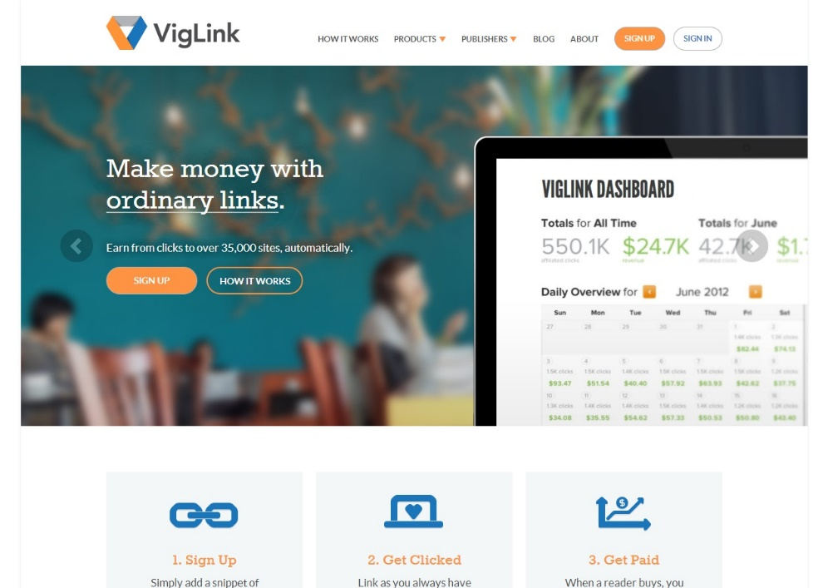

IV: Awesome Ways to do Affiliate Marketing with a Website
There are a variety of ways that you can use your website to do affiliate marketing. Each of them have important considerations, pros, and cons. When you find the right one or more that is right for you, it will increase your chances of making money in your area of strength.
Blogging: Blogs are one of the most popular ways that affiliate marketers use websites to make money. Because it is intended to be content-driven, it is easier to strike a balance between monetizing and viewer interest.
It is also a way to connect with potential customers who share a passion for your niche. A good blogger can incorporate promotion for a product or service organically into their content, which makes it a more positive experience for the reader.
However, there are some requirements that are important for making this method successful. First, you must be able to write intelligently about the blog topic.
For example, if you have no real interest in sports, then you will probably not blog well about sporting goods or team memorabilia. Books on raising children may be in high demand, but if you have no knowledge about parenting and no children, it might not make for the best blog writing.
And speaking of writing, if you have trouble writing well, having your writing flow well in its intended language, and using correct and typical grammar and spelling, the blog may not be the best method of affiliate marketing for you.
Reviews and Recommendations: People want to know how other customers feel about a product. Even in this day and age of technology and apps, word-of-mouth is still the most effective form of advertising. Because of this, using your site to write or share recommendations, reviews, or referrals can be effective.
If you have chosen a niche for which you have a passion, chances are you have already used some of the products you are promoting. That is the perfect place to start; review the products yourself.
There are some cautions to observe when using this mode as well. Copyright infringement and plagiarism are real issues, so avoid taking others’ reviews without permission. It may seem like an obvious warning, but sometimes it happens.
In addition, avoid the temptation to write “stock” reviews or pay someone to generate lots of “phantom reviews” just to get more traffic. This is actually considered black hat SEO and could get your site sanctioned.
Well-positioned Links: There are many options for link placement on your website, but some places work better than others. When you are choosing the placement for your links, keep in mind where on the page your reader will be looking. It usually works well to put text links within a blog. Above and below posts are good places for banner ads.
This is the best way for you, as an affiliate, to use ads and links to promote your products.
For example, links throughout an article that relate to the specific product or niche being discussed would be more effective than just a banner for a general landing page. If you are reviewing a gaming system in your blog, then it would make sense to include a link to Nintendo or Xbox within the text.
Vendor Guest Posts: One of the best ways to promote a product is to have the product vendor write a guest post. You can contact the vendor and ask them to write for you within the following guidelines:
- The post should be genuine, well-written, and unbiased
- Mentioning the product is fine, but the post should not be a full on advertisement or review
- Make sure the product is a good fit for your blog
Use unique pages for each product: It doesn’t make sense to have one website that promotes gardening products, shoes, and graphics programs. It may save money on the front end, but it will be less likely to draw traffic and MAKE money. Have a site focused on each of the product topics/niches with which you are working.
The Free Report: No one can pass up something free, especially if it relates to a topic or niche they enjoy. Be sure to place the report at the top of your page or in a prominent place, and create auto-responder messages that will be mailed to those visitors who sign up to receive the report.
And remember, even though you are contacting them with the hopes of eventually making a sale, it takes an average of seven contacts to do this, so don’t make your auto-responder message a flashing, high-pressure message.

Stay in Touch…Graciously: Once you have their contact information, try to make more than one contact. However, when you do, be sure that the content of your message is focused on how the product you are promoting can make life easier or more enjoyable.
Try to avoid the word “free,” because there are some older spam filters that will dump the message into the junk folder if it contains that type of content.
When you give them useful information periodically without jamming their inbox or sending messages that sound like sales pitches, you’ll be reminding them of the product and planting the seed in their minds that will keep them thinking about it.
The content should be focused on specific reasons to buy the product rather than a high pressure sales pitch or threats of what might happen if they pass it up.
Remember the Reality of Statistics: Generally speaking, 1 out of every 100 people will actually buy your product.
If you can generate 1,000 targeted hits, you are likely to sell 10 of the product. So as an affiliate, remember that your focus is traffic, leads, and referrals.
The more of those you can generate, the more people will visit the merchant website, and that is where the selling takes place.

V: Awesome Ways to do Affiliate Marketing without a Website
Although using a website is the most common way to do affiliate marketing, it can be done effectively without a website, at least in the beginning. It is important to keep in mind that the goal is to get your merchant’s website out there for potential visitors and customers, and this can be done without a website with a bit of creativity. Here are just a few ways to do that:
Blog and Forum Posting: If you can find blogs or forums related to your niche, then an easy way to get your merchant’s information out there is to post comments or create forum posts, and have the affiliate link in your signature.
Of course, you will want to be sure that the topic is actually relevant, and you have to be wary of sounding like you are simply posting to promote a product, as most forums have strict rules about proselytizing.
For example, if you are posting on a dating and relationships site, don’t just post a blurb with the link. Actually become involved in discussions in a helpful way, making it more authentic.
Become a Writer: No, you don’t have to be J. K. Rowling or Gordon Ramsey. However, if you know a lot about a niche or product, consider writing a free eBook or some other type of viral product. Then you make sure to insert affiliate links within the text and content.
For example, if you’re selling nutritional supplements, consider writing an eBook about diet and the role of supplements in nutrition. Then you can insert your affiliate links organically. If you are a strong writer, this can be a great tool.
If not, find a budding writer who wants to promote their own work, and offer to promote their work if they will write a short eBook for you at a reduced rate.
Articles and Blogging: You don’t have to have a site or a domain to have a blog. WordPress.com offers free blogging, as does Google’s BlogSpot. Tumblr is also free.
Write posts and articles about your favorite topics or your niche, and include affiliate links. You can also have people subscribe by email to your blog, and this means they will be alerted every time you make a new post or write a new article.
Social Networking: Google+ and Facebook are both free, and they will both allow you to create a page as a part of your account. Set up your own social networking account, and then create a page to promote your products.
If you are worried about privacy, you can set your personal account privacy settings very high, and everyone will still be able to see your created business page.
Make posts promoting products and sharing your own experiences with the products. And when one of them makes the news, share a link to the story on your page.
Write Ads and Reviews on Classified Sites: You can use classified sites like craigslist to create ads or reviews for you affiliate products as well.
Just be sure to include the affiliate link as well. Below are a few of the sites you can use to do this:

http://www.usfreeads.com/
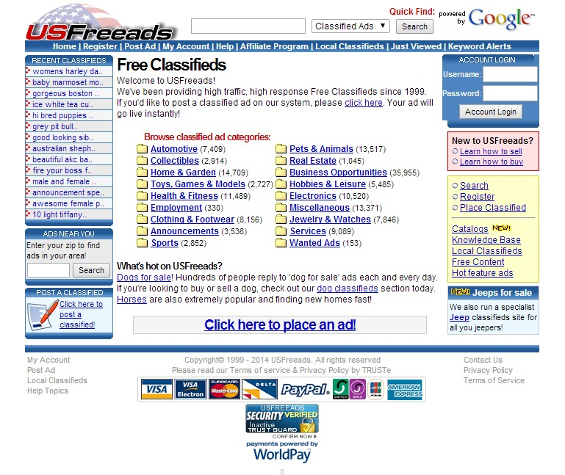
http://epage.com/js/epmain.jsp
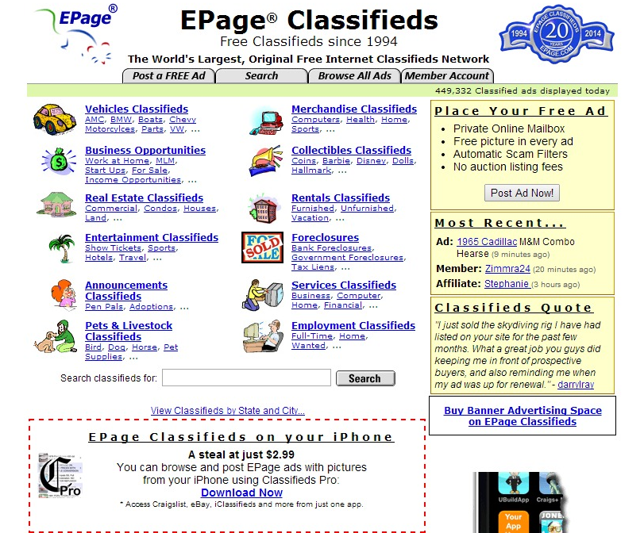

http://www.craigslist.org/about/sites
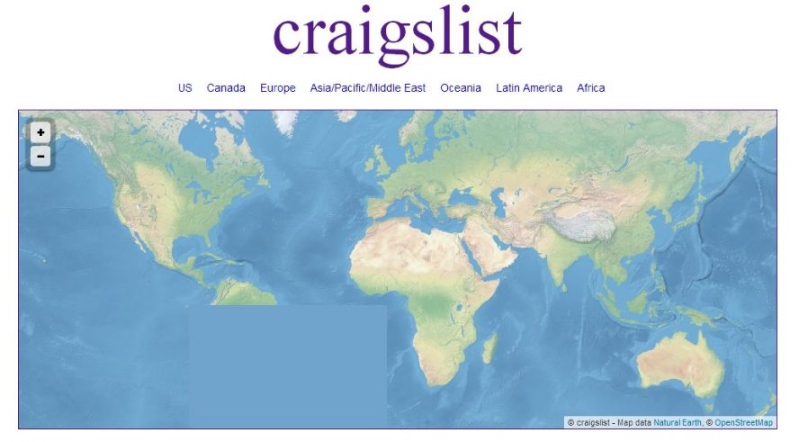
Sell with Squidoo: A Squidoo “lens” is essential a mini-website that is only one page. You can use this to talk about your niche and promote your products without having to create a full site.
Because it is hosted by the Squidoo site, you don’t have to know anything about design in order to make it look sleek and professional. You can build a page about your topic and insert ads and links without having to know anything about HTML.
All you have to do is sign up here: http://www.squidoo.com/
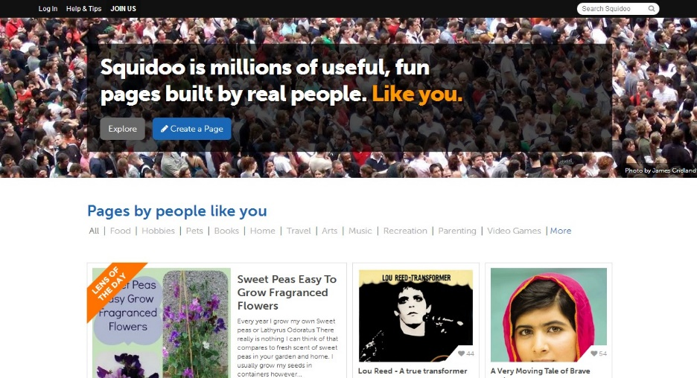
Conclusion:
As you can see, there are lots of great ways to successfully do Affiliate Marketing both with and without a website. All you need to do is gather useful tools, explore the various compensation methods, apply to the programs that fit your niche, and get started.
We’ve guided you through the process of defining affiliate marketing and its features, given you some practical ways to approach this type of marketing successfully, and shown you some great sites to help you as you work.
Whether you have a website or not, you can still make money by promoting merchants’ products and directing customers to their websites. All you have to do is get started.
This report is intended to give you a roadmap that will help you to get started intelligently as an affiliate marketer. Armed with the knowledge, tools, and resources above, all you have to do now is to find your products and hit the ground running. Then do the work and watch your revenue rise.
In order to take your affiliate marketing even farther, we invite you to get the most out of Affiliate Marketing by getting access to the Complete Training clicking here (Insert your Front End Offer URL).
Thanks so much for the time you have dedicated to learning how to get the most advantages from Affiliate Marketing. Affiliate Marketing has come to stay in the market forever.
To Your Success,
Your Name
Resources
Videos
- http://www.youtube.com/watch?v=bedxiZXtxKo
- http://www.youtube.com/watch?v=mfj6IkzCkxs
Tools
- http://www.offervault.com/scoop/2013/02/20/38-affiliate-marketing-tools/
- http://retiredstudent.com/useful-affiliate-marketing-tools/
Training
- http://www.usanfranonline.com/programs/certificates/internet-marketing/advanced-specialized-certificates/advanced-affiliate-marketing/
- http://www.toptensocialmedia.com/social-media-business/ten-affiliate-marketing-training-programs/
Blogs
- http://adamriemer.me/
- http://affiliatetip.com/
Forums
- http://www.abestweb.com/
- http://affiliate-marketing-forums.5staraffiliateprograms.com/
Programs
- http://www.yeahmobi.com/?gclid=CNKmjOWRwL4CFW4R7AodnB8Aeg
- http://blog.intuit.com/marketing/4-highly-profitable-affiliate-marketing-programs/
Demographics
- http://www.alexa.com/siteinfo/www.cj.com
- http://www.alexa.com/siteinfo/www.affilorama.com

Limited Special Offer for You:
Affiliate Marketing Made Easy
(Video Training)
Click Here to Download Your Video Training!
(Insert your Upsell Offer URL)

