The 5-Minute Guide to Entrepreneurial Success

-SPECIAL REPORT-

By [YOUR NAME]
[URL]

5-Minute Guide To Entrepreneurial Success

So, you want to be an entrepreneur? Many people desire to go into business for themselves but few individuals actually do. Why is this? Because it is risky for one thing, it’s a hard, long slog, most of it uphill and it’s going to cut into your free time as well; a lot of your free time. But the rewards for being an entrepreneur are pretty incredible. If you’re successful, you have the ability to earn an unlimited amount of money. Even if you’re not all that successful financially, you’re still working for yourself, paying the bills and living the American dream.

But how do you become successful at an entrepreneurial venture? Although there are many paths to take all of them are paved with the same bricks: hard work, persistence, vision, a good idea and an entrepreneurial mindset. In this guide, we’ll explore what it means to be an entrepreneur and how you can be more successful at your own ventures or start a brand-new life as a business owner. It doesn’t matter what sort of business you are in or what level of success you are seeking – what matters is the journey.

The Tools You Need to Get Started

So, what are the tools of an entrepreneur? What are the attributes or skills that separate the wheat from the chaff? Although each entrepreneur is different, they all seem to share some of the same personality traits. Here are some of them. See if any of these are true for you:

• You have a desire to become better or more successful than you are now.
• You want to be the kind of person that inspires other people.
• You can’t remain at a standstill. You always have to be doing something constructive.
• You have lots of great ideas.
• You admire successful people and are excited about your own success.
• You hate being told what to do but you love learning new information or skills.
• You’re disciplined. You’re willing to stick this out for the long haul.
• If you fail, you’re the kind of person that will get right back up on the horse.

The First Step: Changing Your Mindset


The first thing that you’re going to have to do before you set out on your path to success is change your mindset. Do you really need to change your mindset? Well, unless you have been living in the jungle like Tarzan up until this point, or perhaps in prison, you’ve had opportunities to be successful in the past; you just never took advantage of them. That probably means that your mindset could use a little tweaking.

How important is mindset? Some would argue that this is the most important tool than an entrepreneur has into his or her disposal. That’s because no matter what kind of business you’re trying to run or kind of entrepreneurial venture you’re attempting, whether you succeed or not has nothing to do with luck, is not dependent upon the skills you possess, nor will any of the other myriad of factors that can affect a venture negatively kill your business faster than your own negative attitude.

Many people aren’t even aware that they have a negative attitude. Many people have negative self-talk going on, down deep where no one else sees, but to the world they put on a positive face. Only you can decide if you need to work on your mindset before you can work on your business.

The Second Step: Evaluating Your Skills and Advantages

The second thing – or rather the first thing if you don’t count changing your mindset – is to decide what sort of skills and advantages you have that are going to help you with your entrepreneurial venture. The skills and attributes can help inspire you to figure out a product or service that you can provide that will bring you success. You will have a much greater chance of being successful if you do something that you’re passionate about. If you’re an avid sports fan, for example, you could make a successful e-commerce business selling some sort of sports equipment. There are plenty of niches out there that haven’t been filled completely yet and even if there is competition, all you need do is rise above them.

So, sit down and make a list of all the skills that you have. Don’t just include things that you know how to do, such as typing, surfing the Internet or building houses. Write down personal attributes as well that could help you on your journey. For example, are you a natural leader? Are you a good listener? Whatever your skills and advantages are, that will help you become an entrepreneur, write them all down so you can evaluate what sort of business you can get into using them.

The Third Step: Allowing for Your Weaknesses

Your next task is going to be evaluating your weaknesses, in much the same way that you did with your strengths and advantages. You need to be familiar with your disadvantages so that you can allow for them in your business. For example, if you are really bad at managing your time, and you’ve always had a problem in the past with keeping a schedule, you’re going to want to solve that problem before you start your entrepreneurial journey.

It can be tough to list your weaknesses. It can be embarrassing to realize that there so much about yourself that could be improved. Just know, you aren’t any different than any other human being. Everyone could use improvement in certain areas, and everyone has weaknesses that they must allow for no matter what their goals are.

The Fourth Step: Setting Goals

The fourth step is setting goals. You will notice that it’s the fourth step, not the first step. Many people jump right in and start setting goals without really being prepared for them. That’s like a novelist who starts writing without an outline. Sure, a few people can write “by the seat of their pants” but most require an outline just as most entrepreneurs need an honest evaluation of their advantages and disadvantages before they begin.

So, how do you set goals? You’ve heard of long-term and short-term goals, right? We’re going to use the spreadsheet to plan out your short-term and long-term goals. This is sort of an outdated method, and certainly not in style anymore but it truly is the most effective way to set and reach goals.


The first thing you need to do is decide upon a time frame. Your timeframe can be one year, five years or any period of time that you want. There are only a couple rules that in these to follow. First, it should be no shorter than one year and no longer to take someone to achieve a major accomplishment such as earning a degree were saving up and preparing to buy a home. On average, long-term goals are about five years. Whatever that period of time is, make the top of your spreadsheet today and the bottom of your spreadsheet the end of that period.

Now, you know what you’re trying to accomplish during that period of time, you just need to figure out some smaller goals that you can insert at regular intervals in between your timeframe. Start with bigger gaps; if your timeframe is a year, start with quarterly gaps. If your timeframe is five years, every year is a good bet.

Once you’ve determined those short-term goals, you’re going to break them down even further. If you went with quarterly, now you can break them down in the monthly. You’re going to continue to break down those goals, one by one, until you know what you have to do daily to achieve the next, upcoming short-term goal. So, for example, if your goal in 30 days is to have the idea for your business, then you need to decide what it is that you can do each working day (whether that is five days a week, seven days a week or two) the will allow you to reach that next goal.

It is important that you don’t go any further with your daily goals or habits, then the very first milestone. This is simply because your goal plan needs to be flexible so that you can make changes if you need to.

The Fifth Step: Focus on Your Success

The next step in our plan involves some of the things that you’re going to do mentally to ensure that you achieve success. With your goals in the last section, you’re going to be physically doing something each and every working day that will allow you to reach your goals one short-term milestone of the time. But how do you keep motivated during that time? How do you keep your eye on the prize? That’s exactly what the fifth step is all about.

Each person is unique in what motivates them. What motivates you will be different than what motivates any other entrepreneur out there. But there are some things that have been shown to work that you can start with and then tweak as needed.

Visualize your end result and find some way to remind yourself of it daily. For some people, this is in the form of a yacht that they want, a fast car or a brand-new house. For others, it’s something that’s harder to express visually and they have to write it down, maybe putting it on their computer desktop as a background, in order to read it every day.
Keep track of your progress in some easy-to-read form that you can use to look back and see all of your successes. After a while, the joy of reaching a goal will be forgotten. But if you can keep a record, you’ll be able to go back and see all the things that you’ve accomplished so far which will motivate you to keep going. It’s like a person trying to lose weight. In their current state of mind, they might be feeling frustrated and unmotivated, but if they look back and see that they’ve lost 50 pounds in the past 12 months, they’re going to be motivated to keep going.
Make a commitment and then stick to it. Don’t just be accountable to yourself, tell other people what you’re doing, so that you’ll be accountable to them, at least in your mind, and will be more motivated to stick your goals. You can even create a blog online to track your progress, or if you feel more comfortable in front of the camera, start a vlog instead. No matter how you do it, make your commitment mean something.

The Sixth Step: Continually Learn New Things

Finally, the last that they were going to discuss is the sixth one. For this step, you’re going to improve yourself as you go along your journey. Each and every day, try to learn something new that is going to help you with your business. You can do this a myriad of different ways. You could read a book from a well-known, successful motivational speaker, like Tony Robbins or even Dr. Phil. You can watch speeches that will motivate you and teach you. You can take classes, either in person or virtually, or even just by watching YouTube videos.

However you need to do it, try to improve yourself each day. Try to find one thing that you can do that will allow you to be proud of yourself at the end of the day for accomplishing it. You never want to feel like your stagnating. You always want to feel as if you’re moving forward, and the more momentum that you can build up, the faster you’re going to go along the road to success. Follow these simple steps, and nothing will be able to prevent you from achieving the success that you’ve always wanted and being the kind of entrepreneur that everyone wants to be.

TOP RECOMMENDED GUIDE:
A Simple Guide to Developing the Entrepreneurial Mindset Needed for Success
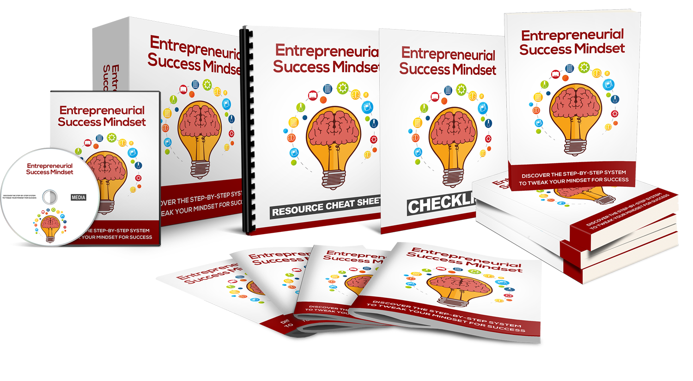
Find Out The Exact Steps You Need To Take!


>> Click Here To Get Your Copy <<

