The 5-Minute Guide to Generating Your First 1000 Website Visitors

- SPECIAL REPORT -

By [YOUR NAME]
[URL]

Introduction

So, you want to generate your first thousand website visitors. That’s a reasonable goal and one that you should be able to achieve easily if you follow the tips in this guide. Having a website is one of the most rewarding things you can do if it starts making money or having visitors that are getting value from your content.

When you see that traffic start to trickle in and then grow to a steady number of visitors onto your website you’ll know that you are a true webmaster and are competing with the other websites out there. But if you want to get visitors to your website, you’re going to need to develop a strategy to get them there. Here are some ways to do exactly that.

Before You Begin, You Need Analytics

Before you begin getting traffic to your website you’re going to need to install some sort of analytics or web stats application. That’s because it is impossible to know if you’ve gotten your 1000 visitors or not if you don’t have some sort of analytics program. Google analytics is one of the best programs out there and will not only help you count the people that are coming to your site, it will also give you a number of other metrics that you’ll want to know later on as you begin to develop more advanced strategies.

For example, Google analytics will allow you to measure a visitor’s bounce rate. The bounce rate is how long they stay on your website before they go somewhere else. You’ll also see where they go when they leave your website, whether that is back to Google by pressing the back button, or onto a different page of your own site. Obviously, your goal is to get them to stay on your site as long as possible.

Analytics will also help you measure what search terms people use to find your website, which pages they are viewing the most and many other factors that will help you improve your website so that you can get the maximum amount of traffic possible.

Add Your Website Link Anywhere You Can

Now, this doesn’t mean that you go around spamming your site on as many websites as possible for posting it places where it doesn’t belong. It does mean that you take advantage of things like your email signature, which could contain a link to your website. There may be other places that you have profiles online where you might be able to post a link to your website legitimately and without spamming.

Start Commenting on Blogs - Especially the High-Traffic Ones

Most of the time, blogs will allow you to place your website URL as part of your blog comment profile. That means that if you typed your name as the person that is going to be doing the commenting it would link to your website. Course, if your website is something completely different - like for a product or service - then you want to use your website name instead.

Find these blogs that allow you to post a URL and link when you register and then comment on them - and make sure that you’re adding valuable insight and that you’re not just spamming and saying random things to get your link on there. The more eloquent and insightful you can be the more people are apt to click on your name and see where links to. The name that you used is also something that can entice people to click if you can come up with something clever that will make people want to know more.

Let Google Know What Your Site Contains

If you want people to find your website, you’re going to have to make sure that your indexed in the search engines. To ensure that all of your pages are indexed in the all the information is proper and correct you’ll want to submit a site map to Google. If you’re using WordPress there are solutions for submitting site maps that make it much easier than if you are manually designing a website or using a different program. No matter what, you should submit a site map to Google as soon as you want your site and you should update it if your site structure changes drastically.

You should also check Google regularly and make sure that your site is indexed for the proper keywords and where you are ranking for them. How do you know what keywords you should be ranking for or should be indexed for? Hopefully, you have tried to target a long tail keyword phrase that there isn’t much competition for but that people are searching for regardless.

For example, if your site sells electronics, choose a keyword phrase that combines a product type with a specific use such as a computer monitor the can be combined with the video card for multiple monitor setups. So your keyword phrase might be “computer monitors for multiple monitor setups”. People are going to be searching for that particular phrase, but there isn’t going to be near as much competition for that is there would be for the phrase “computer monitors”.

Write Indispensable Content

Another way that you can get traffic to come to your site is to write indispensable content. This means that you write content that people simply can’t live without. The information is so good, or so well-written that they simply must share it with others because they know that you’ve solved a problem that many other people are experiencing with your content.

Of course, writing indispensable content is easier said than done but if you have a few dollars to spend you can hire a freelance writer to create something amazing. Make sure that you specify exactly what you’re looking for and come up with the idea beforehand, and make sure that it is edited and as polished as possible before publishing.

Use Fiverr or another Similar Site

Fiverr is a website where you can hire people to do things for five bucks. There are many people offering traffic services for five bucks on Fiverr. Of course, you kind of get what you pay for, so the traffic that you get may not be quality traffic or may not stick around for very long but the point is, you can spend a few dollars and get some people coming to your website.

There are other websites out there as well that offer more comprehensive and expensive services in fact there are entire companies that revolve around getting traffic or optimizing your website for search so that you can start getting a huge flow of potential customers. You may want to consider hiring a SEO service if you can afford it - but make sure that you do your homework and you find one that has a great reputation and has actually gotten results for many, many other websites.

Encourage and Participate in Comments

When you post something on your site you definitely want to encourage people to comment on whatever the content is. You can do this by adding a line to the very end of your article inviting them to voice their opinion or answer a specific question. The reason that you want people to comment on your content is that every single time someone posts a comment you get indexed for new keywords and Google and your chances of getting discovered through search engines goes up.

For that same reason, try to respond to every comment, or at least a few of them. This is a great way to get your site indexed for more keywords and participating with readers will make them want to come back and read the next thing that you write or publish. Never disable your comments or make it difficult for people to register to be able to post, such as requiring an admin to approve their account before they can make a comment.

Become Social on Social Media

You can discuss getting traffic to your website without talking about social media. Social media is the number one way to get the word out about your website, but it is only effective if you already have a following. If you don’t even have social media accounts of this present time, or you have just started them you are going to have a very difficult time getting people to visit your site through social media. However if you already have a following on Facebook or Twitter posting a link every once in a while - particularly when you publish something new - could get you some new traffic.

Conduct Interviews People Will Want to Read

If you can conduct some interviews with popular bloggers or anyone else that is well-known and has a following you will get traffic to your website into different ways. First, people will discover your article when they are using keywords that relate to the person that you interviewed. This is a great way to get traffic to your site and it builds a relationship with an influencer that may help you later on.

The second way that you might get traffic is if the person that you interviewed posts the link to the article on their own social media websites or on their own blog. If they tweet out your article link or post on their Facebook page, you will probably get a huge amount of traffic coming in, reading the interview, and then commenting on it as well. This is a solid strategy as long as the person that you are interviewing is well-known and has people all over the Internet the know who he or she is.

Add Your Blog or Blog Posts to Directories

There are all kinds of places around the Internet that you could add your blog or your blog post that might get you some traffic. First of all, you can submit blog posts on Reddit which is one of the more popular places on the Internet for people to have conversations. There are also specific blog directories that you can submit your blog to or even sometimes, your individual blog posts.

Link to Popular Blogs

When you link to another page, chances are fairly good that whoever runs that page is going to know about it or find out eventually. If you link to them they might come and see what your site is all about and if they like it, they might just link to you back or tweet your article out on their social media platforms. Either way, these popular bloggers or webmasters will get you tons of traffic if they like your content. But of course, that means you have to have awesome content in the first place.

Solicit Good Guest Posters

If you let people write a blog post and publish it on your blog in order to get a link back to their own page, you could definitely get some traffic. The problem with this method is that you already have to have some traffic established in order for them to want to post on your blog. But if you can find someone that is willing to help you out or once a couple links from your site to content of theirs, you might be able to get traffic using this method.

Use Question and Answer Sites

Whatever your particular website is based upon, you can use it as a resource for answering questions. If you’ve written a great blog post that answers a common question, you might be able to go on something like Yahoo answers and answer a question that someone has posted and then list your website as the source of that answer. This doesn’t always work, and it depends entirely upon the questions that you find in the website that you post them on that you may be able to get some traffic this way as well as build your expertise in the industry that you are in.

TOP RECOMMENDED GUIDE:

Discover 10 Proven Methods For Generating Traffic Without Paying a Single Cent!

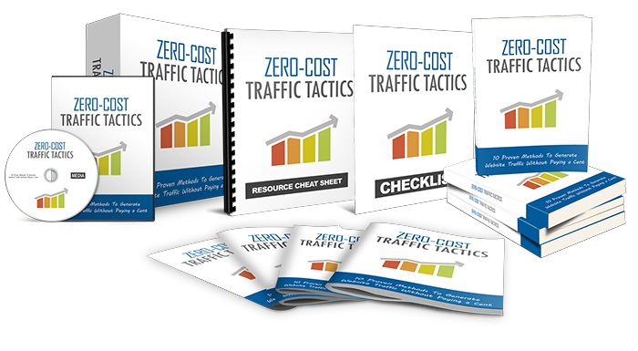
Find Out The Exact Steps And Techniques!


>> Click Here To Get Your Copy <<

