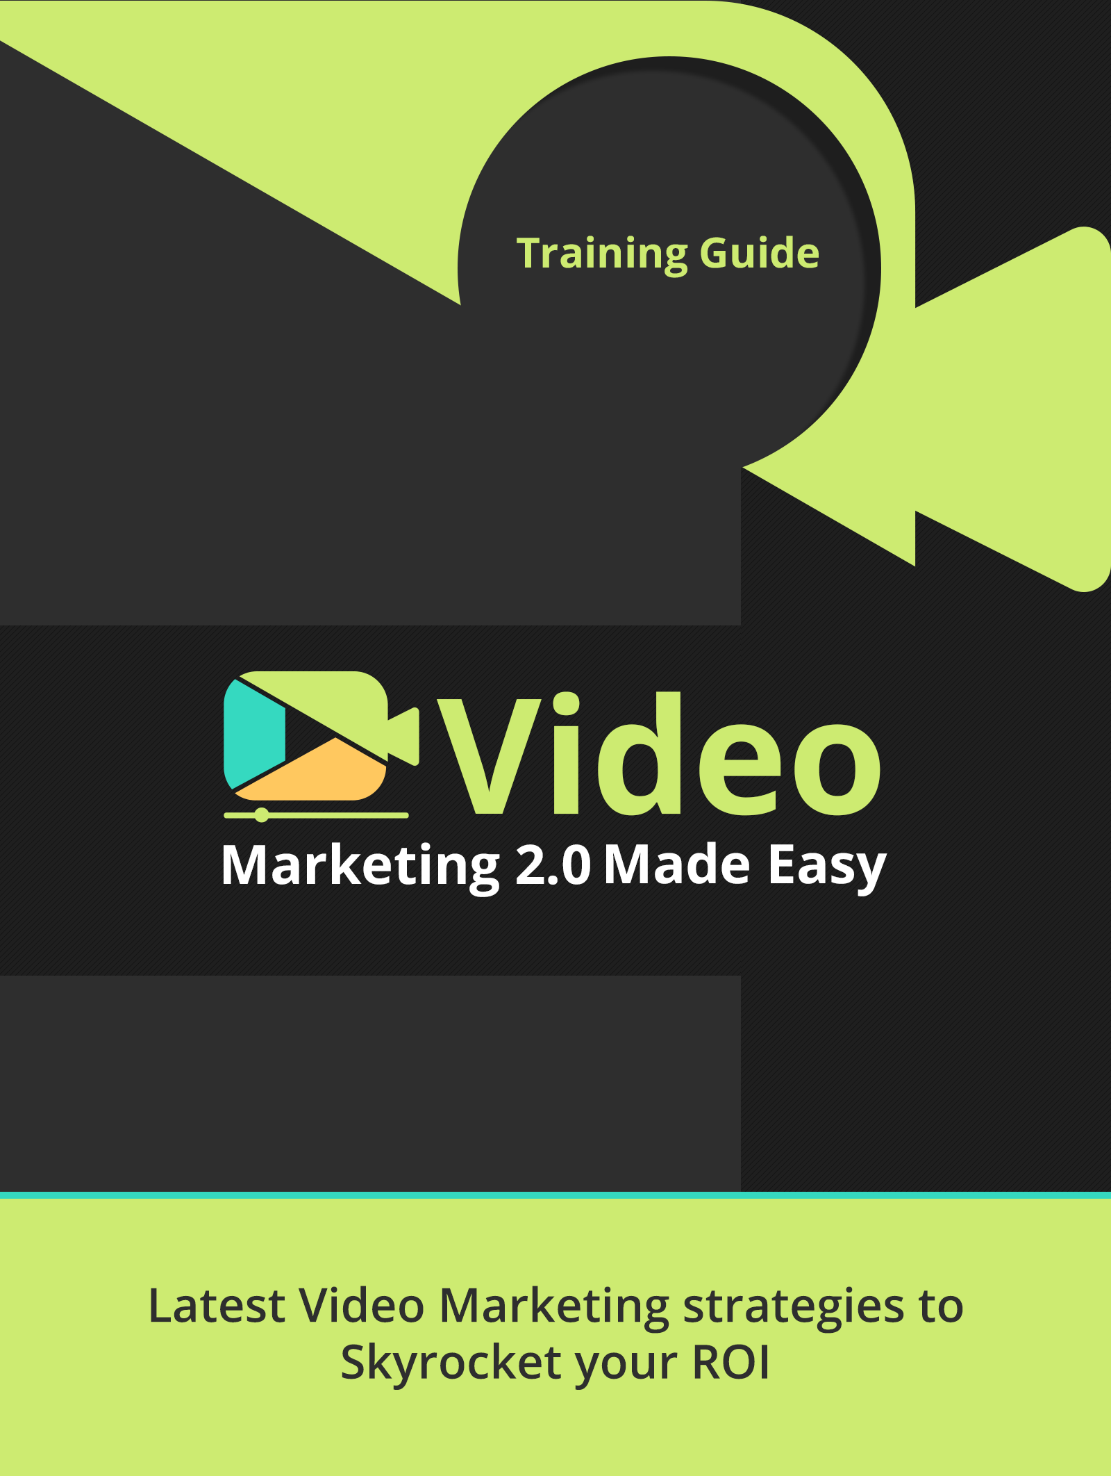

Powered by Your Website URL

Disclaimer:

This work may not be copied, sold, used as content in any manner or your name put on it until you buy sufficient rights to sell it or distribute it as your own from us and the authorized reseller/distributer.

Every effort has been made to be accurate in this publication. The publisher does not assume any responsibility for errors, omissions or contrary interpretation. We do our best to provide the best information on the subject, but just reading it does not guarantee success. You will need to apply every step of the process in order to get the results you are looking for.

This publication is not intended for use as a source of any legal, medical or accounting advice. The information contained in this guide may be subject to laws in the United States and other jurisdictions. We suggest carefully reading the necessary terms of the services/products used before applying it to any activity which is, or may be, regulated. We do not assume any responsibility for what you choose to do with this information. Use your own judgment.

Any perceived slight of specific people or organizations, and any resemblance to characters living, dead or otherwise, real or fictitious, is purely unintentional.

Some examples of past results are used in this publication; they are intended to be for example purposes only and do not guarantee you will get the same results. Your results may differ from ours. Your results from the use of this information will depend on you, your skills and effort, and other different unpredictable factors.

It is important for you to clearly understand that all marketing activities carry the possibility of loss of investment for testing purposes. Use this information wisely and at your own risk.

Limited Special Offer for You:
Video Marketing Made Easy
(Video Training)
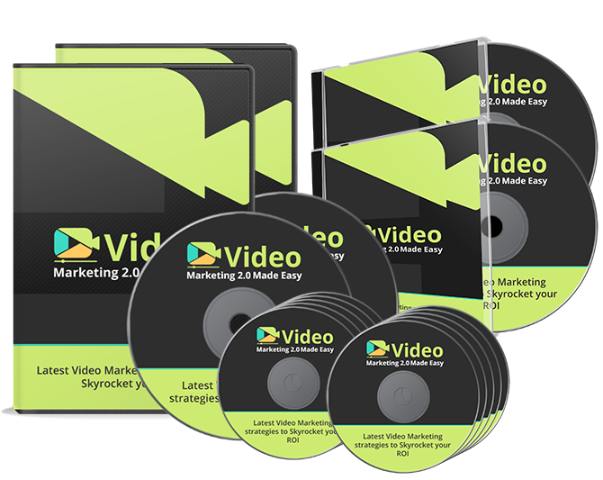

Click Here to Download Your Video Training!
(Insert your Upsell Offer URL)

Table of Contents
Introduction | 04
Chapter I: What Video Marketing is all about | 06
Chapter II: Why you should definitely use Video for your business today | 11
Chapter III: How your business can get the most out of Video. | 16
Researching for a hot topic | 16
Creating you video the right way | 26
Publishing your video on the right places | 28
Advertising your video effectively | 32
Paid Facebook Video Advertising – Step by Step | 38
Paid YouTube Video Advertising – Step by Step | 42
YouTube/Google Video SEO Ranking – Step by Step | 44
Chapter IV: Top Video Marketing Automation Tools & Services | 49
Chapter V: 10 do’s you have to apply | 59
Chapter VI: 10 don’ts you have to avoid | 63
Chapter VII: Shocking Video Marketing Case Studies | 67
Chapter VIII: How to make tons of money with Video Marketing as an Online Marketer | 77
Conclusion | 82
Top Video Marketing Resources | 83
Limited Special Offer (for the next 7 days only) | 84

Introduction:

Welcome to the latest and very easy to apply Video Marketing Training, designed to take you by the hand and walk you through the process of getting the most out of Video Marketing.
I’m so excited to have you here, and I know this will be very helpful for you.
This exclusive training will take you by the hand and show you step-by-step, topic by topic, and tool by tool, what you really need to know in order to dominate Video Marketing the easiest way possible, using the most effective tools and in the shortest time ever.
This is exactly what you are going to learn:
In Chapter I, you will learn what Video Marketing is all about. We will give you the easiest definition for it, as well as cover very important factors so you can have a simple, but accurate and complete understanding of Video Marketing, before you start working on it.
In Chapter II, you will learn why you should definitely use Video Marketing for your Business today. You will learn about some of its amazing benefits, as well as several shocking facts that will make you decide to start getting into it right away.
In Chapter III, you will learn how your business can get the most out of Video. We will cover topics like: Researching for a hot topic, Creating your video the right way, Publishing your video on the right places, Advertising your video effectively, Paid Facebook Video Advertising – Step by Step, Paid YouTube Video Advertising – Step by Step and YouTube/Google Video SEO Ranking – Step by Step
In Chapter IV, you will learn The Top Video Marketing Automation Tools & Services that you can use for your business. These are several tools dedicated to giving you highly useful services for Video Marketing, so you can get the most out of it.
In Chapter V, you will learn the 10 do’s you have to apply for Successful Video Marketing. These are specific things you should remember to use or practice, so you can succeed.
In Chapter VI, you will learn the 10 don’ts you have to avoid for Successful Video Marketing. If you ignore these, be prepared to be disappointed.
In Chapter VII, you will get the chance to look at several shocking Video Marketing Case Studies. These are actual examples we have taken from the internet to show you how Video Marketing actually works for other businesses, so that you can have complete confidence in your ability to achieve your own business success story.
In Chapter VIII, you will learn how to make tons of money with Video Marketing as an online marketer. Strategies that you can apply and definitely see great results. These strategies have been used by experienced online marketers obtaining awesome results.
Well, it’s time to dominate Video Marketing, fellows. I know you will love this training.
To Your Success,
Your Name

Chapter I: What Video Marketing is all about

- Definition
Video marketing refers to incorporating videos into your marketing campaigns so you can promote your company, product or service.
A business using this type of internet advertisement creates short videos about specific topics they want to promote, using content from its own articles and other text sources.
Then, these videos are uploaded to various video sharing websites.
- How it Works
You can’t just create a video and send it to YouTube and hope for the best. You must have an action plan, and an action plan has steps to follow, very important steps that you can’t miss.
There are 4 basics steps you should follow to make video marketing work for you: Research, Create, Publish, and Advertise.
Research
Your video must have a well-defined message. Think about the needs of your audience, things they spend time on, etc. One idea is to pick a topic that has done well in a different content format and turn it into a video.
Create
After you have chosen the appropriate content, turn its main ideas into a script, and practice reading it out loud. As you read, look for places that do not sound right coming out of your mouth and change them to sound more conversational.
Use a webcam, iPhone, or whatever tools you have at hand for recording yourself reading the script. The most important thing here is having quality content.
Publish
Upload your video to as many video sharing sites as possible, and embed it to your website or blog. You should also share the link on as many social networks as possible.
Advertise
There are different ways to advertise your video. It is strongly recommended to use Social Media to reach the target audience you want. You can make use of PPC (Pay Per Click) with YouTube and Facebook. Also, it is an excellent idea to use SEO, with Google and YouTube.
- What elements do you need?
There are many tools available to you when doing your research. You can use the Google Keyword Tool. It is a great instrument when it comes to finding search words that are in use and for new keyword suggestions.
Also, there is Google Trends, which can help you learn the most popular words or expressions recently searched. It shows how often a particular expression is being searched across different parts of the world, and in various languages.
There are online tools providing video creation services, such as Flixpress, PowToon, GoAnimate, or you can use offline tools, such as Camtasia, Explaindio, and VideoMakerFX.
For publishing your video, you can make use of some important Video Sharing Sites, such as YouTube, Vimeo, Yahoo, or social sites. These currently allow Video Publishing, or use Facebook, Twitter, Google Plus, etc.
For advertising your video, you can go for PPC networks, such as Facebook Video Advertising or YouTube Video Advertising. You can even learn how to place YouTube Videos in the top of Google Search, or even look for services that can do it for you
- What Types of Video for Marketing Purpose are there?
There are various video styles based on your specific business objectives, choose the one you like best.
Talking Head Video
This is what most people think of when they think video. Basic “head and shoulders,” direct to the camera, standard shot. The talking head video is popular because it works.
Interview Video
Besides you talking, you can add another person to the mix and make it an interview video. Interview videos can be two or more people on camera. Interview videos can be easily created using Skype, Google Hangouts or Oovoo.com.
Live Webcast Video
This provides the ability to interact with your viewers live. If you have a webcam and an idea, you can produce a live webcast, anytime, anywhere.
PowerPoint Video
Because of its simplicity, the narrated PowerPoint video is a very popular format. You can use PowerPoint or Keynote for Mac.
Tips Series Video
If you want to establish a presence on YouTube, a tips series is ideal for you. Also, video tips help to establish you as an expert in your niche and build your credibility.
Live Demo Video (on-camera)
On camera demonstrations are among the most effective videos you can produce. It can be as simple as teaching live to the camera. You can use resources to help you teach your point, like a whiteboard for example.
Sales Video
This kind of video consists of a PowerPoint with a voice over or simply text and narration.

Launch Series Video
These videos usually come before a sales video in a launch sequence of three or four videos. The idea is to provide value and establish credibility before releasing the final “pitch” video at the end of the series.
Customer Testimonial Video
Testimonial videos are powerful. You can promote a specific product or service by embedding these on your website or on a sales page.
Teaching/Webinar Video
You can use a recorded webinar, using Camtasia or any other software of your preference, as a video for sales or distribution. You can post the video webinar on YouTube, or on your own website.
Animated Video
Video creation sites like XtraNormal.com and GoAnimate.com have opened up new possibilities for creating your own cartoons.
Video E-mail
It is a great way to connect and engage with your customers, colleagues or prospects. It can be made by simply using your webcam. It is incredibly easy to record and send a video email. There are free websites providing this service, such as MailVu.com or Eyejot.com. Video email provides a powerful, personal touch that makes you stand out.

Chapter II: Why you should definitely use Video Marketing for your Business today
The number of Internet businesses is growing and so is the list of competitors, so why would consumers choose your business through the Internet? Could video make the difference for increasing your sales?
Here, I will give you at least 10 reasons why you should use video for your business.
Make yourself known
Today, it is estimated that over 40% of Internet traffic is devoted to videos, so you must aim to advertise your business through video.
The easiest way to make yourself known is through videos or images, because these draw the attention of viewers. Not doing so may be the cause for being dismissed, no matter how good your product is.
It is more likely that a person will watch a video than read a page
It is simple. By using a video, you can quickly capture the attention of people. Because of its practicality, more people prefer it for learning more about your offer than reading all your content.
Presentations are effective
People can learn faster about a product through a video than by any other means.
An example of this would be when someone wants to know what a certain movie is about. By watching its trailer, they get the information they want and are left with a desire to watch the whole movie.
In business, videos work the same way. Watching a video is much faster than reading all the content.
It builds confidence
Internet commerce is increasing all the time. More people are looking for someone to trust when it comes to spending their money, and videos can generate that kind of trust.
It is easier to show people your team-work, your facilities or your products, through a video than through text.
Besides, you can interact with your customers through videos, and this could be the key to keeping them away from your competitors. You can include testimonials from customers in your videos which greatly increases a customer’s trust in you.
Make a difference
On the web, you will find many competitors, and in many cases selling the same product. The main difference resides in how you promote yours. Using a video is the best way of doing it.
In addition, you can use social networks to reach more people. The results will come from the effectiveness of your method. A great way to make a difference in the internet market is through videos.
It generates traffic
It is very easy to share the content of a video on the internet. When a video depicts a common interest, you are going to have free publicity.
Moreover, you can measure that traffic and see if your product is of interest to people.
Sell ​​more
The increase in traffic you can experience will have a direct impact on sales. Even if the video reaches just a few people, it has a higher chance to convert into a sale. Especially if the visual content is good and entices customers.
At the end of each video, you could include a banner aimed for that person who has devoted his time to watch your video, prompting them to leave their personal information to become part of your list.
Free advertising
While this might have some conditions, in many cases this could be one of the best advantages.
There are sites, such as YouTube, where you can create sales channels in which you can include your videos. However, if you want to have more chances of being seen, you have to invest a little, but overall this is an open option.

Reach a specific target audience
Imagine this, you are worried about a replacement for your washing machine and you do not know who sells them. Then, all of a sudden a TV commercial comes on talking about the importance of saving energy. That's not the right video for solving your specific need at that time.
However, when it comes to the internet, if you want to find a video about a specific topic, you are 100% sure that you will find what you are looking for.
For that reason, video marketing is a very easy way to reach those people who are interested in the product you are offering.
This method allows you to interact with your customers in a way for them to see you as an expert, which mean you can build a deep trust.
Your videos can be as interactive as your imagination
Through images, sounds and movements, you can evoke many emotions in your audience. It is advisable that your videos be short and have good content, but there are not set duration limits for videos.
Keep in mind that you can work from home and use inexpensive or free tools.
Shocking Facts
- Videos increase people’s understanding of your product or service by 74%. (Source)
- YouTube alone has more than 4 billion views per day, and it’s the second-largest search engine. (Source)
- A third of all online activity is spent watching video. (Source)
- The average internet user is exposed to an average of 32.2 videos in a month. (Source)
- Every day 100 million internet users watch an online video. (Source)
- 50% of users watch business related videos on YouTube once a week. (Source)
- 75% of users visit the marketer’s website after viewing a video. (Source)
- 75% of executives watch work-related videos on business websites at least once a week. (Source)
- An average viewer spends 16 minutes 49 seconds watching online video ads every month. (Source)
- 80% of internet users remember the video ads they watch online. (Source)
- 26% of internet users look for more information after viewing a video ad. (Source)
- 22% of internet users visit the website named in a video ad they viewed. (Source)
- After viewing a video ad, 12% of viewers purchase the specific product featured in the ad. (Source)
- Web site visitors are 64% more likely to buy a product from an online retail site after watching a video. (Source)
- Click-through rates increase 2-3 times when marketers include a video in an e-mail. (Source)
- Subscribers to lead conversation rates increase 51% when video is included in an e-mail marketing campaign. (Source)
- 80% of your online visitors will watch a video, while only 20% will actually read content in its entirety. (Source)
- Your website is 53 times more likely to appear on the first page of a search engine results page if it includes video. (Source)
- In 30 days, more video content is uploaded than all three major U.S. TV Networks combined have created in 30 years. (Source)
- 90% of users say that seeing a video about a product is helpful in the decision process. (Source)

Chapter III: How your business can get the most out of Video.
Video is just amazing. It has become the most effective way to convert visitors into sales. It has been proven that people buy a lot more, thanks to video.
There are 4 principal phases you must cover in order to get the most out of Video Marketing. Those phases are Research, Create, Publish and Advertise.
In order for you to get the most out of Video Marketing, here is what we are going to show you in videos 4 through 10:
- Researching for a hot topic.
- Creating your video, the right way.
- Publishing your video in the right places.
- Advertising your video effectively.
- Paid Facebook Video Advertising – Step by Step.
- Paid YouTube Video Advertising – Step by Step.
- YouTube/Google Video SEO Ranking – Step by Step.
Researching for a Hot Topic
Currently, one of the best and most wonderful ways to positively promote your company, your products, and save large investment costs that are not always effective and successful in the market, is by creating and posting videos on different platforms to target potential customers.
Previously, we expected a certain amount of customers to buy the product; making this very expensive and impractical, because not everybody is really interested in your product, only a select group of people.
Today, we select our ideal client because we choose the type of people to whom we want to have access through paid advertising. It can be defined by sex, age, country, socio-economic status, culture, marital status, if they have children, etc.
It is important, before creating your video, to locate those that are eager to learn about your business. We accomplish this through what is called Hot Topic Research.
The Internet makes it very easy to find specific tools to help you create your video, and to know how well they perform.
Social Networks and Keyword Tools are among the most commonly used tools.
Social Networks
Among the most used are Facebook, Twitter, LinkedIn and Pinterest.
What you will be looking for in social networks is the highest social activity possible on any topic of your choice.
The way to go with Facebook is as follows:
On Facebook.com you can perform a normal search in the search bar on any topic you choose.
You will then see several results related to your search. Look for any item that has as many social activities as possible.
There are several more places you can check.
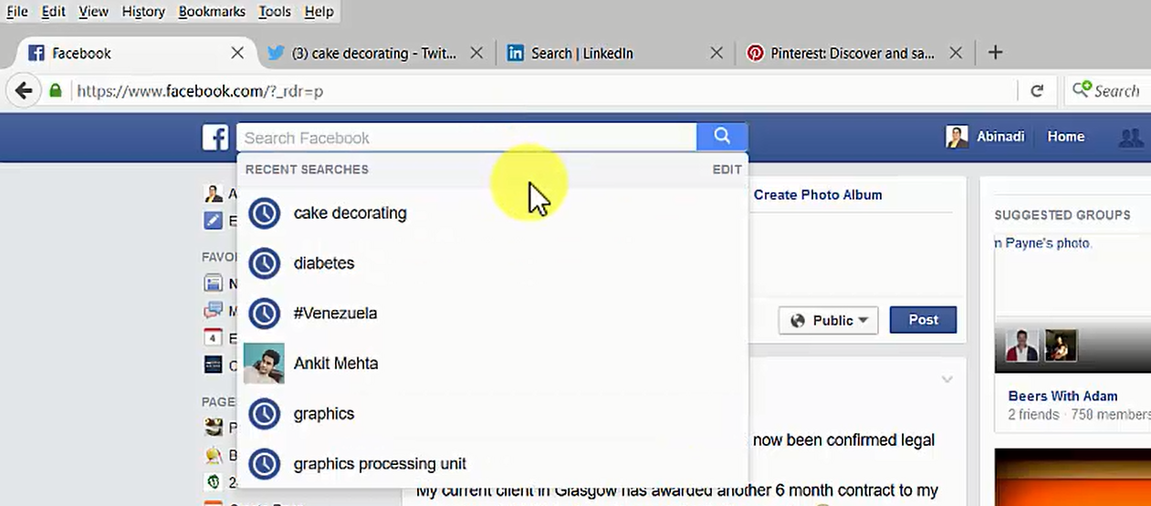
In the Photos section, you will find awesome topic related images. You can see their social interaction and take notes on the images that have the most likes and shares.
You can even click on the image and read what people are talking about in regards to the picture. While reading their posts, you may find a lot of ideas for your own purposes. I can assure you, a lot of great ideas will come to mind, just take note of them.
You can do the same in the videos section. Pick any video and take a look at its social activity. You can even chat with the people there, to get a lot more ideas.
There is also an option to take a look at pages. There you can go on to the page and check out the posts to find the one with the most social activity. Remember, the more social activity, the hotter the topic is on social networks.
Groups are an awesome resource, as well. You can directly interact with people highly interested in your topic, which is just incredible.
You can do the exact same thing with Twitter.com. You can perform the exact same search, and also look over the several options twitter gives you.
Here, you can also see photos. You can check on tweets, and even on videos.
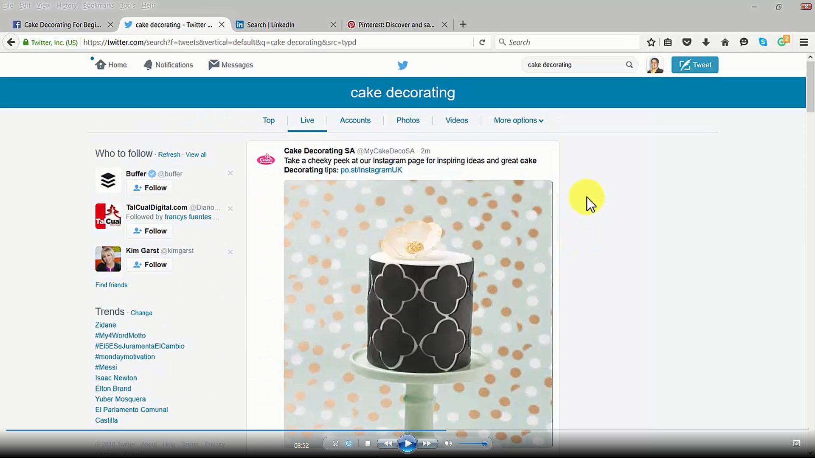
LinkedIn.com also gives you the same search functions. There, you have several results also directly related to the topic of your choice. The posts section is a very helpful one.
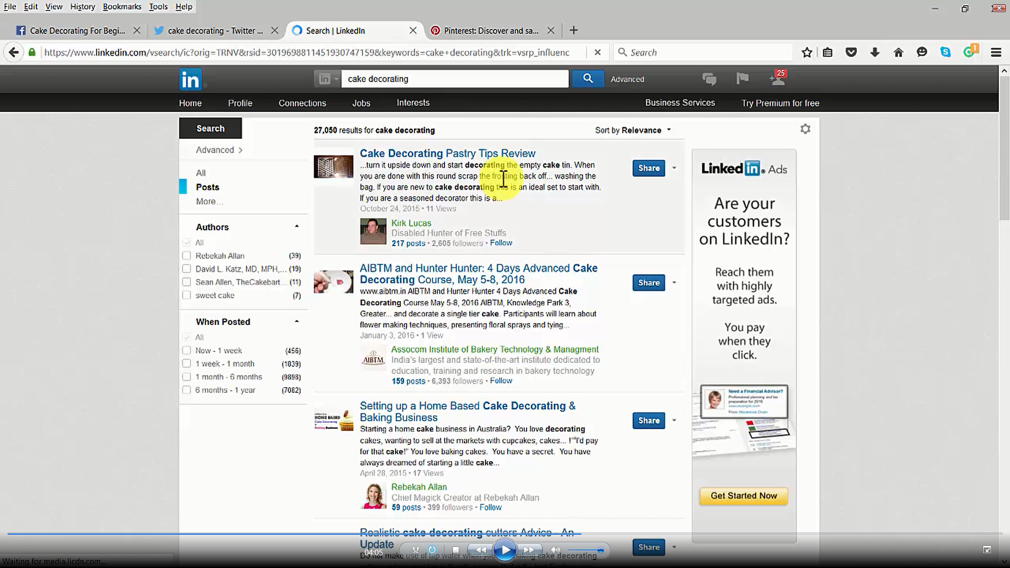
With Pinterest.com, you will find a lot of social interaction, too. You just need to take a look at the images and see their social interaction, which will tell you how hot your topic is on Pinterest.
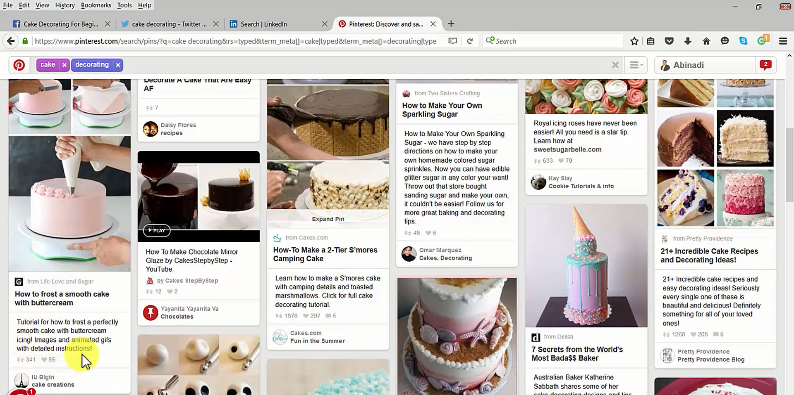
Keyword Tools
The most popular tools are Google Keyword Planner, SEMRush, and Google Trends
The Google Keyword Planner is a free Google AdWords Keyword Tool owned by Google, where you can search for new keywords or ad group ideas. However, the most powerful function it has is its ability to give you performance insights for each and every keyword people have used to search using Google.com
With this tool you are able to search for new keywords using a phrase, website or category.
You can also decide the Country, Language, keyword filters and pick among several keyword options. For instance, “Only show ideas closely related to my search terms” is a very used one.
Then, you will see a list of topics known as “keyword ideas”, where you'll find some extremely important data that will tell you how hot every one of those topics are.
You'll find data like Average Monthly Searches, Google AdWords Competition and Cost Per Click, for people advertising on Google AdWords using those keywords. The higher the numbers, the hotter the topic is for that particular keyword idea.
SEMrush is a keyword and competitor analysis tool which has grown into the world's leading competitive research service for online marketing. With 29 databases available for 27 regions and in 17 languages, SEMrush aims to share its expertise and experience with SEO, PPC and marketing specialists all around the globe.
This is another great tool where you can enter a keyword, click on search, and see important data similar to the Google Keyword Planner, but it's a lot faster and has a lot more options.
You can look at the “Phrase Match Keywords Full Report” and get a lot more to consider. Of course, you will need to pay for that speed and flexibility.
Google Trends is a public web tool owned by Google, based on Google Search. It shows how often a particular search-term is entered relative to the total search-volume across various regions of the world, and in various languages.
With it, you can also type the topic of your choice and you will see more data, but with different points of view and other similar ideas you might be interested in to use for your business.
You can look at your topic by “Regional Interest”, as well as by “Related Searches”
Under the “Regional Interest” area, you can go even deeper by taking a look at the cities inside each country. Under “Related Searches”, you will be able to see more related topics inside each listing.
The internet can help you significantly pick a really hot topic to position your business on the web with the help of video.
Creating your video, the right way
Once you have identified the hot online topic which you want to use to bring potential clients into your business, it’s time to start creating your video.
First of all, you must plan the content you want to deliver to your potential clients, so you can create your video.
Here are some examples of video content that successful companies have used to promote their businesses through video.
#1. Creation or development of something
A restaurant could generate a video of how to prepare a certain dish, an insurance company could provide a video of how to react to a car accident, a clothing store would make a video explaining how to combine different styles of clothing.
If your company sells third party products, you may produce a video which would be complementary to the product you are promoting.

#2. Promotions-Advertisements- Events
Each time a new product of your company is going to be launched, you can make a promotional video to attract the attention of customers. Thus, you can meet their needs before and after launching the product.
#3. Interviews with the staff of the Company
This is a means used by various businesses. Who else would better know the business?
Employees can express their expertise in front of the cameras, the day-to-day events, production processes, and any other aspect related to the business.
#4. Testimonials of prospects
Do not let go of a customer without letting him know, through a survey, about your product. If you can, record their testimony. With their testimonies, they can contribute to the selling of your products.
#5. Give a tour of your business
Hotels, restaurants, amusement parks, clothing stores, recording and photography studios, and almost any other business can effectively achieve success by providing a tour of the company facilities.
#6. Useful Tips
You can create videos in which you share some practical advice. If you have a bakery, you can advise about types of bread and which one would be better in accompanying a certain meal.
Let’s proceed to creating our video. For that, I'm going to show you a tool that will surely help you in the creation process. That service is called Animoto.com
Animoto.com
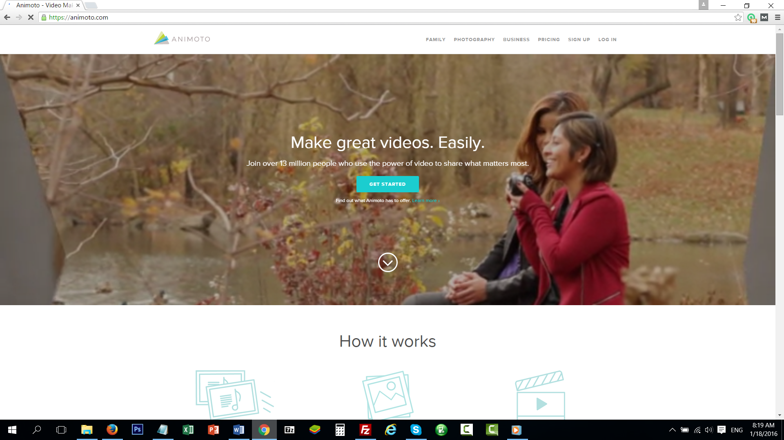
Millions of people agree that video is the best way to preserve those important moments of our life. With just a few simple steps, you can now immortalize them, and share them in a fun, simple and very professional way.
If you love those family moments such as birthdays, weddings or other events, Animoto will make your family gatherings much more fun.
For professional photographers, Animoto is a must have tool. If you want to provide your clients with excellent work, sign up and give your customers the quality they deserve.
Animoto is the most used tool throughout the business world. More than 50,000 companies constantly use Animoto to create their marketing videos. More than 14 million videos have been created with Animoto.

Success Stories
Museware Pottery
Gift shop owners love video, especially when a picture of their store and display is included. That personal touch makes a huge difference.
They are now using their Animoto videos to expand their business by selling directly to consumers online.
Stealth Marketing
Using the client's existing photos and video clips, Stealth was able to create a polished video in minutes.
Boosted by the success of that video, the client asked the Stealth team to create more videos to help their yacht listings stand out from the online competitors and boost the company's SEO.
Vail Marriott Mountain Resort
Making videos that showcase everything the resort has to offer year-round, means they can easily make a variety of videos to suit the client.
Hawaii Life Real-Estate Brokers
Making a high-quality video tour in minutes, with music and themes to create a "mood", helps bring each listing to life. Prospective buyers often watch the videos several times when making a decision to buy a house.
Features
You will have access to several video styles with unique filters, transitions and more, to display your brand.
Also, Animoto has more than 1,000 licensed music tracks.
You can use one of its customizable video styles and choose background colors and fonts to suit your brand's image.
Some additional features are:
- Unlimited use for creating high-quality videos.
- Add your company logo to the start or end of your video.
- Download your videos for offline viewing or burning to DVD
- Animoto makes it easy to share your creations over email, social networks, your website, and more.
- At the end of your video, you can direct your viewers to your website.
- Animoto hosts your videos in the cloud for easy viewing by you and your customers.
Pricing
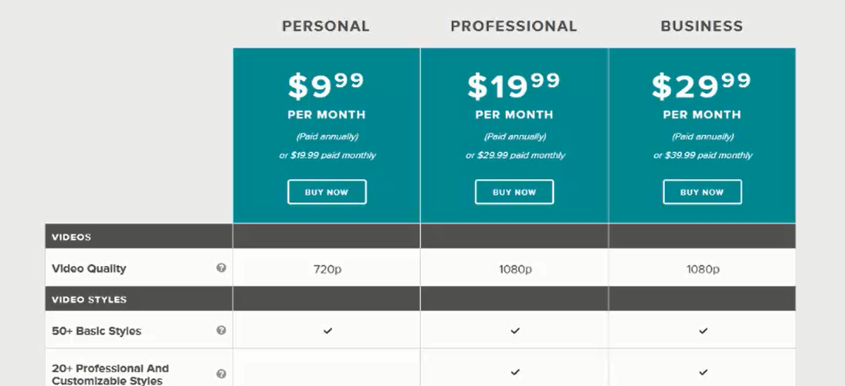
Animoto’s plans are: Personal for $9.99 per month, Professional for $19.99 per month, and Business for $29.99 per month, in which you will find many features that will be of great help.
Registration is very straightforward. As required information, you will be asked for your e-mail, full name, a password, and what kind of video you want to create.
Once registered, you can start creating your presentation.
As a first step, choose the style you want. You can select from a wide range of categories: popular, kids, school, party, wedding, travel, holiday, memorial, and all. In turn, these categories have subcategories.
Once you have selected your favorite category, you can proceed to creating your video.
Choose the song that suits your presentation. There is a great variety of music. Select the one you like, and it will be set as your presentation background song.
With Animoto, you can use pictures and videos from your favorite social network, or upload them from your computer.
After that, select “Add text” to create templates and define the trend of your video. Bear in mind that the purpose of the video is to get your message to your viewers.
Remember to let your viewers know about your website. When you are finished, click on “Preview Video” so you can watch your creation.
Then, select “Produce” to create the video. Provide your work with a title, date, producer name, description, and select the video quality.

Publishing your video in the right places
Now that your video is already created, we can now publish it for sharing it with the world. For that, you need to get to know the most popular Video Sharing sites on the internet.
YouTube.com
YouTube.com is a website where users can upload and share videos for free, and view them simultaneously. It provides an opportunity for doing business because it has a powerful reach worldwide. It is a big center of focus, and thus, it can help you to build your brand.
Vimeo.com
Vimeo.com is a basic free social network based on high-quality video playback with a professional touch. It was created by a group of filmmakers and offers the user a range of possibilities to become known. This tool also has paid plans: plus, and pro.
Dailymotion.com
Dailymotion.com is a website dedicated to viewing video. Users can upload, view, and share great quality videos.
If you are someone who wants to see a high-quality video that is less than 20 minutes in length, this is the right site for you. You can post videos in Dailymotion and earn money with your postings.
Phanfare.com
Phanfare.com was created in 2004, and its main function is to offer its subscribers the best experience in sharing their photos and videos.
It provides a place to improve and organize those photos and videos into albums that will appear immediately online. It can include full-size slideshow presentations with music.
Metacafe.com
Metacafe.com is a website dedicated to video-addicts, i.e. people devoted to constantly uploading videos.
This site is very versatile because it has Community Rank Services, which means that the most watched videos are identified. You can gain money here by uploading your creations.
Veoh.com
Veoh.com is a website where you can watch videos in their original format. It looks more like an online TV, having its own videos and music catalog.
It differs from others sites in its large restrictions as far as copyright is concerned. All your videos must be under 20 minutes.
Break.com
Break.com was founded in 1998. Its main feature is that it displays humor-related videos.
Because of its policies, all people who access this site can rate videos and have fun in various ways. That’s why it is the most visited page with audiences from 19 to 35 years.

UStream.tv
It is an online platform whose main function is to broadcast live events without the need of installing any special software. Anyone that is registered can broadcast right from their mobile device. These services may be free or paid.
Facebook.com
Presently, it is the most popular social network. It offers its fans the opportunity to watch very good quality videos. Every day, more users enjoy interaction with the site, thus sharing not only photos but also videos of their own.
Twitter.com
When Twitter started, it was a social network characterized by uploading information almost every minute, with only 142 characters. It has been emerging to become one of the most commonly used apps. Today, you can include videos in MP4 and H264 format, with AAC audio, by using the same button that was previously only used for photographs.
Before uploading videos to any site, we advise that you research videos related to your topic inside the video sharing site that you plan to upload your videos to. That way, you can make sure your videos will get approved, and also so that people might be able to find them by searching for them using keywords.
One of the most important places where you will want to upload your videos to is YouTube.com of course.
Once you are logged in to YouTube.com, you will want to upload your videos into the right channel, so it’s important that you create a channel for your business.
To do so, you will need to click on the account icon located in the top right corner. Then click on the YouTube Settings icon.
Under the Additional features section, click on “See all my channels or create a new one”.
You will see listed all the YouTube Channels you have created under your Google Account, and also the ability to create a new Channel.
You will then be able to name your new channel as well as select a category.
Your new channel will also come with a new Google+ Page.
Check on the “I agree to the Pages Terms” and click on “Done”.
The option of selecting which channel you would like to view YouTube with might come up, as well.
You will then make sure the correct channel is selected, so you don’t upload your business videos into the wrong YouTube Channel.
To make it more professional, add channel art as well as a channel icon.
When you click on “Add Channel art”, you can upload artwork, select from your uploaded photos or use the YouTube Gallery.
The recommended channel art size is 2560 x 1440 and it should be no more than 4MB.
For adding the channel icon, you will be redirected to the Google+ Page connected to that YouTube Channel. You can upload an image, use one from your albums, use one from photos of you or even take a picture with your web camera at that time.
Back at the YouTube Channel, select the Videos tab and see that there are no videos, because this is a new YouTube Channel.
Then, click on Upload. Look for your video and start uploading it.
While uploading your video you can add things like a Title, description, which would be a great place to insert your Business Website URL, and also add some tags. For this, you can get some help from keywords tools like Google Keyword Planner, Semrush.com or even Google Trends.
Once your video is done uploading, you can then share it with the world by using the social icons provided.
You can also embed your video and share it by email.
Now, go to the video manager, which is where you can edit your video.
You will see a list of nice things you can to with your videos. Also, if you click on the edit button, you will be able to see even more editing options.
You can edit basic info and set up some advanced settings. YouTube is really awesome. You just need to upload your video and see everything you are able to do with it.
Finally, by clicking on the title of the video, you can watch it and see how the world will see it once it is shared everywhere.
Advertising your video effectively
Advertising a video over the web is something very similar to advertising any website, blog or anything.
Your video will be located at a specific URL that you can promote as much as you can by using as many different advertising models as possible, both free and paid.
Also, there are some other great ways to promote videos besides the regular online advertising channels.
We suggest you use specific techniques to advertise videos, and many of the regular online advertising services offer these services.
Facebook.com
There are 2 ways to Promote your videos on Facebook, the freeway and the paid way.
The freeway is really easy, you can just upload your video to Facebook, or take the URL of your video and share that with as many people as possible on Facebook.
You could share your video on your wall, so your friends can watch it. You could also invite your friends to like, comment and share your video with their friends.
You could even share your video on Facebook Pages or Facebook Groups and many more.
The paid way is by using the Facebook Advertising Platform. You pay Facebook so as many people as possible can see your video.
With the Paid Facebook advertising experience, you get to decide what age, gender, country, city, etc., can watch your video.

YouTube.com
You could also advertise your YouTube Videos for free by using YouTube itself. You could share your video to all of your YouTube subscribers so they can see it. You can invite them to share your video with their contacts.
Also, you could optimize your video with some highly effective SEO techniques, so your videos gain top ranking on YouTube, Google and other search engines. This can definitely bring you free traffic.
Additionally, YouTube offers a Paid Advertising Platform, which works inside Google AdWords, so you can speed up YouTube video advertising activity significantly.
You can also take a look at some Video Ad Networks that can help you accelerate your video advertising:
- Brightroll.com
- Yume.com
- Hulu.com
- Tubemogul.com
- Auditude
- Advertising.aol.com
- Tremorvideo.com
- Advertising.com
You can also take a look at some low cost or even free video advertising alternatives like:
- Ytmonster.net
- Growviews.com
- Kingdomlikes.com
- View2.be
- Vidiq.com
Promoting your videos effectively through all these resources, as well as through media such as radio, TV, websites, forums, newsletters, social networking platforms, or even if you link your video to as many websites, blogs and magazines as possible, etc., is not enough.
Here are some more ideas that will have a direct influence on the promotion of your videos, catching the attention of your clients and helping to keep them with you at all times.
Titles and Attractive names
If you want to grab the interest of the customer and make them watch your content, you have to catch them with a good title.
Remember, that you have only one opportunity to capture the customer's attention, and that's very important. Usually, if a human is not interested in what he sees in the first 10 seconds, he will close the video and do something else.
People may not watch it because it doesn't look good, striking, interesting or they simply think it is not what they are looking for.
Invite action in the title
Apart from music videos and adorable pets, much of the content on YouTube is pursuing something practical: "Repairing ...", "How to cook ...", "Tutorial on ...".
It is always important to include the action terms relating to why you created your video in both the title and description.
Apart from being more attractive and convenient for the user, search engines better understand what you are offering.
Diffusion
You should allow embedding of your video on external websites to give all possible diffusion through groups and communities.
Do not forget to share your video periodically to maintain some activity around your video.
The health of your company, your channel and your websites will depend largely on how regularly you post videos.
As always, consistency is an unavoidable factor if we want to gain some relevance and authority in any social network.
Production Quality
Something important is to make the video look good in terms of lighting and make sure the sound is decent, as well. It is recommended to spend some time editing the recorded material to make it as pleasant, direct and beneficial as possible.
Bear in mind that the viewer will not spend too much time watching your video, so go straight to the content, which is what they are looking for.
It can be useful to add some music to make your content more fun, especially for long pieces. It will break up the monotony.
Record using the highest quality possible and select the largest format size that your equipment allows. All online video platforms accept content in HD (1920 × 1080 or 1280 × 720).
Watch your audience
You have good content, you've done your homework regarding the production and dissemination, the results start coming, and you get your first comment on your video. Now, you cannot fail your audience.
Thank the commenter, create conversation and debate. It is quite likely that valuable feedback information will help you generate good content in the future.
Don’t miss the opportunity to respond to comments with new videos. It is a very effective way of retaining your subscribers.
The biggest compromise is making your audience feel comfortable with the work, so that they can be interested in the projects to follow.
Optimize long content
This is one of the most important things that must be done if you're offering considerable lengths of content. Do not be shocked or surprised if your video does not accumulate many shares if it exceeds 10 or 15 minutes.
The impatience of the viewer is well known. Even if it is a subject that arouses interest, it is recommended that you reduce the promotional pieces, which act as bait or a hook.
Above all, make an effort to summarize the content of longer videos. This will create great expectations, give more movement to your business, and more movement to your channel and websites.
Also, try to divide a long piece into several shorter pieces, progressively linking them, to keep the continuity of the information you want to provide.
Paid Facebook Video Advertising – Step by Step
Facebook.com is known as the greatest Social Media Site ever. It dominates Social Media with its presence. Hence, Facebook.com is considered to be one of the most powerful online advertising power tools.
Facebook has created an absolutely amazing advertising platform specially design for businesses, where you can also access their Paid Video Advertising service, with which you can do wonders on behalf of your business.
You can access it by going to www.facebook.com/business
With the Facebook Advertising platform, you will be able to meet people who’ll love your business. Being able to reach that kind of audience will surely take your business to the next level a lot quicker than any other advertising strategy.
Facebook helps you drive online sales, increasing local sales, promote your app and raise your brand awareness immensely.
You know your business better than anyone else. Facebook knows a lot of people, and it will also know the people you need that are looking to acquire your products and services. That’s why you and Facebook are the perfect companions to take your business to areal path of success.
Facebook won’t only show you where and how to spend your money wisely for your business, it will also show you how other businesses have gotten highly productive results by using its flexible and highly profitable advertising tools.
Facebook is an active Business, constantly making changes and improving, looking to give you the greatest and easiest to use advertising tools which are constantly being tested to achieve the best possible results for your company.
Facebook has gone farther, though. They offer additional products and services such as Instagram, Atlas and LiveRail. Facebook can really help your large, medium and small business grow.
Ok, it’s wonderful to know all the awesome things Facebook can do for you, but now, let’s have a look at its powerful advertising platform.
Direct your mouse to the upper right corner and click on "Create Ad"
You must have a Facebook account, which I’m pretty sure you already have. Enter your email and password and click on "Login".
Just wait a few seconds while Facebook loads the advertising page.
There are four principal sections you will come across while setting up your Facebook Advertising Campaign. Those sections are Campaign Objective, Ad Account, Ad set, and Ad.
As you can see, there are all kinds of highly effective advertising channels inside Facebook with the ability to boost your posts, promote your page, send people to your website, increase conversions on your website, get installs of your app, increase engagement in your app, raise attendance at your event, get people to claim your offer and get video views.
You can pick anyone that best fits your marketing needs. Our objective in this training is using the Video Advertising power that Facebook offers for your business.
You will need to have a Facebook Page already created. We advise you to create and optimize a page that is centered on the topic of your business. It's the same principle of having a YouTube Channel specifically for your business. It should be applied here, as well.
Then click on Create Ad Account.
You will now be able to enter your account info. You will need to pick your country, currency, and time zone. Then, click on Set Audience and budget.
Now, you will need to decide whom you want your ads to reach. For that, you will need to pick your location. You can decide your country or countries, as well as specific geographical areas.
You can also decide the age, gender and language of the people to whom you want to show your video ads.
One of the most important features is the ability to decide an even more detailed targeted audience, which is absolutely important. For the interests of your audience, you can choose from general to specific topics.
You can also target people interested in other business directly related to your business audience. They are also your objective audience.
You can add a connection type. Finally, for this part you can also decide how much to spend.
You will then click on Choose Ad creative.
Something very useful with Facebook is that besides advertising your video, you can also use images to create a slideshow.
You can create an ad or you could use an existing post to advertise it.
Something important to consider is the Recommended Video Specs located at the right side
To advertise a video, just click on the big "+" icon, select your video and upload it.
Once it's uploaded, this little warning here will tell you something important about your video. You better take a look at it.
Choose a preview image from the thumbnails.
If your video is not optimized to be advertised on Instagram, we advise you to remove that option.
Remember to add the text, as well as pick a call to action and also the URL to where you want to redirect people once they click on your ad.
Once you are done setting up your campaign, click on Place Order.
If you have not set up your payment method, that is what will appear next.
After you submit your Payment info, your ad will be reviewed. After it is approved, it will start running right away.
Paid YouTube Video Advertising – Step by Step
YouTube has an amazing advertising platform that will skyrocket your business success with just a few clicks. For direct access to the YouTube Advertising platform, you can go to www.youtube.com/ads.
Did you know that any video uploaded to Youtube can include advertisements? These ads appear before the video is displayed on YouTube and are used for promoting businesses, products or services to customers.
Only a few clicks are enough to grant millions of potential customers worldwide access to your video ads. This service is called Paid YouTube Video Advertising and has produced excellent results for advertisers worldwide.
What is a video ad?
A video ad is a video that promotes a product, a company or services provided by that company. The topics can vary greatly, from a handcrafted product to a major corporation. All are welcome in Youtube Video Advertising.
What is the cost?
The advertiser has full control over the cost of the video ad. You decide how much you want to invest daily, and you only start paying when your video ad starts being displayed.
If the visitor withdraws from the video before 30 seconds, you don’t pay a penny.
Who can be your target audience?
There are several options that YouTube offers to help you choose the right audience for your video ads. You can target by age, gender, location, interests and more.
All of these can help you select the right social group for which to aim your ads.
How are results measured?
Youtube has a very efficient tool called Analytics, which is integrated into its platform and is used to show the detailed performance of your video ad once it begins to be viewed by visitors.
This tool gives you the opportunity to observe at any time, in detail, how many visitors have seen your ad. Thus, determining whether it has been successful or not.
By making use of this tool, you can make improvements to your ads. Also, several ads can be displayed at a time in order to determine which one works best. It is a very important tool that can keep you informed of the efficiency of your video ad.
A very interesting offer that Youtube Advertising has is to provide you with a $100 credit for each $25 you spend on ads. This credit allows you to keep your ads running a lot more.
Your first campaign
To start your first ad campaign, click on the Get Started tab, which takes you to step 1.
It is a spreadsheet format that asks you to type the URL of the video you want to promote. You can find the video URL in the address bar of your web browser.
In step 2, write a description of your product or business and select a thumbnail image for your video ad.
In step 3, establish the currency you will use and the amount of money you will pay for your ads.
In step 4, choose a target audience.
Select the location, i.e. the countries in which you want your ad to be displayed. You can select the age, gender, and interests of your target audience. If, for example, your ad is about making chocolate cakes, you can select ‘all ages’ and ‘both sexes’.
The system then asks you whether you have had previous experiences with Youtube Advertising. Mark your experience as positive or negative.
Finally, if everything is OK, click on Create and your video ad will be all set to be viewed by millions of people worldwide.
YouTube/Google Video SEO Ranking – Step by Step
One of the strategies being massively used, because of its almost instantaneous and highly productive results, is to position YouTube videos among the top results of Google.com and YouTube.com during searches.
It is very important to consider a few things if you want your video to be positioned successfully. There are many companies that offer, to people producing videos, software that helps to effectively meet this objective.
When you become skilled in positioning videos and these, in turn, provide you with revenue, then you will decide which software to use. For now, let’s dedicate this time to learning how to produce winning videos.
Step 1: Keyword Research
To begin, you must find words that connect you with your audience. Keep in mind that your video will be available for thousands of viewers. You need to start looking for keywords that connect your video content to as many people as possible.
The main objective of your video, other than helping your target audience, is to have the power to earn money, and that money is in the pocket of your target audience. That’s why it is important to be among the first options when a user is searching Google or YouTube.
An effective keyword stems from a thorough search, using the Google Keyword Tool. There are some words that can contribute to 500 searches a month.
The more searches, the more people will see it. That way, you can reach a greater number of people, and that means a potential increase in your income.
Step 2: Optimizing your Video
When you upload your video, it will be on the web, and it is likely that the SEO will start operating as well. It is very important to ensure that you have the right keywords in the video title, description, and tags.
The description of the video is the most relevant part of the SEO. Place your link at the top, include keywords in the first 25 words, give a description of at least 250 words, and include your keyword 3-4 times.
In the Tags, your keywords must be separated by commas, otherwise, they will be counted as one unique word.
You must remember that YouTube receives over 30 million visits a day, which is why you want the SEO to consider your video.
Step 3: Spreading the Word
YouTube is unique at evaluating the percentage of visits your video has, comments made, number of subscriptions after watching it, whether your video is shared on social networks, whether your video is a favorite, and also the thumbs up for your video.
The interaction of users with the video helps in positioning it, and also for an SEO to show it as a first choice.
Spending a lot of money in production does not guarantee acceptance. It is more profitable to NOT spend that much in production, and use that money to let as many people as possible know about your new video. After that, SEO will do its part and your video will start receiving free advertising.
There are many services that can help you achieve this. Fiverr.com is one of them. There, you will find a considerable number of people who can publish your video in various ways, remembering that social bookmarking is one of the most powerful ways for SEO.
Final Tips
There are many ways to use YouTube as a tool to earn income. You just have to make use of it. Note that neither Google nor YouTube listen to your videos, they just rely on its description to determine the content of the video.
Often, YouTube can yield false visits. To avoid this, link your videos to sites where people seeking information meet, such as Yahoo! Answers. Doing this, you will get you many visitors and positioning, thus making YouTube see that you're real.
Consider creating a YouTube channel. This can generate a greater interest from viewers to visit your site, and offers you greater range for compiling all your productions. Thus, making it possible to design and establish your brand. That way, when your target audience visits your public channel, they can better understand what you are offering.
Think about a strategy to align with the goal of your channel. Do everything in your power to encourage people to visit your site, subscribe, and give feedback. It will bring good results in the end.
YouTube offers all kinds of videos, ranging from leisure to major tutorials. So, don’t waste your time making advertising videos. Recurring audiences never look for that. They are more interested in either solving a problem or taking their boredom away.
Make videos that are topical, such as: downloading a video-editing program, how to classify an eBook on Amazon, products reviews, business. At the end of the video, send those viewers to your website.
Set aside the excesses, be more precise, and make relatively short videos in which people may be tempted to watch and share. Make constant use of your social networks and create bonds that could be beneficial in the future, whether in this or in any other activity.
Do not skip any details that can be useful, build links, ensure HD video, always keep you channel up to date and leave nothing to chance. If someone leaves a comment, try to respond. That way, you help to increase the number of visits.
Do not exceed, nor spare. Hire a professional cameraman for the day, pay an editor to add graphics, and rent a studio.

Chapter IV: Top Video Marketing Automation Tools& Services.
CamStudio
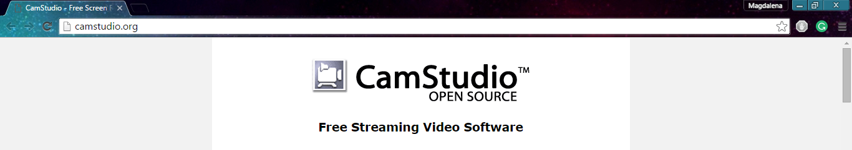
CamStudio is a recommended program that comes with the exact amount of tools needed. It is open source software for recording your screen in AVI format, and it has an option to add an audio file.
You can download it and use it completely for free.
Animoto
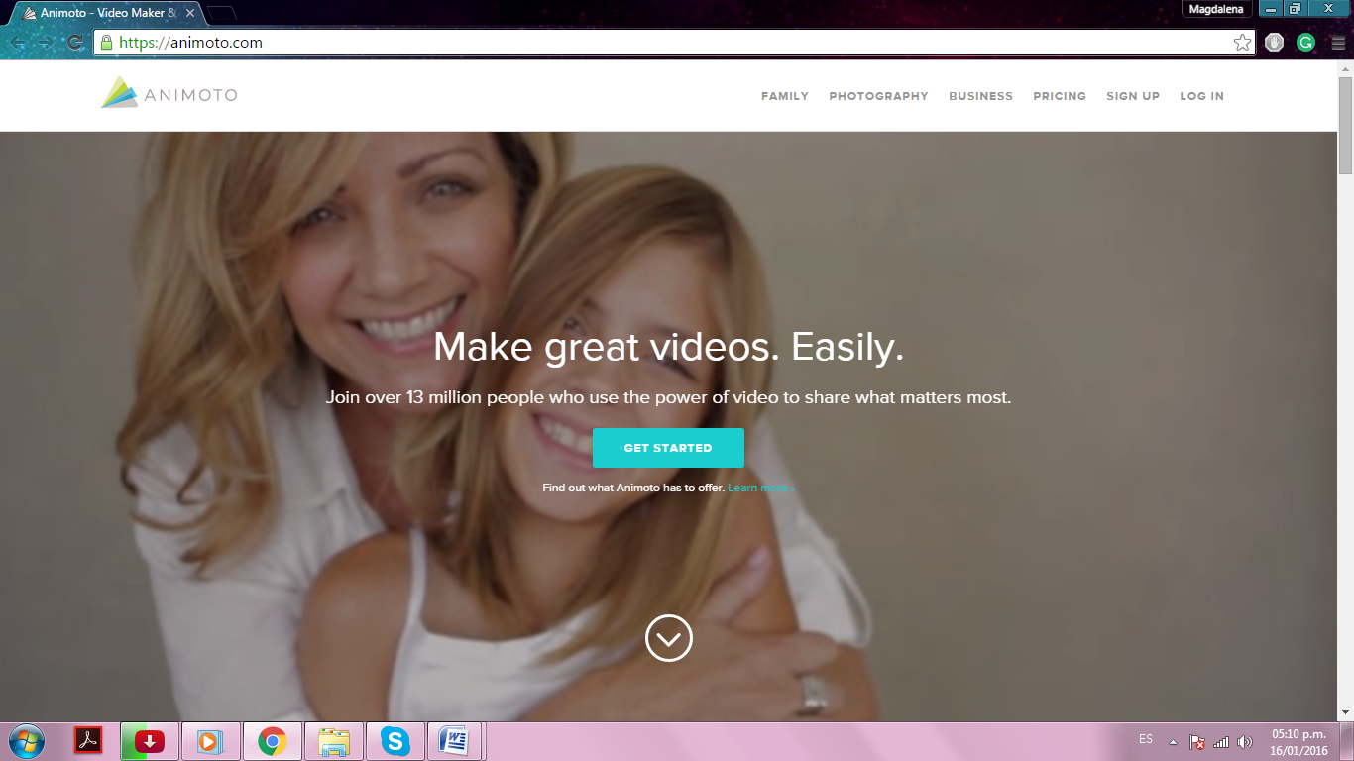
Animoto is a video creation service with a cloud-based system that produces video using photos, video clips, and music by placing them into video slideshows.
It only takes minutes to make a video, giving you the best of both worlds – ease and beauty.
Screencast-O-Matic
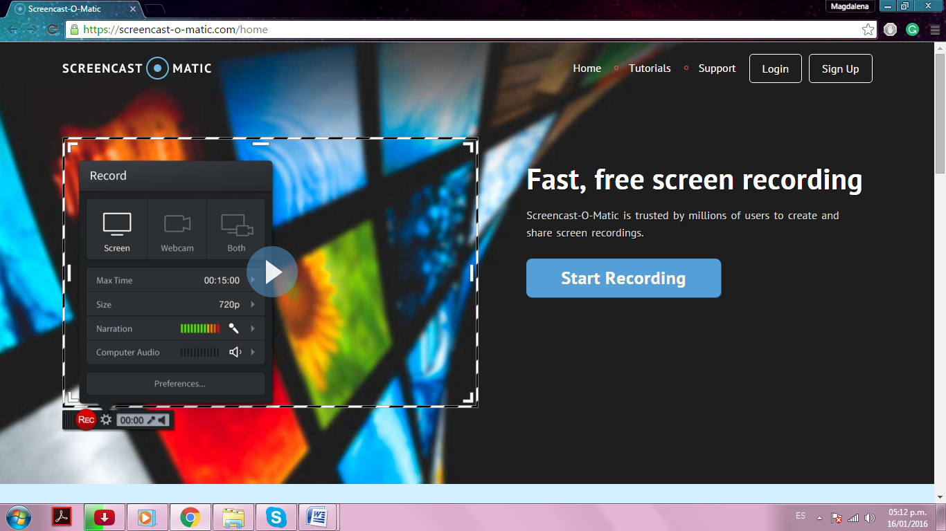
It is a free and useful tool for online operation. With this tool, you can easily create video tutorials. It supports three of the most popular formats: MP4, AVI, and Flash Video.
You can use it without downloading any software, because it is online.
Debut Video Capture Software
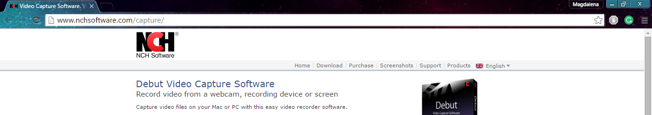
Debut Video is a free software that gives you many editing options, such as adding your personal images, filming with your webcam, assembly drawings, inserting transitions and other effects.

PowerPoint
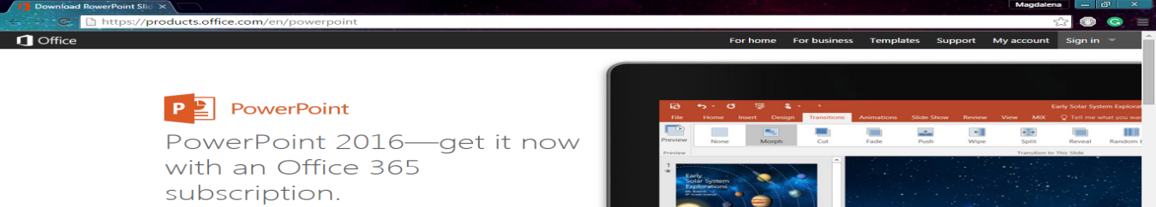
PowerPoint is a desktop tool used by many companies to produce video with a slideshow and adding a narration audio. It is an excellent way to create a smooth presentation.
Slidely
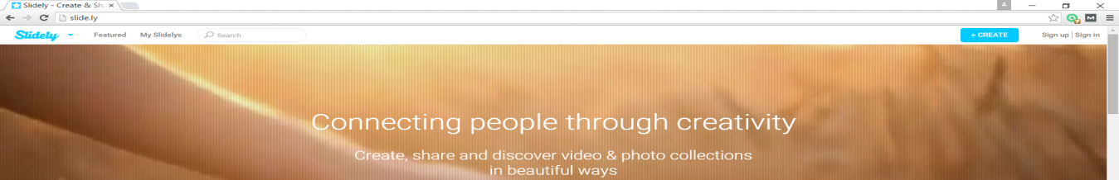
Slidely is an image-based social network and a cloud-based video creation service that allows users to create video slideshows from photos, slideshows, video clips, and music.
Slidely describes its mission as empowering and inspiring people, brands and publishers to get creative with their visual storytelling.
WeVideo
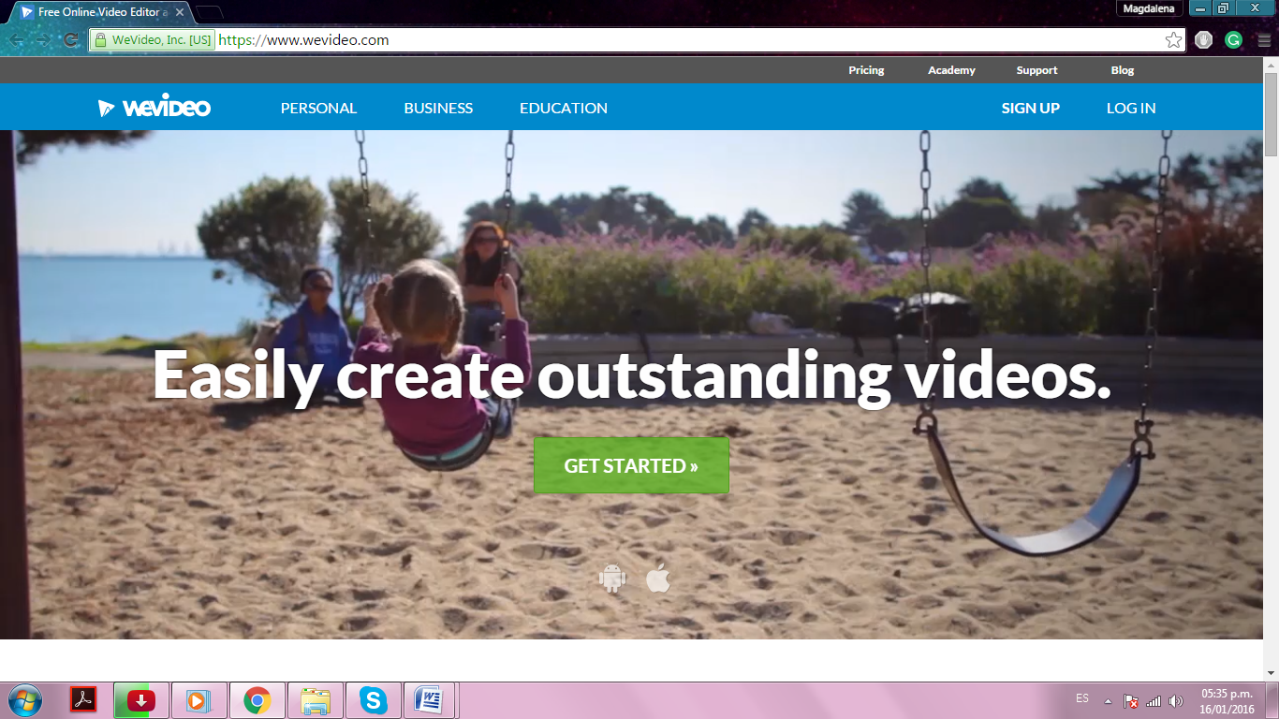
WeVideo is company that provides a collaborative video editing platform.
Its software lets you create and edit great videos for your business, customize your videos by adding your logo, business information, etc.
WeVideo offers a free plan, and you can opt for paid options, for bigger cloud storage.
Loopster
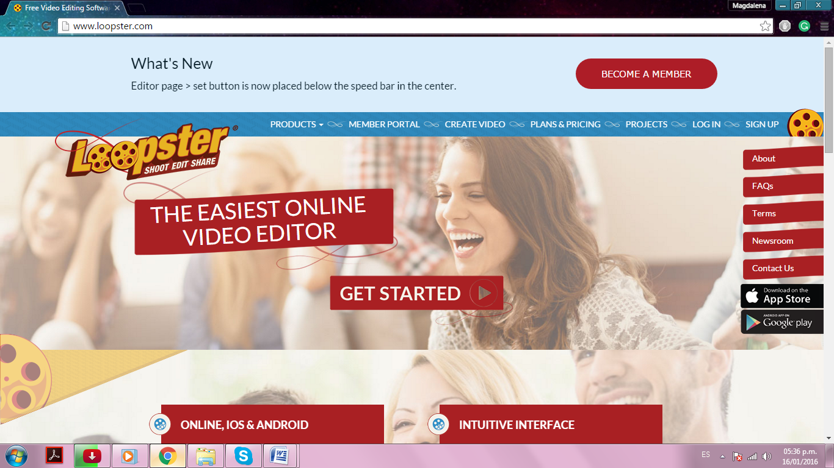
Loopster is the world's easiest to use HD video editing app. You can easily reorder and slow or speed up video clips, as well as add text, graphics, sound effects and fancy transitions.
With Loopster, you do not need any video editing experience to create videos like a pro.
Flixpress
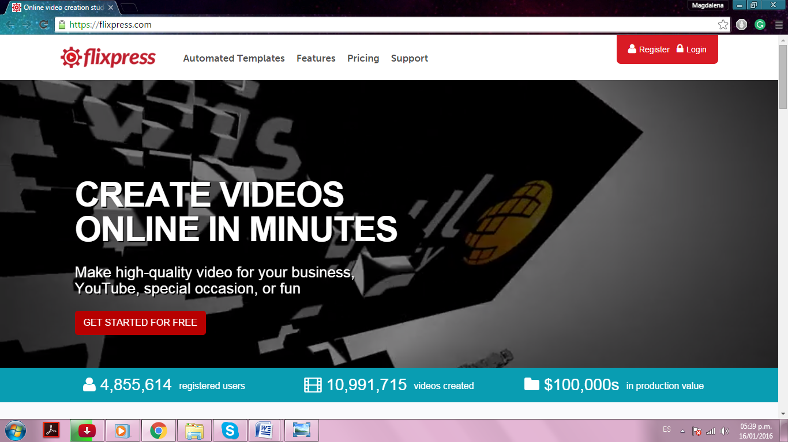
Using Flixpress, you can create high-quality videos for your business in minutes.
For services, it offers Video Customization using automated templates, and Media Personalization for businesses and organizations.
Cellsea
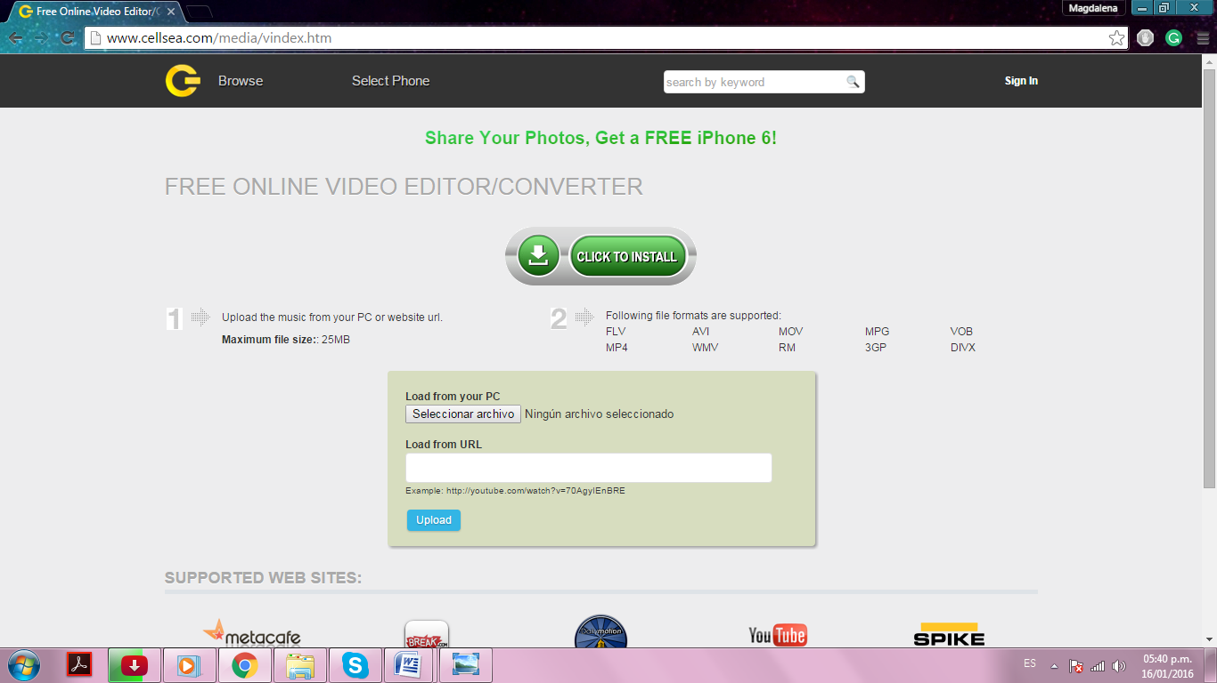
Cellsea is a free online video editor/converter that lets you add effects, resize, add sound, or simply convert your videos to a different format, such as 3G for mobile use, MP4 for iPod or PSP, etc.
Tawe
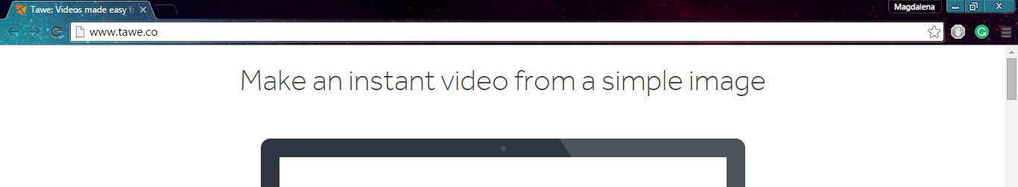
With Tawe, you can create captivating presentations and videos from a single photo. It is a little app that allows you to upload a photo or take a new photo, and then use that image as the basis for your presentation.
You choose the areas to zoom into and focus on, and the order in which to move to those areas. It can transform a simple image into an impressive presentation or video.

Camtasia
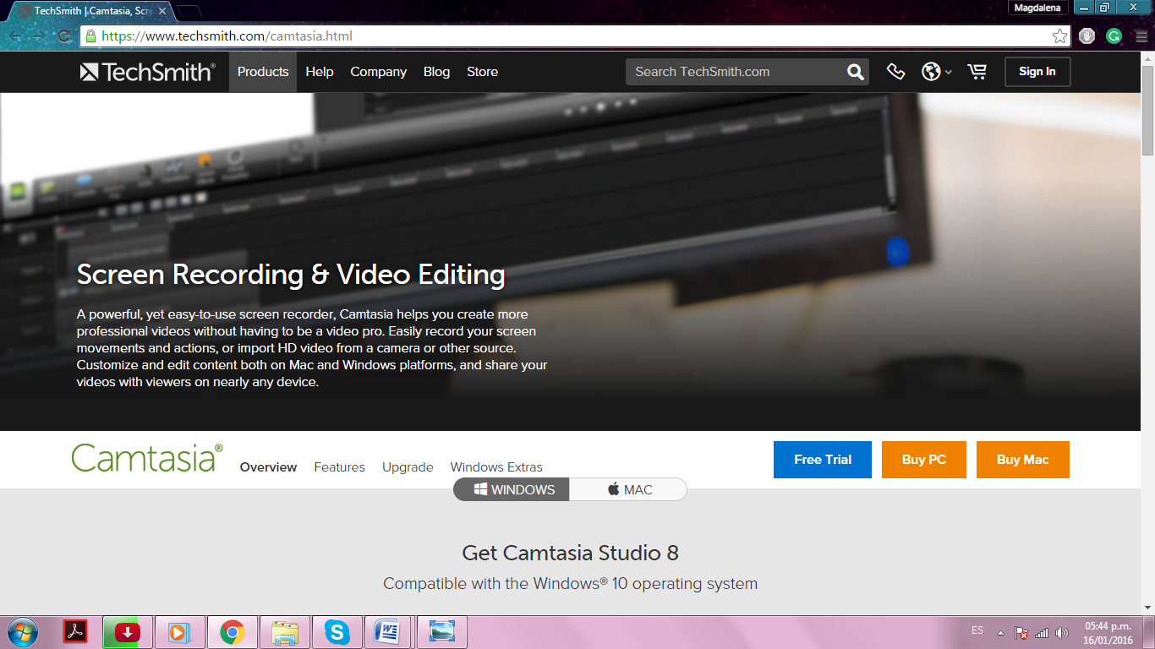
Camtasia is a software meant for creating video tutorials and presentations via screencast, or using a direct recording plug-in to Microsoft PowerPoint.
With this, you can capture anything that is displayed on the screen, then edit and improve the resulting video.
You can freely choose the screen area to be recorded, and audio or other multimedia recordings may be recorded at the same time or added separately from any other source.
Adobe Captivate
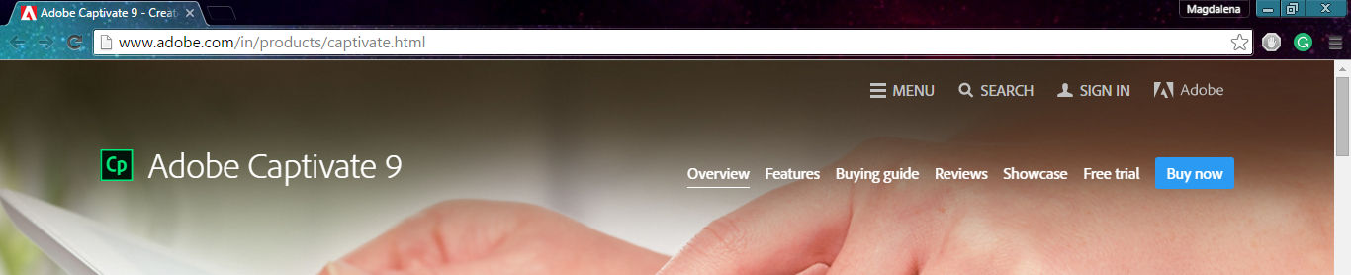
It is a recommended tool for demanding users because this software is the perfect product for creating high-quality and complex videos, with the option of adding effects.
The results are of an impeccable technical quality and great beauty.

Wideo
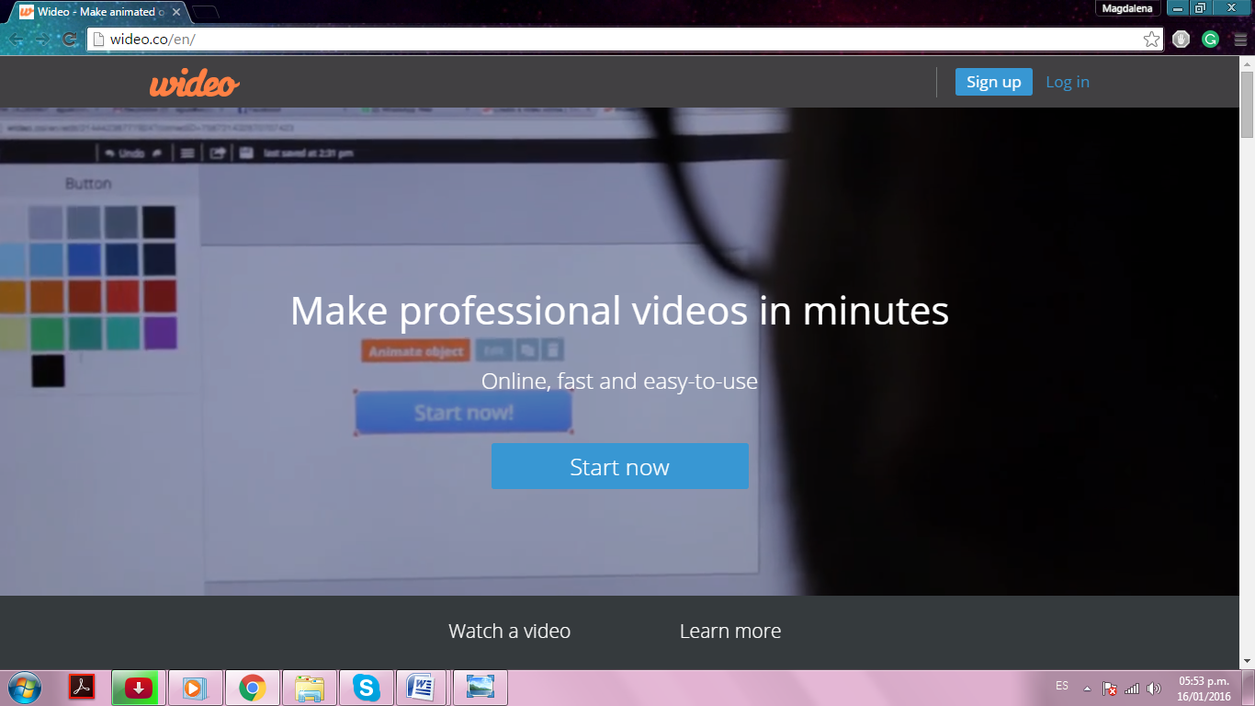
Wideo offers you the option of customizing your ad, presentation, video tutorial or demo of the product. It allows you to add images or background music.
There is an option of hiring one of the professional Wideo graphic designers, if creating something unique is what you really want.
Wideo has a free plan for creating videos up to 45 seconds long. In case you need longer videos, its prices range from $9 to $39 a month.
PowToon
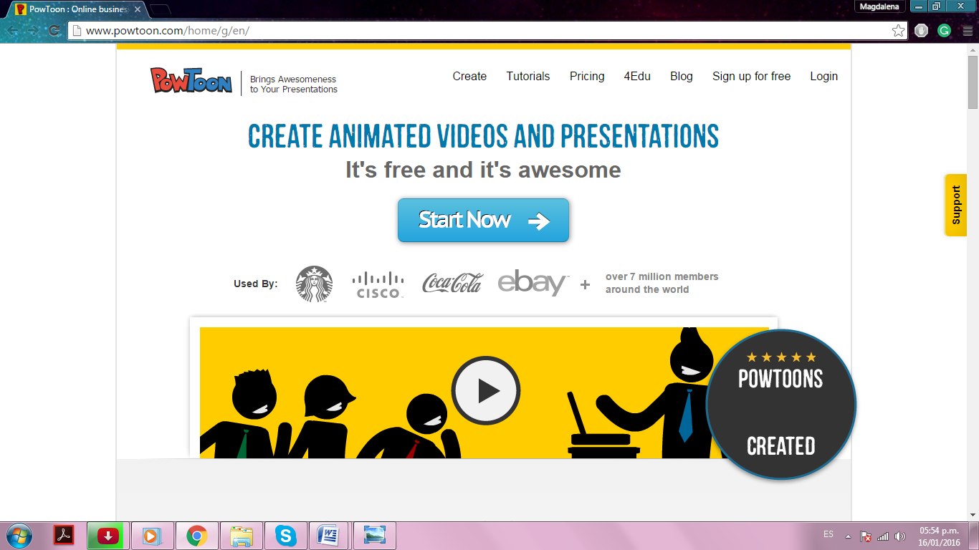
This tool allows you to easily create animated videos, presentations, and tutorials.
PowToon is known for having a straightforward and intuitive interface that guides you through each step of the creation of your video.
It offers a free version that comes with a watermark and allows to produce videos of up to five minutes long. Watermark-free plans start from $ 18 per month.
VideoScribe
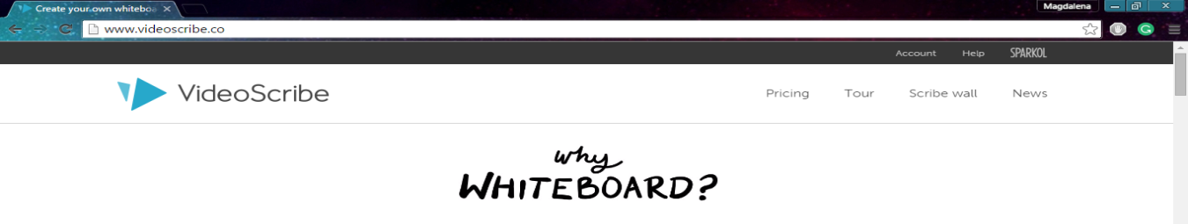
VideoScribe is a software for creating whiteboard animations automatically.
There is a 7-day free trial. Once you buy the software ($ 11 / month), the logo watermark will be removed and you will be able to create HD videos and work offline.
Filmora
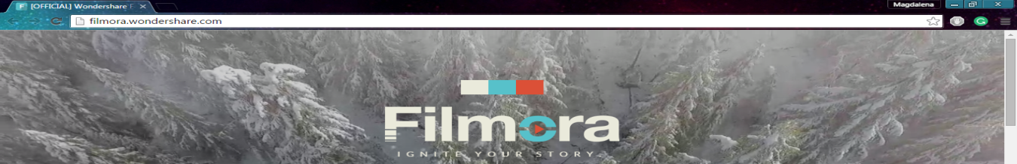
Known as Wondershare Video Editor, Filmora is a software that gives you the opportunity to perform basic editing (trim, rotate, brightness, contrast, speed), and advanced audio editing effects.
For buying this software, there are two options: $19.95 per year and $39.99 for a lifetime license.

Wistia
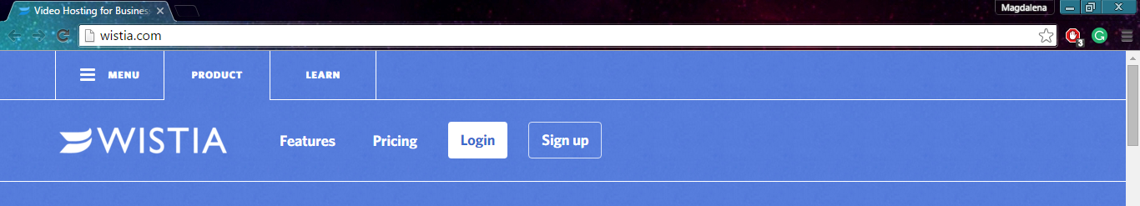
Wistia allows you to create 25 videos for free, but you may want to check out its paid plans, starting at $ 25 / month.
With its paid plans, you will be able to use features such as marketing integration, lead generation tools, and advanced analysis.
Explaindio
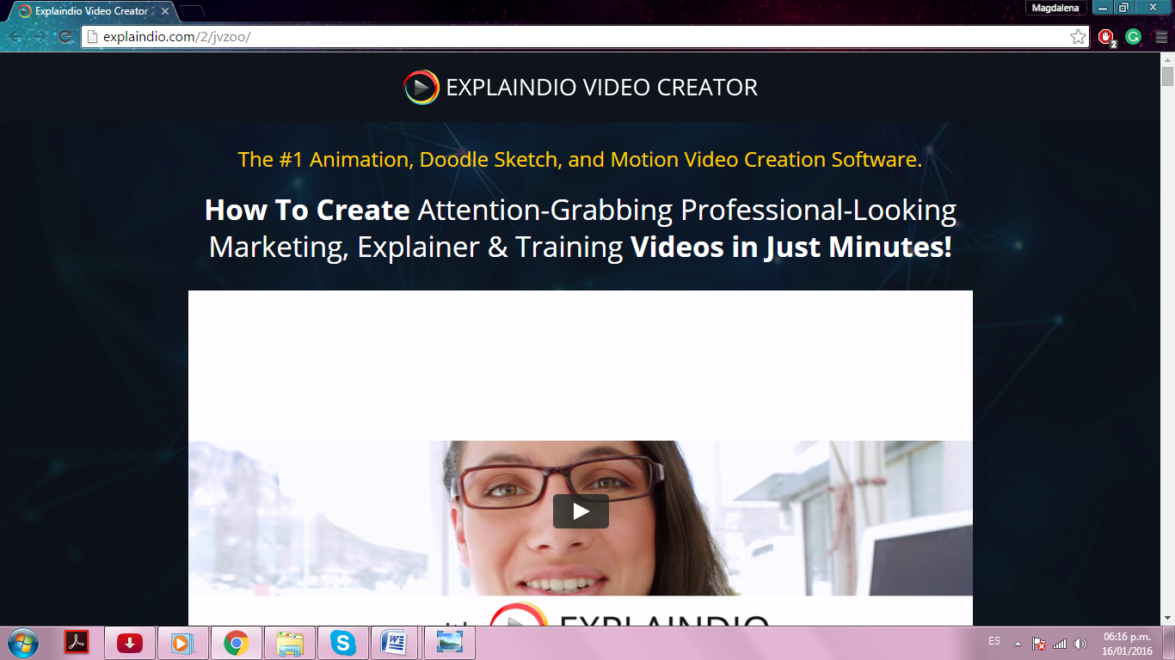
Explaindio helps you to create attention grabbing marketing videos in just minutes.
It is the result of the desire to build up the most efficient video creation software possible.
Explaindio enables people to do amazing things, and for many people, it is the most important creative tool they use.

VideoMakerFX
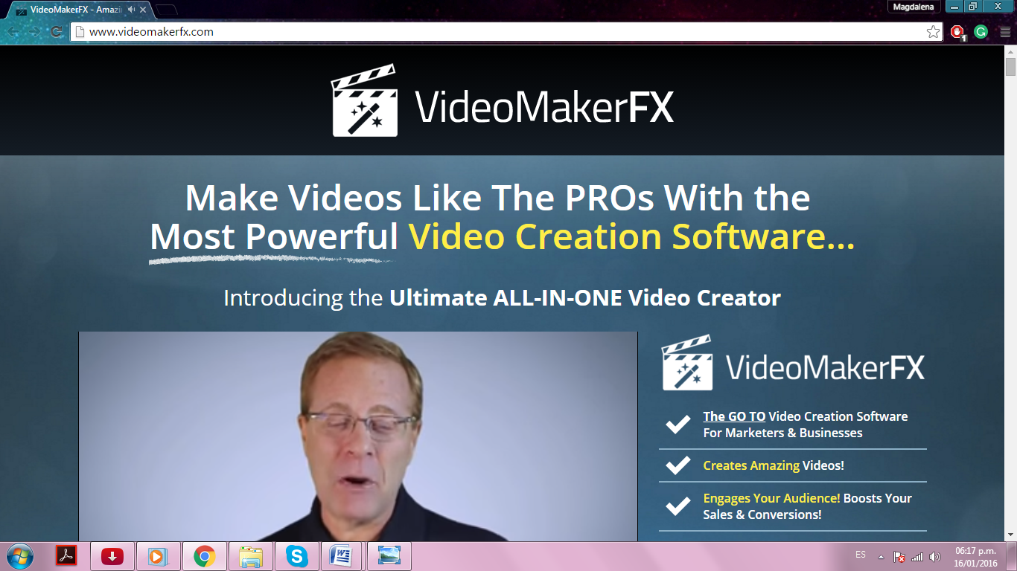
VideoMakerFX is a software meant for creating and editing video. You can literally make any kind of video; such as sales videos, presentations, photo slideshows, etc.
You will be able to make impressive videos with no previous skills of video editing needed.

Chapter V: 10 do’s you have to apply.
Some of the things that you can implement when using this powerful tool to grow your business are the following:

Use a professional service
It is extremely important to pay close attention to having great quality content in your video. It reflects your brand and engages your audience.
You can look for someone with the experience and skills necessary to capture professional footage for creating a visually interesting production.
Low-quality video will not communicate your message very well and risks discouraging your target audience.
Use online video platforms
One mistake some people starting in the business make is to place a video in one simple location, such as on your business website.
You should upload your video to sharing sites such as YouTube and Vimeo to gain maximum exposure.
Find a platform offering analytical reports in order to measure the efficiency of your campaigns and help you understand your audience demographics.

Use social media
You can link your videos from your online video platform to popular social media sites, such as Twitter, Google+, Facebook, LinkedIn, and others.
This is a great way to increase the exposure of your publishing and helps to engage with your audience, because it allows your fans to share it within their networks.
Create an interesting script
People care more about their own problems and what you can do to solve them than about your company’s history. Your content is to give your audience something useful to take away.
While creating your video, consider your target audience and include the most important points that would be of interest to them.
What product or service are you providing? How can this product or service help your audience? These are questions you definitely need to answer in your script.
A boring script will most likely make your audience lose interest.
Have a call to action
One common mistake is to leave out a call to action after you have gotten your audience's attention. Always let them know what step they should take after watching the video.
As you create your video content, make sure it includes a clear call to action. For example, close your blog posts with a question that can bring to mind a comment or question.
In case you get positive feedback about any particular aspect of the content, you can use it again in the future.
Remind your customers to sign up for your emails in order to send them all updates, news about your service, and free content.
Be transparent and authentic
Always be transparent and as authentic as you can when communicating your message on a video.
Express your message with honesty and passion through the video. You can pick topics that had done well in the past in a different format, or topics that other people are not currently speaking about, just remember to keep it authentic.
Create video tutorials
Video tutorials are a great way to create content that is certainly going to be searched for.
People love the visuals that a step-by-step video can offer. If you have a computer and a webcam, then you are all set to create video tutorials that include your screen.
There are several instruments available whether online or offline. As online tools, you have Flixpress, PowToon, and GoAnimate, and for offline, there are Camtasia, Explaindio, and VideoMakerFX.

Use video to respond to your customers
If one or more customers create a video, whether to highlight your product or to criticize it, it is the perfect opportunity to engage in the conversation.
It is a way to attract more traffic and create more conversations about the same topic, which is your video content.
In this case, you need to move quickly and be creative in how you provide your response.
Demonstrate how to use your product
If you are launching software products, you can use screencasts to show people how to use your product by focusing on the interface. People love step-by-step teaching and this is your opportunity to reach them. Professional marketing videos sell your vision, and screencasts make your customers feel you are there with them for every step.
Invest in SEO
If you do it correctly, your video can send your content to the top of search engines.
In order to achieve success in this niche, you need to do more than just embed a YouTube video on the homepage of your website. You must pay close attention to the title, tags, description, and other features of your video, and invest in a good video hosting service.
Whether you are new to video marketing or simply looking to refresh your strategy, a video marketing firm can get you on the right path.
Chapter VI: 10 don’ts you have to avoid.
As useful and as popular as Video Marketing is, there is a chance of having some problems when not used properly.
Incorrectly using it may have consequences that can be dangerous for your business or simply make your customers feel uncomfortable. Here, I show you 10 things you should not do:

Don’t make your video too long
Keep it short and simple. It is proven that audience engagement drops after 30 seconds, particularly if customers are not familiar with your brand. Your aim should be to make a maximum impact in a minimum amount of time.
It is essential to communicate your message quickly, otherwise, there is the risk that people won’t watch it all the way through.
Don’t Use jargon
Your goal should be to get your video shared by as many people as possible. Keep the language simple and avoid unnecessary terminology, because it may turn off your audience.
Keep in mind that your video content must reach as many people as possible in your target audience.
Don’t forget to assess results
It is important to measure the results of your video, as with any other marketing activity.
This helps you understand what content works well and what platforms are the most effective, so that you can focus your time and attention in the right places.
Don’t make it too informative
It is important that your video does not contain too much information about your company because you could confuse your audience.
The video content needs to contain the most important points about your business. A lengthy marketing video filled with too much information will likely be ineffective with customers.
Don’t ignore aesthetics
There is no need for a Hollywood production, but remember that quality is related to credibility. Don't forget that your name is at stake here.
Don’t shamelessly self-promote
Avoid posting videos that do nothing but talk about how great your company is. Share your value instead.
Use content that people will likely share on social media, like testimonials of satisfied customers, scenes of your customers behind the scenes, or offer free advice about your business.
Don’t focus too much on going viral
Every business seems to treasure the idea of their video “going viral” but, often, too much energy is placed on achieving this, even when it doesn’t make sense commercially.
Hits or video views are often used to measure success but, from a marketing point of view, this is a poor way to define success.
A well-targeted video could see just 5,000 hits and bring in $10,000, while some other video could rack up millions of hits but only bring in $1,000.
Also, you must consider whether a viral video would suit your business. For example, a video produced for a small-town automobile repair shop is unlikely to lead to an influx of business, even if people around the globe see it.
Don’t express a confusing concept
Not all online videos are as straightforward as they should be, and sometimes videos revolve around a specific concept. It is important that this concept is clear and does not confuse your audience.
Some of the most moneymaking online ads have revolved around a central, simple concept that is effectively linked to a brand.
If you are running a global distribution company, a “cute cat” video will only confuse people and most likely will not promote your company as expected.
Aim to create an effective concept. Make sure the concept relates to your business in an easy-to-understand way.
Don’t sell too soon
Online video is certainly an excellent sales tool, but starting out with a sales pitch video can be shortsighted.
It is essential that you first aim to establish trust, add value and build your likeability factor, and a video is a great way for achieving this.
The fundamental and most important factor is to establish trust first. As soon as you have gained some reputation with your videos, then you can go for the sale.
You need to earn their trust just like when using any other marketing tool.
Don’t post and pray
When people are starting in this business, sometimes they think that once the video is done, their work is done, when in fact, it is just beginning.
Don’t bet on the “post and pray” strategy, which is not actually a strategy at all. Some people simply upload their video to YouTube or their own website and wait for the views to magically appear.
It is more reasonable to believe that unless you effectively promote your video, the likes and shares will not come.
You need to create a marketing plan for every video and determine how you are going to get the best possible reach out of it.
One tactic is to get your video on to as many platforms as possible. You can start with YouTube, and then share your video to Google+, Twitter, Facebook, LinkedIn, and others. Keep in mind that more exposure means more views.
Chapter VII: Shocking Video Marketing Case Studies.
Ice Bucket Challenge
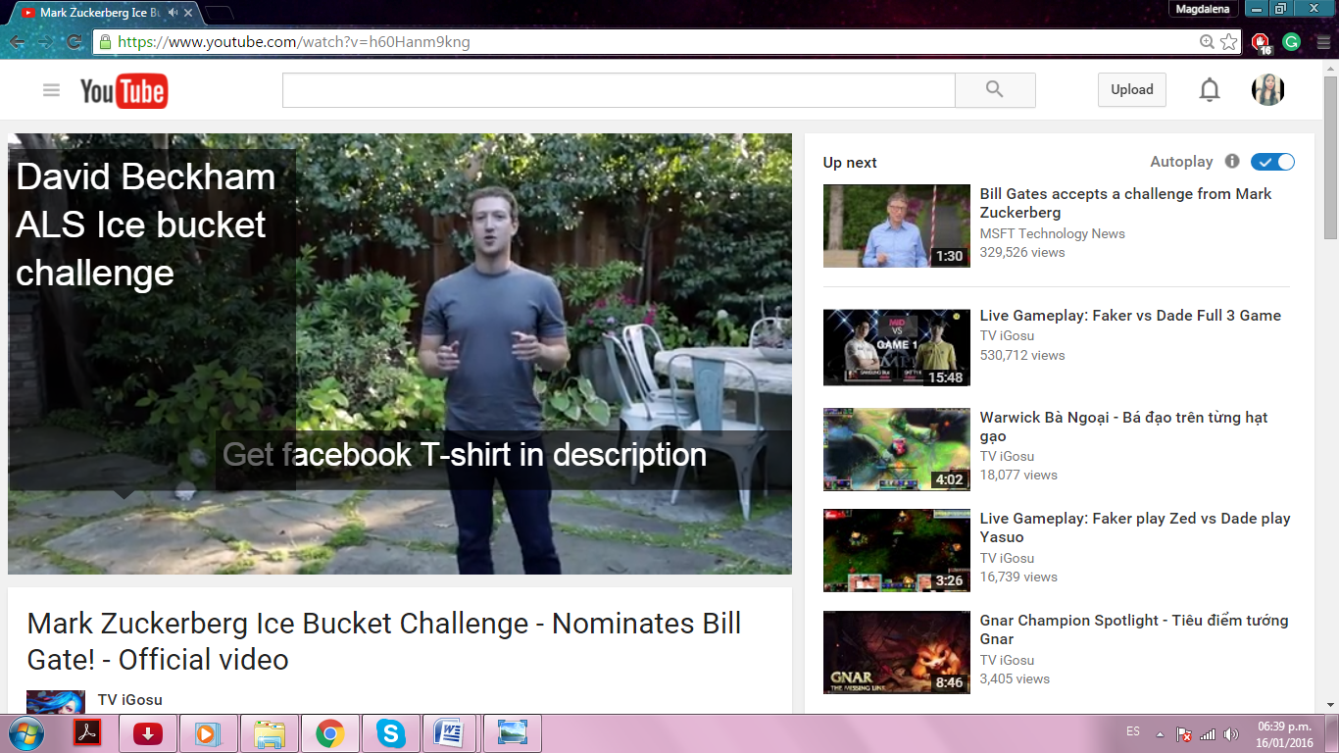
The Ice Bucket Challenge was a campaign driven by Corey Grifin in July 2014.
Objective: Corey Griffin started the campaign to help a friend who was diagnosed with amyotrophic lateral sclerosis, a progressive degenerative disease.
Strategy: He designed the Ice Bucket Challenge, which is based on having a bucket of ice water poured on one’s head and challenge others to do so, and if they do not accept the challenge, they must make a $100 donation.
Results: This challenge managed to raise $ 16 million in contributions. Challenge videos were uploaded by 2.4 million people worldwide, being viewed more than 10 billion times, reaching over 440 million views, between June 1 and August 17, 2014.
LG
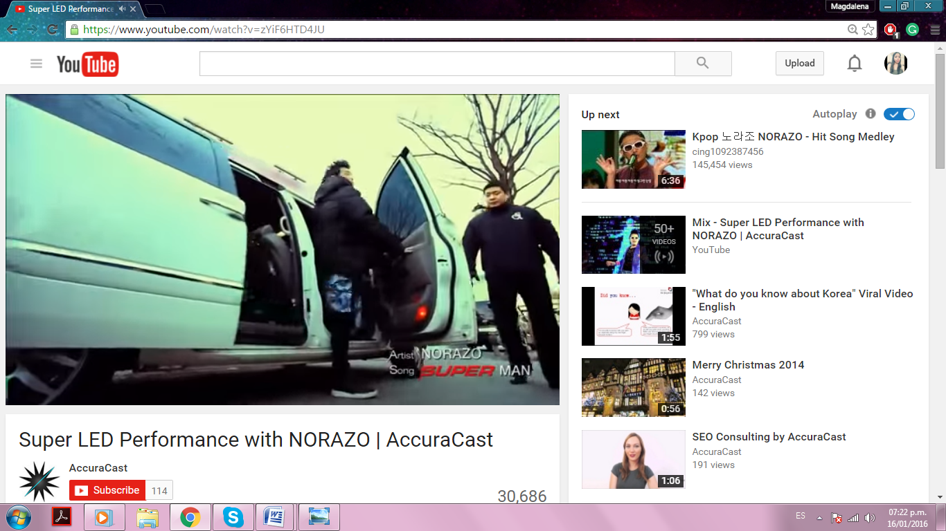
LG Electronics is one of the largest electronics companies, based in Seoul, South Korea. It is one of the largest electronic conglomerates in the world and is a trademark of LG Group.
Objective: LG launched its new range of ultra-thin Super LED monitors and wanted to sponsor these new products in order to obtain a growth in sales.
Strategy: They did this through a flash mob performance, and then broadcast it on the world's largest LED screen.
Results: This video became a viral success in Europe, North and South America, getting more than 1 million views in just a couple of months.

Dove
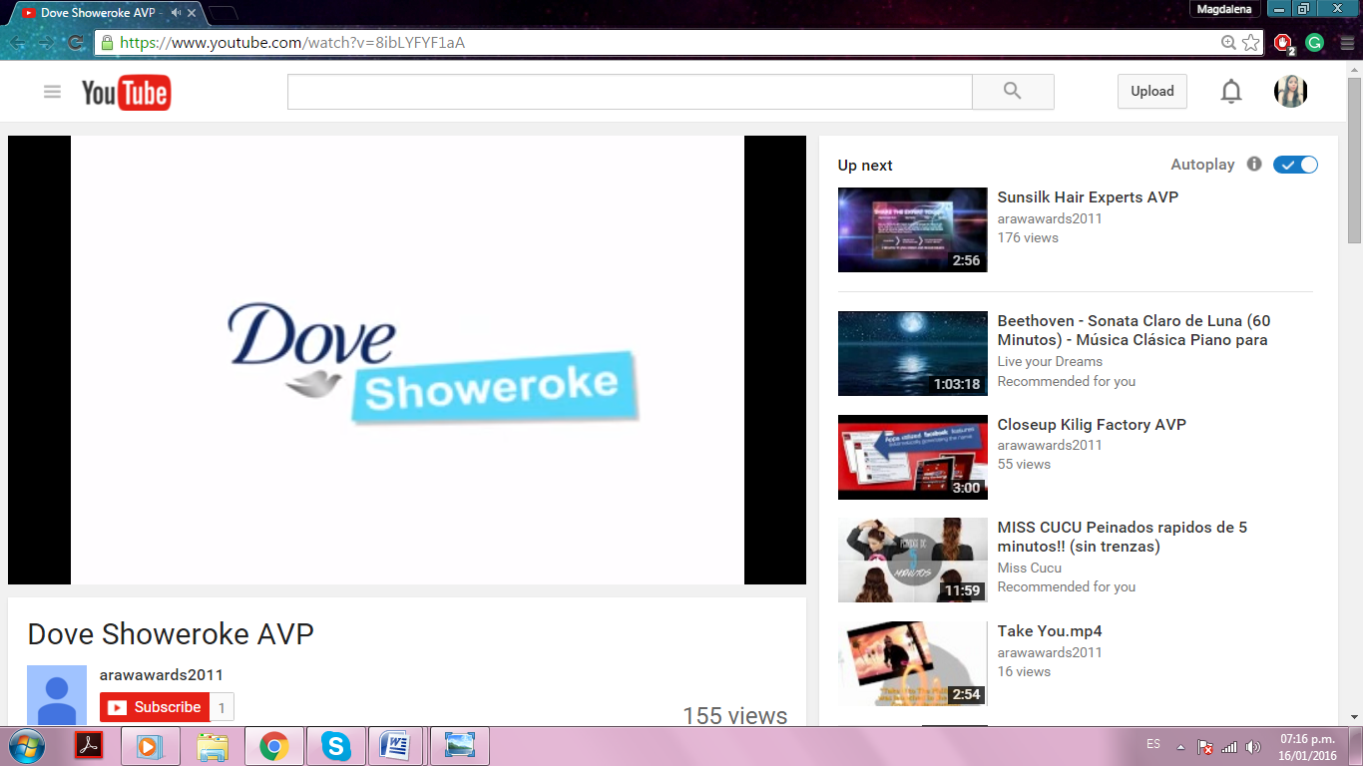
Dove is a line of personal care products.
Objective: Media Contacts Philippines was challenged by Dove to expand its consumer base to include younger women. They wanted to do this with a new product called Dove Go Fresh.
Strategy: The strategy they used was to give young people an opportunity to become a celebrity, reinforcing the importance of personal hygiene and expressing their own personality by adding accessories to their shower and singing a song in the shower.
The challenge ended up as a live talent show, and the participants ’videos, as part of the "Showeroke", were collected in several blogs.
Results: They obtained 18,000 readers, and fans voted for their favorites. The top rated ones sang live with a band. The Dove Bar penetration went from 13.7% to 18.4%, and the Dove Body wash loyalty went from 24% to 27.6%.
Social Robot Case Study
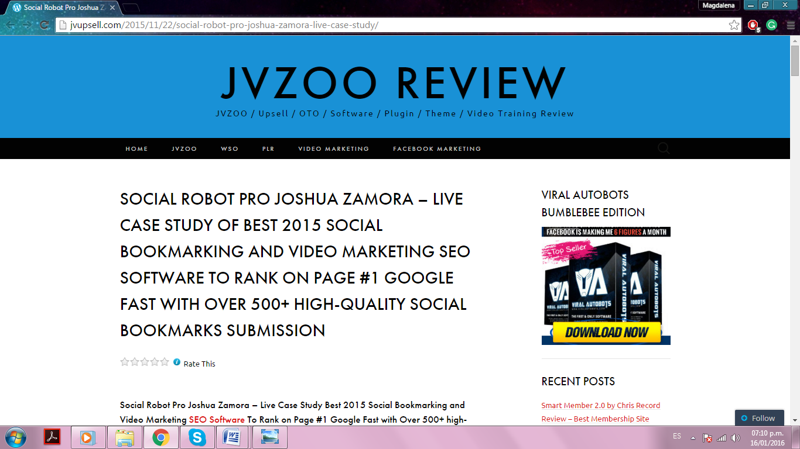
Objective: Social Robot Pro is a software able to build more than 500 high-quality links to any URL you want, with just a few mouse clicks.
You can easily filter individual projects and Social Base sites to target exactly what you want. This software will give you the ranking you deserve.
Social Robot Pro uses a local database. That means that everything that happens in Social Robot is stored in its database and remains there until you remove it
Results: Joshua Zamora says ‘I use this software and record everything on video, all live’. This tool places your video in the first page of Google in 48 hours or less.

Scale Social
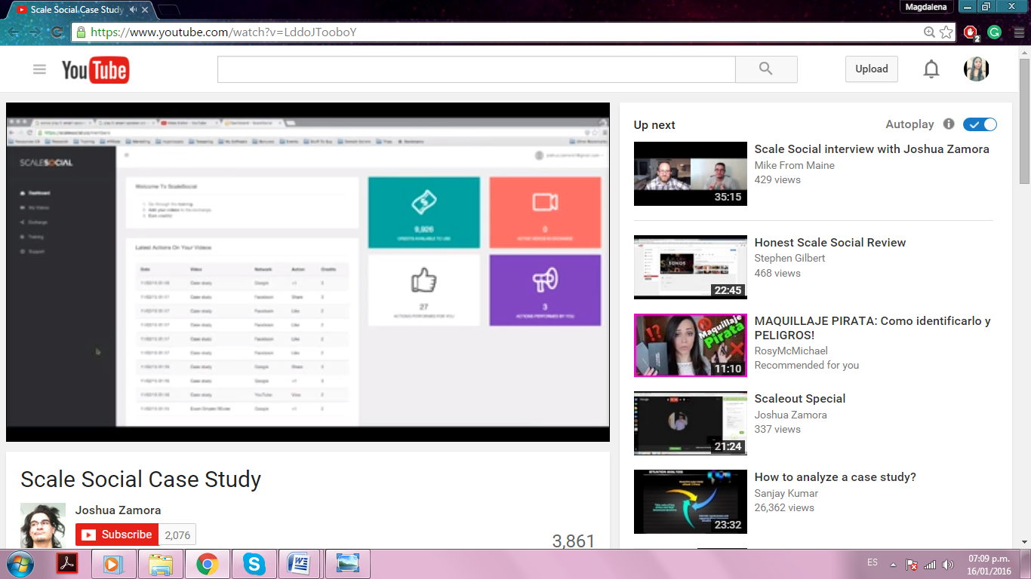
Joshua Zamora again provides a little guidance, but this time on using "ScaleSocial” software.
Objective: He wanted to get a good search engine ranking in a short time, and also earn a good commission for it.
Strategy: He is an Amazon affiliate. He provides a product, promotes it with a video, and uses the Scale Social software to obtain excellent results. Also, he shows what products may more likely be sold.
Results: He achieved his goal, getting positioned among Google’s top search rankings in just 19 hours. This gave him the opportunity to quickly sell this product.

Imagine The Possibilities | Barbie
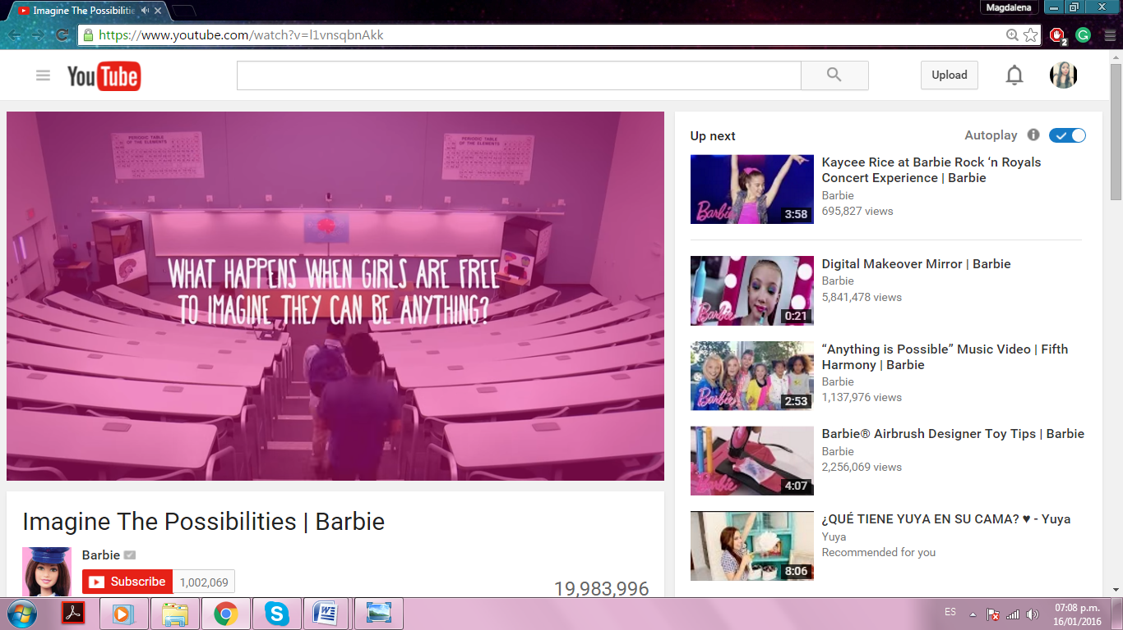
Barbie is a doll brand, manufactured by the American toy-company Mattel, Inc. and launched in March of 1959.
Objective: Mattel wanted to create an advertisement aimed to parents, in order to connect with a new generation of parents, and the ad they used was "Imagine the possibilities".
Strategy: They created a video focusing on the "You can be anything" theme. It was a video without a script in which girls were posing as professionals: veterinarians, athletes, businesswomen, and teachers, all of whom were chosen by the girls, and hidden cameras filmed the action while the adults played with them.
Results: This video has accumulated 10 million views on YouTube, receiving many favorable comments and reactions.

Android: Friends Forever
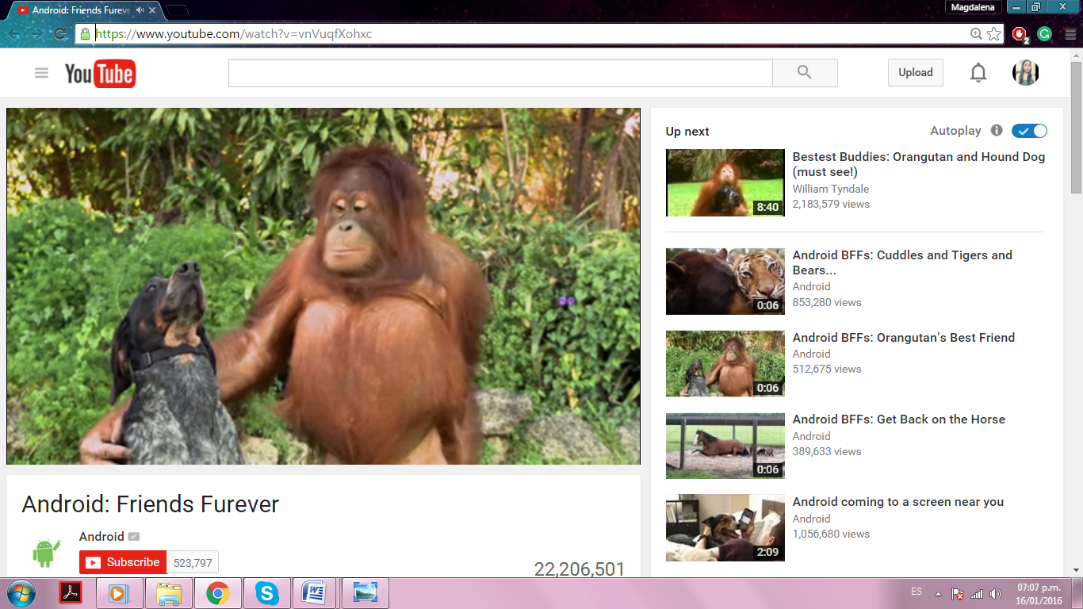
Android is an operating system based on the Linux kernel.
Objective: Android wanted to spread a message about being together, cooperation and tolerance.
Strategy: They made a unique advertisement, presenting a life lesson by showing the love and friendship that is developed between animals of different species. In the video, there are unconventional pairs of animals: dogs and elephants, chimpanzees and horses, and even tigers and bears.
Results: The one-minute video has become the most common ad of all times. It has been shared a total of 6.4 million times in social networks like Facebook, Twitter, and blogs.

Coldplay's Game of Thrones: The Musical
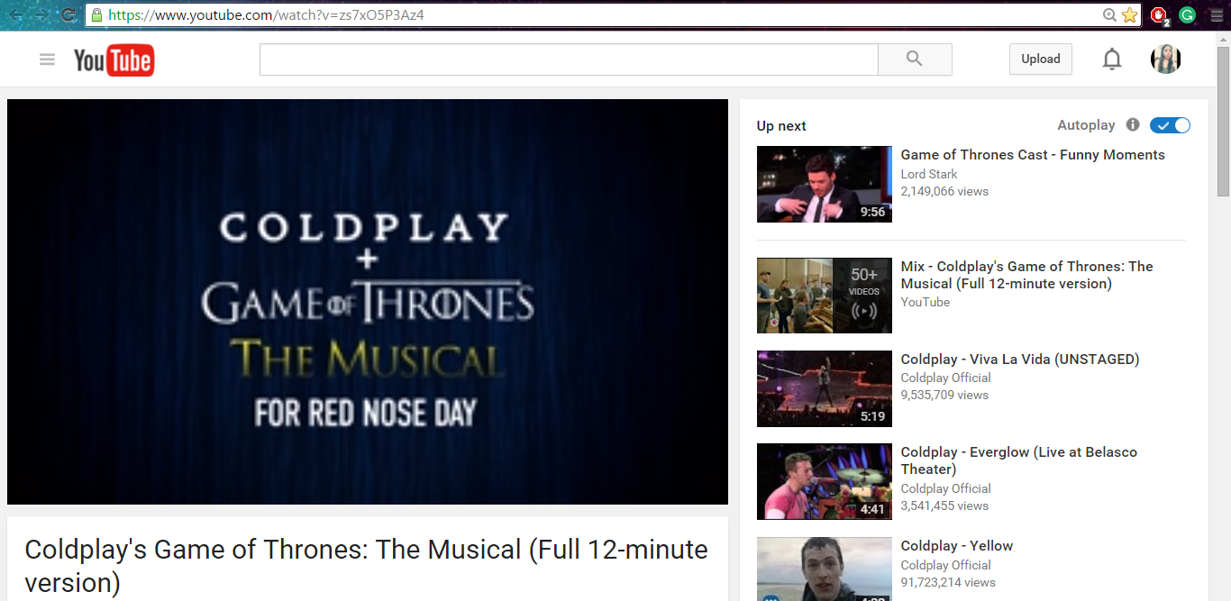
Game of Thrones is a medieval fantasy series, based on the novel series by George RR Martin.
Objective: One would think that Game of Thrones was not suitable for the Broadway musical format, but they wanted to see the impact if it was carried out.
Strategy: Coldplay created a parody video that included the cast of the hit show. In the video, the narrator Liam Neeson says that Coldplay is "working secretly" in his Thrones musical. The band is dedicated to creating 16 ridiculous songs based on actions committed in the series.
The only problem is that the writer, George RR Martin denied the band the permission to carry out the project.
Results: Even though they did not get the permission from the author of the books, the video turned out to be a huge hit on the Internet, getting 15 million visits.
"My dad's story": Dream for My Child | MetLife
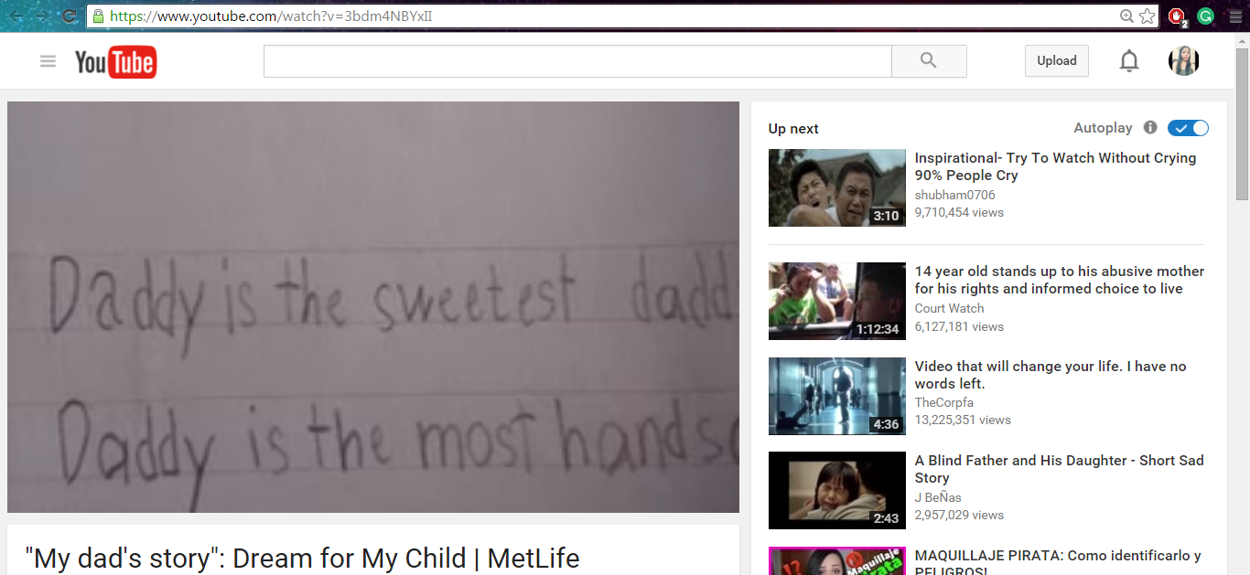
MetLife is a world class company.
Objective: It invites viewers to visit dreamformychild.com and find out about MetLife savings plans for parents, to save money for the higher education of children.
Strategy: They made a video entitled "My dad's story", in which a father reads the essay that his daughter wrote about him, as the voice of the girl narrates the essay.
It praises the father, highlighting his features. Then, she reveals that she knows more than what her father lets her see. “He lies”, she says, "he lies because of me”.
It becomes clear that the father is carrying a wide range of menial jobs to earn money for the higher education of his daughter. The bottom line is "The future of a child is worth any sacrifice."
Results: The video has touched people throughout the region, 27.6 million people watched the video on YouTube and Facebook, 7 million people shared the video with friends and family, 268 million people have read about the video through 91 news reports and 280,000 people visited BIDV MetLife and MetLife microsites in Hong Kong, Malaysia, and Vietnam.
Disney Characters Surprise Shoppers | Disney Side | Disney Parks
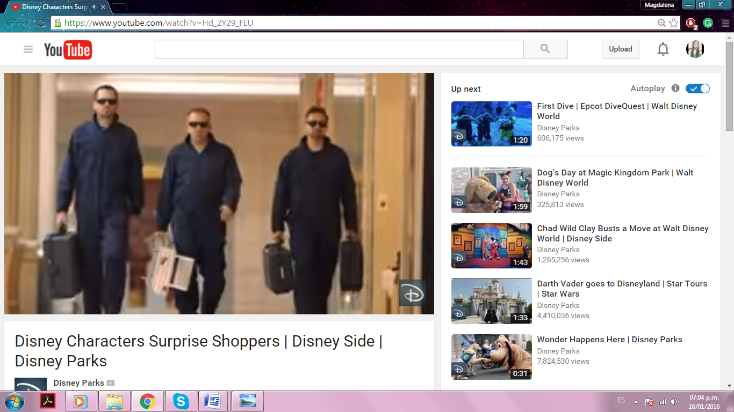
The Walt Disney Company is the world's second largest media and entertainment company.
Strategy: Disney produced a video in February 2015 in which Disney characters hid behind a moving lighted screen, disguised as a showcase. As people walked, the characters became their shadow, showing movements and a mimic dance, thus getting smiles and interaction with people.
Results: The video received 5 million views on YouTube and has gained a lot of media coverage. It also got more people to consider visiting Disney with their family.

Chapter VIII: How to make tons of money with Video Marketing as an Online Marketer.

YouTube
YouTube receives more than one million unique users per month, which is a large audience. Many people are already making money with YouTube.
You can use the YouTube Partner Program. Once you are a member, YouTube will display ads next to your video, and pay a percentage of their income to you.
If you have a website or blog, you can use YouTube to increase your traffic. You can create products and promote them on YouTube by simply adding your product link in the description of your video.
Coaching
A coach is a guide that establishes a relationship of trust and generates impact strategies. You can become a coach and start training people through video. By offering your services as a coach, you'll be willing to train others on a topic that you’re good at.
For starters, you need to create a YouTube channel. Let’s say, you excel in marketing. You can start uploading videos in which you talk about different strategies, thus evaluating and providing analysis for others to learn.
By selling your knowledge like this, and joining the YouTube Partner Program, you enable your channel for monetization, and you will receive a share of revenue from advertising on YouTube.
Just as the YouTube stars do, you will then receive some revenue per each one thousand views on your videos.

Revver
Revver is a sponsorship market for online video, which seeks to connect artists with audiences and advertisers.
Revver gives you the tools to distribute your work online and earn money. The site aims to support free, online accessible videos, and also reward the efforts of creators.
Revver works as follows: when you upload a video, it attaches a brief ad at the end of the video. People see the video on Revver.com or other sites that the video has been embedded in.
If someone that sees your video then clicks on your ad, Revver deposits a portion of the click-through value into your account. You can follow your video's performance through your Revver account and Revver sends you money.

Sell your content on iStockVideo
iStockVideo.com is a new service created by iStockPhoto.com, it is a wonderful Free Stock Photography website.
With iStockVideo, you get paid for uploading video (stock footage) that other people may want to use as part of their videos. You can upload animations, digitized sequences, video, etc.
If you contribute a video in the first 90 days, you receive 10 free credits to use anywhere on iStock. If you tell your friends about iStock, you can receive up to $50.
Seek sponsors for your videos
You may be able to find sponsors to help you pay for reaching the audience that you want. You can offer those sponsors the ability to advertise through your video.
WebVideoZonePlayer, at www.webvideozone.com/public/main.cfm, makes it easy to add powerful, interactive web video presentations to websites.
You can charge sponsors by the month, per click-through, or per unique viewer. By checking your video stats, you and your sponsors know exactly how many people saw the video.
Sell products
If you have your own online store, you can promote your products by creating a video in which you talk about your products.
The most effective way to sell your product through videos is by showing how the product can meet the consumers’ needs. You can also stay one step ahead by including answers to possible objections of consumers, even before they arise.
An online, well-produced video, can be beneficial to almost anything that is being sold through the internet. These videos are the key to making your viewers become customers and thus, increasing your income.

Create promotional videos for local businesses
You can offer your knowledge about video marketing to small businesses that request video advertising services; such as real estate agents, new and used car dealers, travel and leisure destinations, restaurants, tour groups, antique shops, galleries, shops with interesting inventory to show, local shopping malls, etc.
They pay you to create videos to promote their store. You can make a good amount of money just by using your camera and some editing software.

Place Google ads next to your videos
If you are creating your own videos, you can add a good description and place some Google AdSense ads next to them, because they might be of interest to your viewers.
If you want good results, make sure your video is about an appealing topic for the target audience that the advertisers are trying to reach.
Also, make sure you use keywords in the title and in the description.

Start a campaign
If you want to draw the attention of more viewers for your products, you can go beyond showing an independent video.
To cover a longer range and get better exposure, start creating video campaigns, i.e. a video series with content that you can post on a regular basis.
This will help you to create a synergy around your content, and also allow you to build an online identity through the publication of each video.
Have a call to action
Do not miss the opportunity to ask your audience to take action at the end of your video.
You can ask them to visit your website and check out your products, leave a comment or ask any questions.
Use your video to define a problem and discuss solutions. If they like your video, it is likely that they will do what you are asking, so make sure you take advantage of that.

Conclusion:

We’re thrilled that you have chosen to take advantage of our Training Guide, and we wish you amazing success.
And in order to take your Video Marketing even farther, we invite you to get the most out of it by getting access to our Live Video Training clicking here (Insert your Upsell offer URL).
Thanks so much for the time you have dedicated to learning how to get the most advantages from Video Marketing.
Video Marketing has come to stay in the market forever.
To Your Success,
Your Name


Top Video Marketing Resources
Videos
- https://www.youtube.com/watch?v=ZXvHKL1OD78
- https://www.youtube.com/watch?v=i16Qjm8FuT4
Tools & Services
- https://www.searchenginejournal.com/11-awesome-video-marketing-tools/137767/
- https://www.americanexpress.com/us/small-business/openforum/articles/10-tools-to-make-your-marketing-videos-wow/
Training Courses
- http://www.marketmotive.com/content-marketing-training-courses/
- http://vidpow.com/
Blogs
- http://blog.hubspot.com/marketing/topic/video
- http://wistia.com/blog
Forums
- http://www.smallbusinessbrief.com/forum/showthread.php?t=62529
- http://www.v7n.com/forums/marketing-forum/331298-do-you-use-video-marketing-sucessfully.html

Affiliate Programs
- http://www.homeinspectionvideomarketingpro.com/idevaffiliate/index.php
- http://www.webvideozone.com/public/department52.cfm
Demographics
- http://www.codefuel.com/blog/video-marketing-statistics-for-2015-the-next-big-thing-is-here/
- http://www.marketingprofs.com/charts/2014/25121/online-video-trends-demographics-devices-audience-size
Webinars
- http://blog.vidcaster.com/5-video-marketing-webinars/
- https://www.brighttalk.com/community/webinar-video-marketing
Infographics
- https://highq.com/2015-year-of-video-marketing/
- https://contently.com/strategist/2015/11/04/infographic-why-millennials-love-video-marketing/
Case Studies
- http://www.digitalstrategyconsulting.com/intelligence/2014/08/viral_case_study_how_the_ice_bucket_challenge_raised_15m_in_3_weeks.php
- http://www.flimp.net/video-marketing-strategy
Facts
- https://www.youtube.com/watch?v=1JhnuFkfzfY
- https://www.youtube.com/watch?v=TIaEHIHlGts

Limited Special Offer for You:
Video Marketing Made Easy
(Video Training)
Click Here to Download Your Video Training!
(Insert your Upsell Offer URL)

