

The Ultimate Guide to Looking After Your Mental and Physical Health as an Internet Marketer
Being an internet marketer is an amazing job in many different ways. This is a type of work that allows you to work from home, to be your own boss and to enjoy the incredible sense of accomplishment that comes from making money through a business that you own and created. You can work from anywhere, explore the world and potentially make a lot of money without having to work all that many hours.
But while all this is true, there are also a number of pitfalls and challenges associated with working for yourself.
One of these is the simple fact that you might end up with a little too much freedom. You may find yourself struggling with the discipline required to make sure you go to bed on time every day, or wake up on time to get the maximum work done each morning! Likewise, you might find yourself struggling with the urge to procrastinate or the soul destroying feeling you can get from doing the same work day in and day out.
And then there’s the health side of it – the mental and physical health implications of working from home and facing the kind of stress that comes from running your own business and having clients demanding your time and effort at all times of day.
In this guide, we’re going to take a brief look at some of the health challenges associated with internet marketing, as well as some of the psychological stresses that you’ll face. Ultimately, we’ll see how you can manage your work life balance and protect your health, so that you can enjoy feeling fitter, healthier and happier than ever before – all while getting more work done!

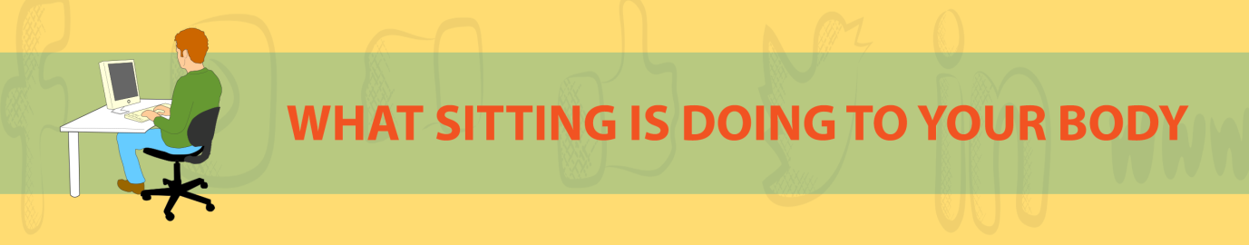

What Sitting is Doing to Your Body
Perhaps the most obvious challenge that internet marketers face, is that of having to work sitting down for long stretches. Sitting is actually terrible for your body for a number of different reasons.
For starters, sitting means that you are completely static and that in turn means that your heart is going to be doing zero work. Over long durations, this can lead to atrophy and weaken your cardiovascular health. This is also combined with the fact that sitting will likely cause you to gain weight, and it will mean that you rarely use your body’s ‘energy systems’ in order to use glucose or improve the health of your mitochondria.
Thus heart attacks and strokes become more likely, so too does obesity, dementia and diabetes. And in short, studies suggest that sitting for a more than five hours in a day can take minutes off of your life every time.
Then there are the ways that sitting makes you less healthy in the short term. You can expect to find you become out breath more quickly sure, but more concerning is how it affects your mobility, your posture and your likelihood of developing numerous injuries.
When you sit for long periods of time, it causes your hip flexors (quadriceps etc.) to shorten and your hip extensors (hamstrings) to lengthen and become weaker. This can place uneven pressure on your hips, resulting in something called an ‘anterior pelvic tilt’ whereby you get a squat posture with your buttocks sticking out. Not only is it unattractive (often called ‘Donald Duck Butt’), but it also makes you shorter and causes back problems and knee problems.
Then there’s kyphosis, which is the appearance of hunched, rounded shoulders, caused by constantly reaching forward to use the computer and craning your head down to the laptop.
Now combine all this with the stress that comes from running your own business and the lack of routine that you might be experiencing too. If you are getting up late in the day to start work, then spending the following five hours sitting like this, then you might well be wrecking your health!
So, what can you do?

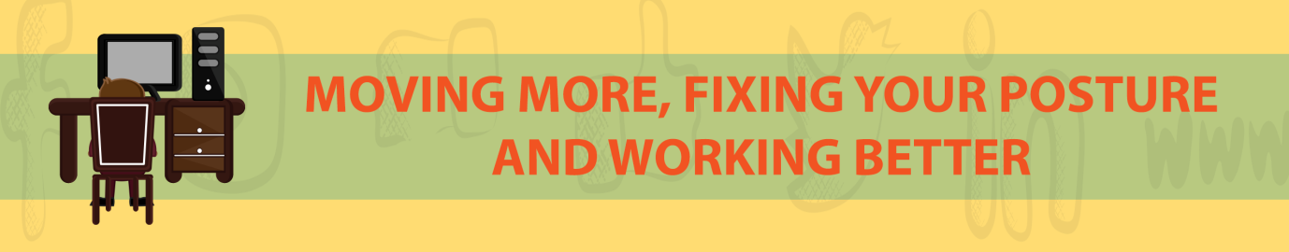

Moving More, Fixing Your Posture and Working Better
Getting regular exercise will help to improve some of these negative effects. Studies show that although you can’t completely reverse the issues that sitting for long periods causes, you can nevertheless at least improve your overall health just a little by moving more regularly.
Being self-employed and working online means that you have the freedom to go to the gym in the morning when no one else is around. I also highly recommend going for walks on your lunch break – if you need to make any calls, this is a perfect time to do that.
Another tip is to consider investing in some extra gadgets to help you out. One such gadget is a standing desk. This will elevate your computer while you work, allowing you to work in an upright position instead of sitting down. This will make it tough to focus as well as you do when sitting but you can get around that issue by focussing on work that you can do with a little less concentration – for instance, you could use this time to answer your morning emails.
Likewise, you should also look into investing in a cushion for your chair that will provide lumbar support and also take the pressure off your coccyx, which can otherwise cause pain as well as various health problems. You could alternatively look into sitting on a medicine ball, which will have the added benefit of training your core as you’re working.


Breathing for Internet Marketers
Another problem that can come from working on a laptop or computer all day, is that it can ruin your breathing.
This might sound strange but the problem comes from sitting. The irony is that the human body was actually never designed for sitting – in the wild we would have squatted. One bad consequence of this switch is that our stomachs are compressed and this prevents us from using the correct ‘abdominal breathing’.
To breathe properly, we are supposed to start by relaxing our stomach and allowing it to distend. This creates space in our abdominal cavity, which in turn allows the diaphragm to drop down into it, expanding the lungs from the bottom first. You then follow this motion by breathing in actively and expanding the rib cage in order to let in even more air.
When you sit, you can’t do this because the stomach is squashed, which means that you are force to breathe with your lungs and chest alone. This forces you to take shorter, faster and shallower breaths, which in turn means you’ll not take in as much oxygen and you’ll increase your own heartrate.
This in turn triggers a stress response: because our stress levels are closely tied to our breathing through our sympathetic and parasympathetic nervous systems. When you are stressed, you take shorter, shallower breaths. And when you take shorter, shallower breaths, you become more stressed!
If you are going to be working on the computer and facing the stress of being self-employed, then you better learn to start breathing correctly! Start by sitting up straighter in order to give your gut more room to expand. To encourage this, you can try tying a loose piece of string around your abs. This will force you to gently contract your transverse abdominis – the muscle that wraps around your midriff – and that in turn will keep you more upright and stable.
From here, it is a matter of focussing on your breathing. Do this especially when you’re stressed and hopefully it will start to become a habit!
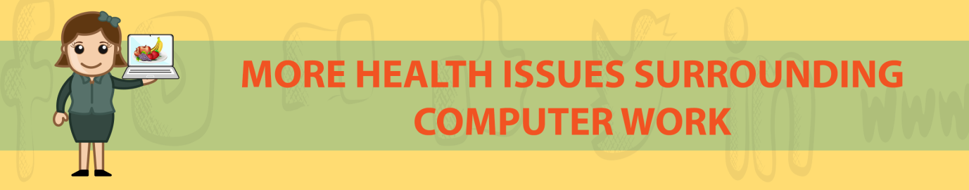

More Health Issues Surrounding Computer Work
There are other potential health issues related to working on computers all day though. One of these is the fact that you will be typing for such long stretches, which can cause RSI in your hands (repetitive strain injury).
One good way to combat this, is to make sure that you use a good keyboard that will help to cushion the impacts you make on the keys and that will allow you to type quickly and comfortably. The best type of keyboard to this end is a mechanical keyboard, which will have ‘clicky’ switches to allow for a more satisfying key travel. Many people say that the Cherry MX Blue switch is the ideal switch for people who work on the computer.
Another consideration is your monitor but there’s good news here: looking at computer screens is actually not bad for your eyes. This is a myth that was created by one incorrect study that found a correlation between people who sat near the computer/TV and people who wore glasses. The reality that the study missed is that these people were sitting near the screen because they had glasses (not the other way around!).
That said, it is important to avoid glare and I would also recommend getting a wide monitor to give you plenty of real estate for working.



Managing Clients and Avoiding Stress
While all these tips will help you to look after your health in many ways, the biggest danger is still by far the stress that is caused by working to constant deadlines, dealing with difficult clients or having things go wrong.
So how do you combat this and make sure you remain happy as you work?
One key thing to consider, is that you should take pains to try and separate your work and play as much as possible. In other words, draw a line under your day when you clock off and then don’t answer any further emails about work until the next day. Don’t think about work and don’t even check the emails!
This is harder for an internet marketer, as we will constantly have our computers and phones on us for checking. If you struggle with your discipline here then, you should strongly consider getting a separate work account.
One problem you’ll face as an internet marketer, is that you’ll always have the option to take on more work for more money. The problem is that you’ll be sacrificing your free time and thereby giving yourself no actual time to enjoy that success!
So instead, you need to find a limit and stop there. A good way to do this is to assess your current outgoings and the things you want to spend money on and then to see how much money you actually need. With this in mind, you can then determine how long you need to work, how many clients you need to juggle and when to stop so that you can enjoy the rest of your evening.
You’ll of course still get emails from people asking you to do just a little more work, or to rewrite something, or to fix an error with a website design – but don’t do it. Keep these times separate because once you do it once, you’ll find that you are constantly doing it.



How to Get Paid More and Work Less
Ultimately of course, the objective is that you’ll be able to get paid more and do less work. This isn’t easy though and it requires a certain amount of courage in order to negotiate higher pay with your clients. This is something that can be scary if you have been dealing with the same clients for a long time: you probably rely on them for business and if you stop offering the same work at the same price, they might decide to drop you. In turn, this could leave you without the amount of work you need in order to live your current lifestyle!
It’s this same pressure that can lead to internet marketers taking on more and more clients, even though they’re already struggling to get everything finished in a day.
The first thing you need to do, is to start picking and choosing your clients. That means getting rid of the most difficult clients: the ones that ask you to do work that you really don’t believe in, the ones that keep asking you to rework things you’ve done for them and the ones that want to communicate a lot.
‘Communication overhead’ is one of your major enemies here. This refers to the emails you send, the Skype chats you have and the phone calls you have. All these things add up to countless hours spent conversing and not actually working, which causes you stress, wastes money and results in zero pay.
Have you ever met a client who wants to have a Skype chat about their new project, talks to you for an hour and then orders a single guest post and back link? Was that worth your while?
This is what we call ‘playing business’. These are the people who want to pretend they’re big shots (hence having important ‘meetings’) but don’t really have the success to back it up. Avoid these kinds of clients and instead, seek out the kinds who order work quickly and without problem.
Tim Ferriss describes something called the ‘80/20’ rule: that you probably get 80% of your business from 20% of your clients. Moreover, the ones who order barely anything are probably the same ones who cause you the most time and stress. So streamline your client roster and focus on the ones that let you work rather than kicking up fuss all the time. That way, you can do better work for them and feel far less stressed.
When cutting down, this will also give you the ideal opportunity to try and negotiate higher pay. If you find this stressful, then one tip you can use is to try increasing your service in some way. If you approach someone and ask for a pay rise, then chances are they’ll be put out or they’ll look elsewhere for their services.
To soften this blow, you can instead show them how the service that you’re providing has actually improved and how you’re going to deliver something that’s worth the extra money.
But the key here is to do this in a way where your relative time><pay ratio still benefits you. So, add a small extra feature and repackage it to sound like something bigger and newer. Make sure you’re still providing value of course, but consider this merely a way to sweeten the deal slightly.
Ultimately, you will get to decide how much your services are worth. Don’t under value yourself!

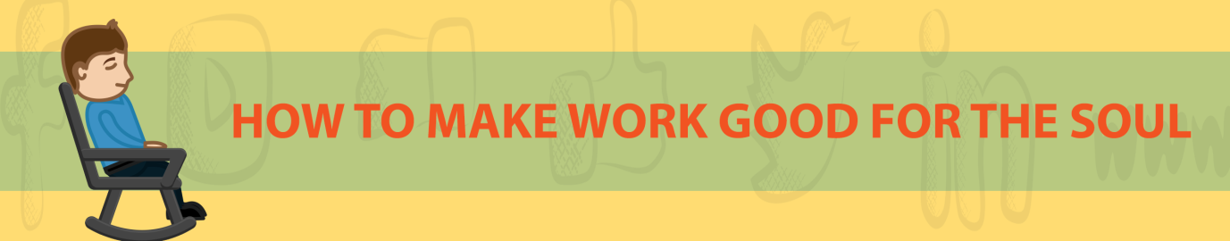

How to Make Work Good for the Soul
Hopefully, you’re now improving your health slightly as you work while also getting paid more for less time spent working. This is all good news but you might still find that there are some challenges associated with digital marketing.
For one, you’ll still be completing work that other people have set and helping them to promote their brands and services while you remain unseen. This can be a little disheartening and especially when the products you’re promoting might not be things that you can really get behind.
To solve this issue, try to create a scenario where you’ll believe in most of the work you’re having to do. One tip to help you do this is to market yourself as offering internet marketing within a specific niche. You might be an internet marketer for the fitness niche for instance, or for the fashion industry. That way, the work you will get will be something that inherently interests you. You’ll have more fun researching the keywords and a better understanding of the blog posts you’re asked to write. Passion makes everything a lot more bearable and this is something that can help you to feel much more excited when you wake up each morning.
Another tip is to consider setting up your own site or blog. Having a site through which to promote your marketing services is a great way to take ownership of the business you run and to feel much prouder of it as a result. It’s a great way to bring new clients to your business too and if you advertise a higher rate than you’re currently offering, then this can be an excellent way to again, work less.
Likewise, why not run blogs in other niches? This is a great way to enjoy a little internet fame and to set up some additional passive income. Moreover, you can use the internet marketing skills you’re developing and maybe even in some cases benefit from the marketing you’re doing with others. You’re building all those connections with influencers right? Why not use them for yourself too! Apart from anything else, this is a great way to demonstrate what you can do to potential new clients.
Another tip is to make sure that you aren’t spending all day in your front room typing in your pyjamas. This can quickly drive you mad, so a good start would be to invest in some good hardware and to create a home office with a powerful computer you can use to do more advanced work. Another tip is to sometimes go out of the office. Of course, some internet marketers will go the whole way and become ‘digital nomads’ – travelling the world while working out of coffee shops. This isn’t for everyone, but what you can do is to enjoy working in places other than home even in your own country. For example, why not work in a local coffee shop from time to time?
This is a fantastic way to remove distractions, to get a little human contact, to enjoy some nice coffee and to work in an environment that is conducive to work and will make you feel more productive.
These are just some of the ways that internet marketers can help make their lives easier, healthier and more fun. There are plenty more and if you read the full ebook, you’ll discover how you can travel more while you’re working, how you can finish your work in less time, how you can drastically boost your productivity and much more.
Internet marketing gives you the freedom to control your income, your lifestyle and more. It just takes a little practice and time to get everything just how you want it and to know what you need in order to work and feel your best.

